

OPENING DAY 2016
ANSON ATHLETIC YOUTH
ASSOCIATION
APRIL 16, 2016 1:00pm

- Teams need to be dressed in uniform and at Field of Dreams at 12:00pm
- Weeball – Field 1
- T-ball – Field 3
- Rookie – Field 1
- Majors – Field 3
- Softball – Field 1

- Ceremonies will begin at 1:00pm on Field 2
- Concession Stand will open after Opening Ceremonies
- Games begin at 2:00pm (see online schedule)
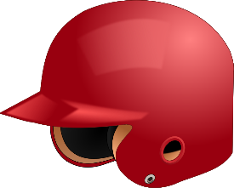Helmet Painting-There will be a vendor onsite that will be taking orders (cash only). The turnaround time is approximately 2 days. Price range $40 - $50

Face Painting Photography Great Food

