Waiver
I, undersigned, understand that softball is an active sport in which an injury may occur. I do not hold the Andover Softball Clinic or its staff, Andover High School or its staff responsible for any incidents:
Signature:

X ___________________________

REGISTRATION

FIRST NAME LAST NAME

STREET ADDRESS

DOB GRADE

PARENT OR GUARDIAN NAME

EMAIL (for confirmation only)

HOME PHONE CELL PHONE

T-Shirt size

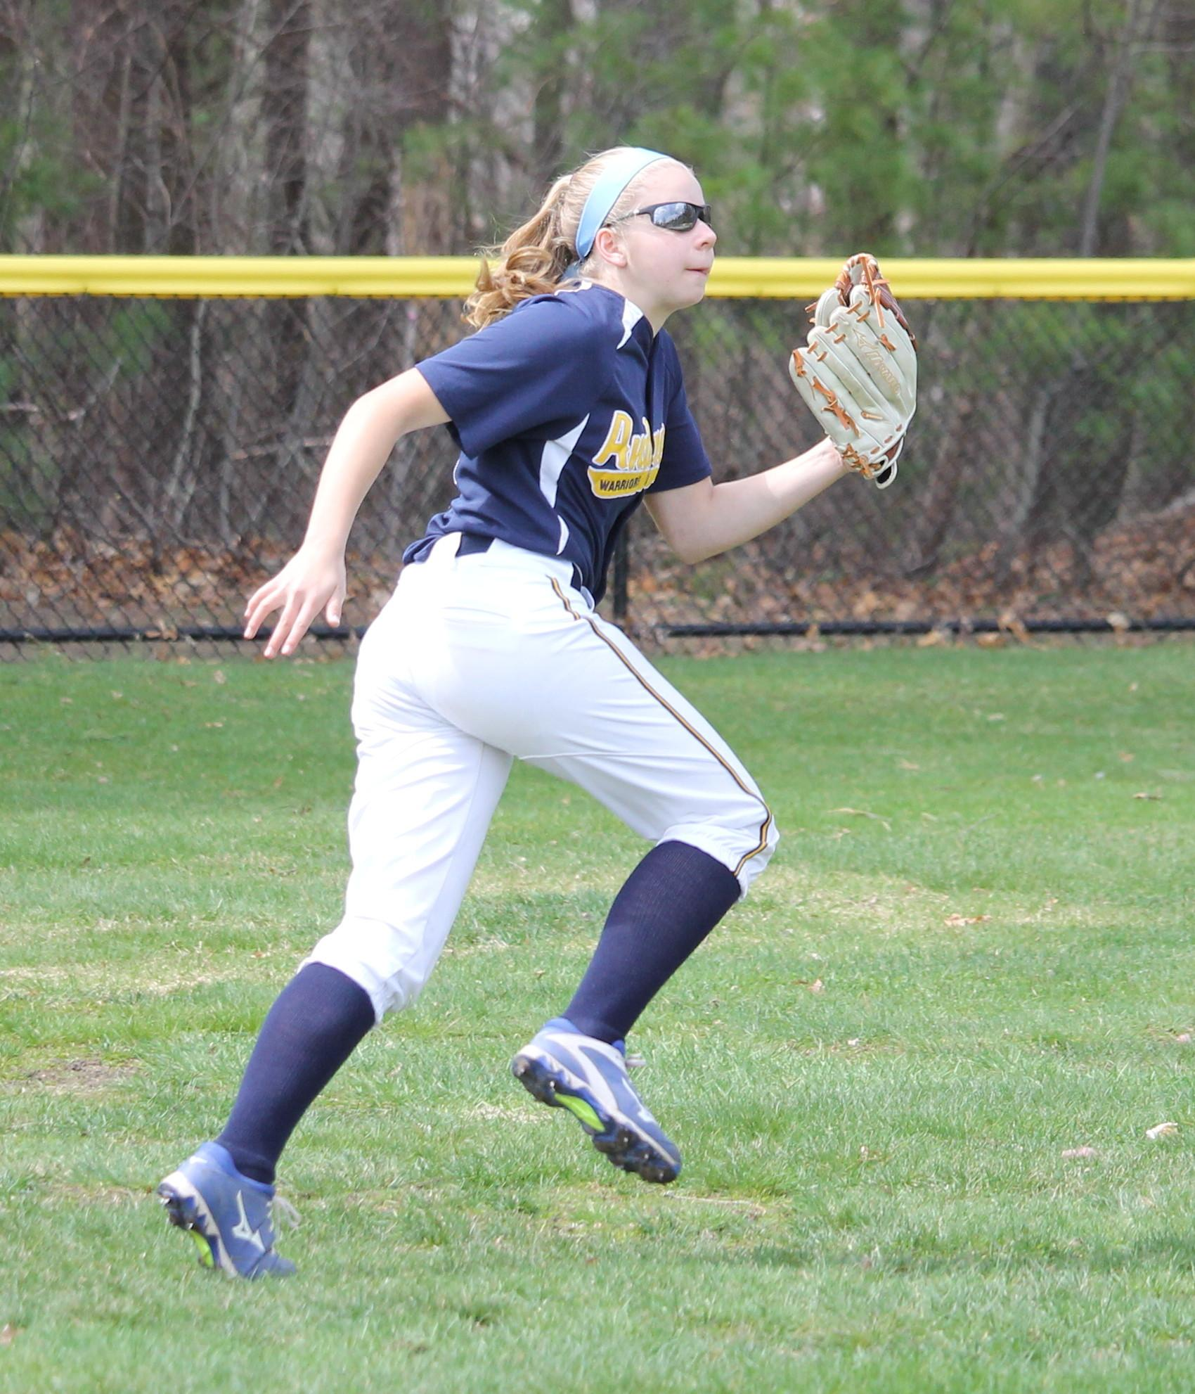
ANDOVER
SOFTBALL
WINTER CLINIC

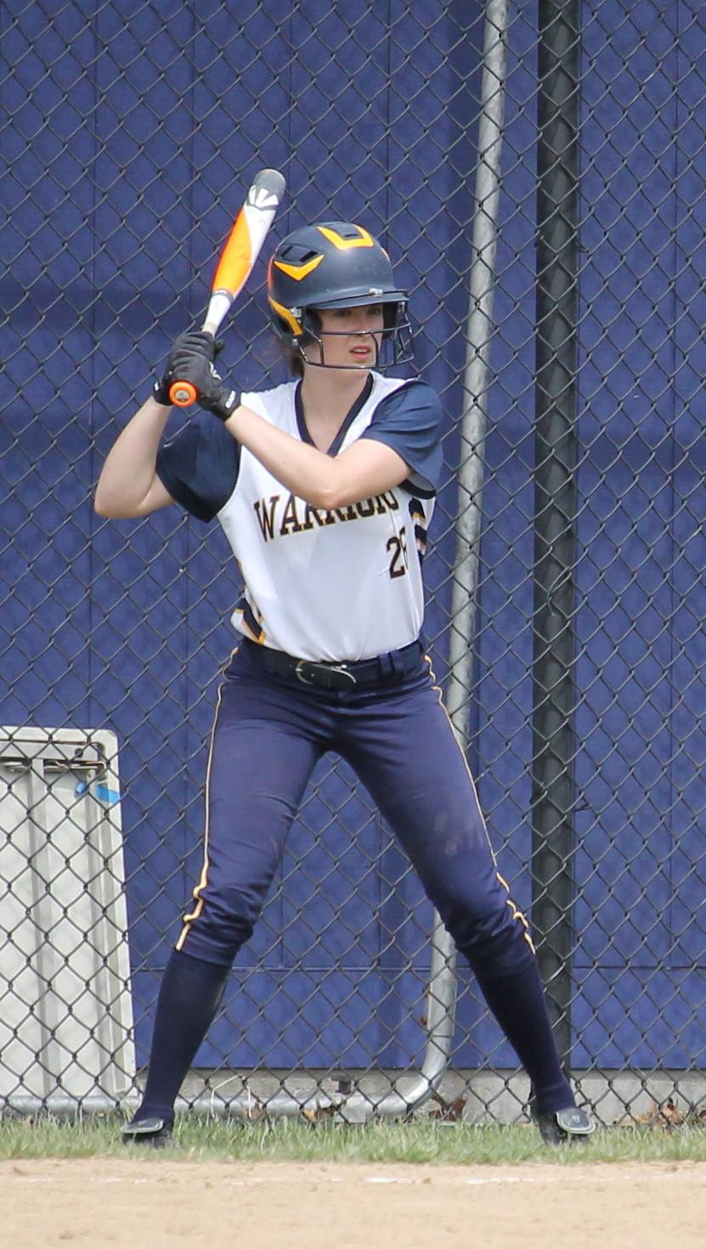

ANDOVER
SOFTBALL
WINTER CLINIC

GRADES K-9

Sundays 12:00 – 2:00
January 7 – March 11
(No clinic 1/28, 2/18 or 2/25)


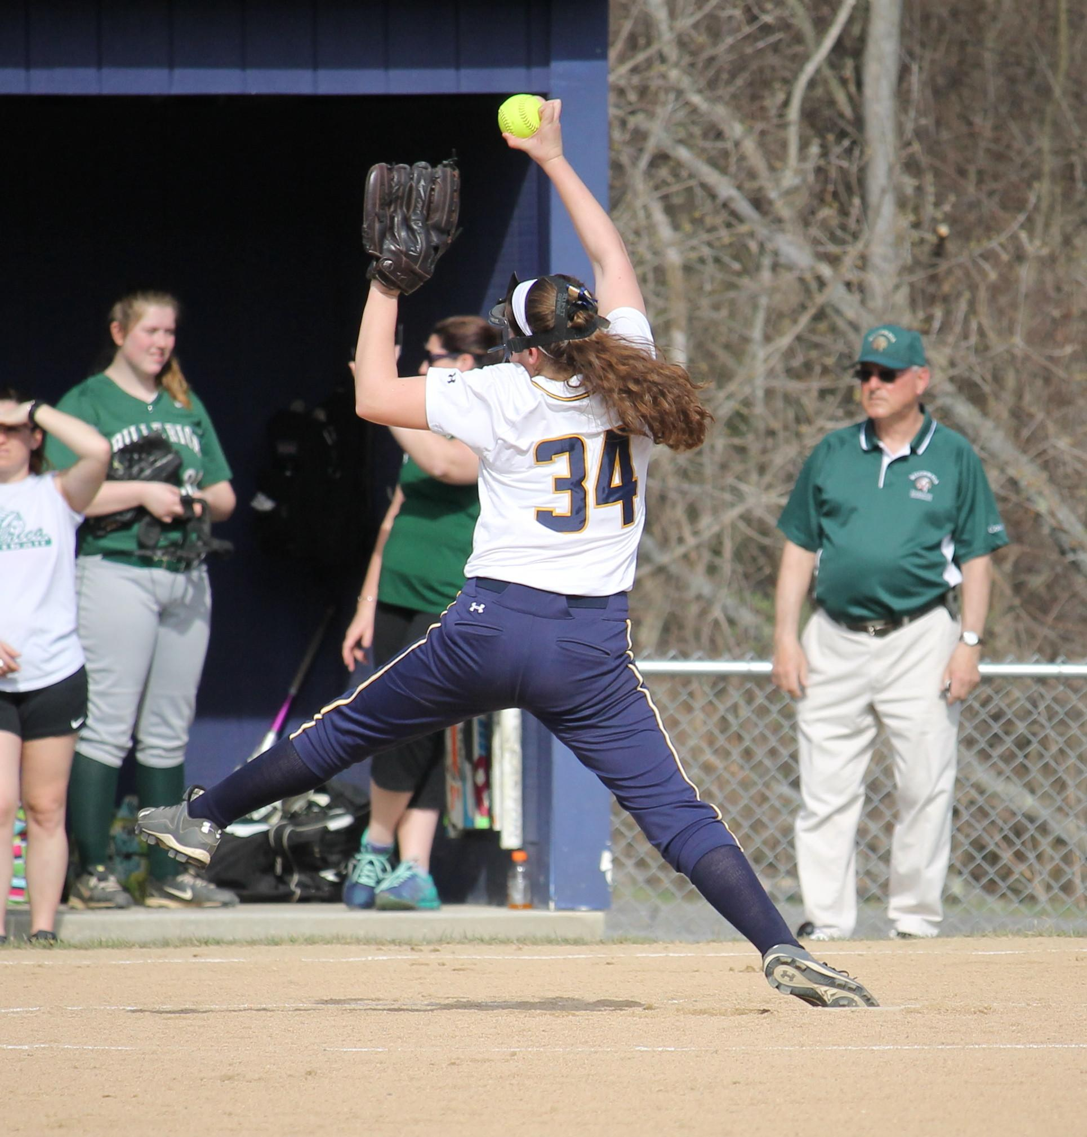

ANDOVER SOFTBALL
CLINIC

Sundays 12:00 – 2:00
January 7 – March 11
(No clinic 2/18 or 2/25) 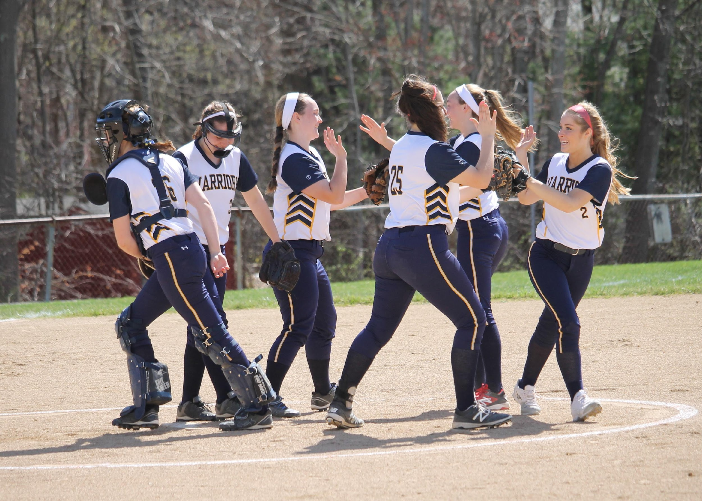

Goal:
The goal of the ANDOVER SOFTBALL CLINIC is to instruct YOUNG SOFTBALL PLAYERS in the finer points of athletics and SOFTBALL. All participants will be closely monitored as well as evaluated.

Location:
Andover High School Field House

Equipment:
Clinicians should bring sneakers and a glove. Helmets and bats are optional. All equipment should have players name on it.

CLINIC SCHEDULE

12:00 – 2:00

12:00– player check in.
12:05– staff led warm-ups. Players will loosen arms and prepare themselves for the day.
12:30– station work
Include: Hitting, infield, outfield, pitching, catching, and baserunning. Players will rotate to get time at each skill.
1:55 - Review of skills practiced
2:00 – Dismissal to Parent or Guardian

Checks Payable to:
Andover Softball Clinic
Mail to:
Andover Softball Clinic
1 Fern Road
Andover, MA 0180

AndoverSoftballClinic@gmail.com

Tuition Information

Sundays January 7 – March 11
Cost: $175 combined all 8 weeks
Or $30 drop in

Best value for any softball clinic around the Merrimack Valley!

Clinic Staff
* Varsity Coach Steve Tisbert
*Junior Varsity and Assistant Coaches
* Current and Former AHS Softball Players


