Billerica Youth Soccer Association
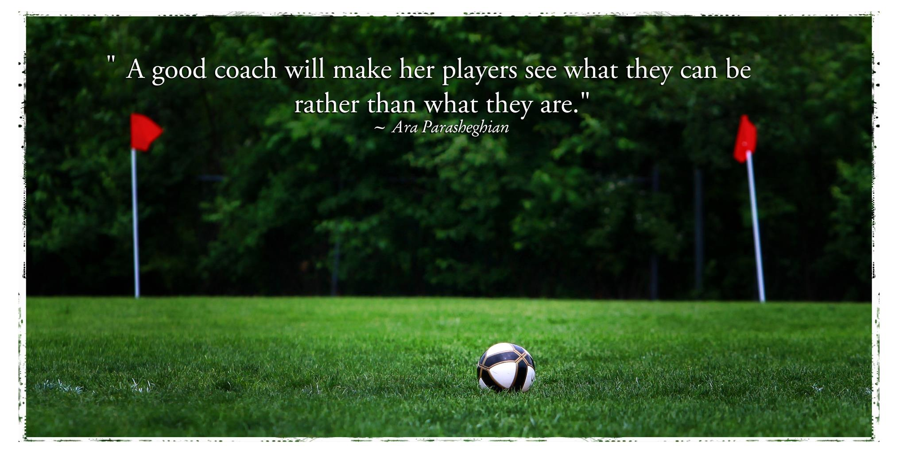
U8 Coaches Handbook
Spring 2014

Welcome to Billerica Youth Soccer Association (BYSA) soccer!

BYSA's purpose is to develop and deliver superior soccer programs, for the youth of Billerica that help to develop sportsmanship, fitness, confidence and team spirit amongst our young athletes. BYSA seeks to provide soccer training that is fun, supportive on all skill levels, and is inclusive in its orientation.
We want to thank you for taking the time and having the patience needed to be a wonderful mentor for so many kids. This program relies on people like you to make it work.
The purpose of this coaching handbook is to provide parent coaches with a reference guide to prepare for the season, and for each practice and game. As such, we have included the Mass Youth Soccer (MAYS) curriculum, training drills and sample practice plans. While this should be a useful resource, it is not a substitute for the MAYS coaching courses. The following are the coach license levels BYSA expects each coach to obtain:
G Course: Intended for U6 & U8 coaches, it covers how to organize practices, prepare for games, ideas on parent education, learning theory and demonstration of basic skills and techniques including dribbling, passing and shooting.
F Course: Intended for U1O & U12 coaches with some experience. It covers how to structure progressive topic-focused practices, games and exercises for practices, and a more thorough demonstration of techniques including receiving, heading and goalkeeping.
E Course: Intended for U14 coaches with experience.

Please visit the MAYS (www.mayouthsoccer.org) website to sign up for a course. BYSA will reimburse you for the cost of the course.
This coach's handbook is the first of its kind for BYSA and is a work in progress. We welcome any comments or suggestions for improvement.

Table of Contents

Introduction
  - Coaches Code of Conduct
  - Guided discovery
  - Standard practice plan template
  - Implementing a practice plan

- Mass Youth Soccer (MAYS) U
  - U8 Curriculum
  - U8 Practice Plans

- Other Resources
  - Risk/Injury management
  - Styles of play
  - 10 Tips for parents
  - Sample Parent Communications
  - Volunteer responsibilities
  - Important Contacts
  - Soccer Websites

It is the expectation of BYSA and the Middlesex Youth Soccer League that coaches will be responsible for not only their actions but those of their players and fans of the team. The BYSA coaches code of conduct and a reprint of the MYSL zero tolerance policy is attached.

COACHES' CODE OF CONDUCT FOR BYSA

I as a coach hereby agree to follow the BYSA and the MYSA guidelines.

- Referees are to be treated with respect.

- I will display good sportsmanship and fair play at all times. I will teach my players to win graciously and lose graciously.

- The emotional and physical well-being of my players will be placed ahead of my personal desire to win.

- I will remember that this game is for the children and not the adults.

- I will make myself knowledgeable in the game of soccer for the level that I coach.

- Practices will be run so that they are enjoyable and challenging.

- It is imperative to explain to parents and players acceptable behavior, at practices and games, in a preseason meeting.

- I will check the playing field before practice and game for reasons of safety.

- I will make a reasonable attempt to play each player 50% of the time during a game.

- I will bring any suggestions or comments to my coordinator.

Signature

GUIDED DISCOVERY (From MAYS)

If you ever attended a youth soccer game, you were likely to hear many specific directions from coaches and spectators alike. We then expect this young player to sort through the information and then make a quality decision. All the contradicting information interferes with the player's ability to solve the problem. As a result, the
player now tries to kick the ball as far as possible or lower their head and run with it. It's simple and sometimes gets results; however, that doesn't make for better soccer players.

If we asked these players to explain their decisions to us at the end of the game, or
even immediately after their actions, it is unlikely they would be able to provide us with a rational explanation. If these players are placed in the same situation at a later time, they will not have experience from which to draw upon when faced with a similar situation. Many times the player will continue to make the same mistake or randomly try something else in order to please the adults.

So what can we do as coaches to prevent players from making the same mistakes and feeling a sense of frustration? We could continue to yell louder and hope they are listening to us. Of course, that will continue to make the game less enjoyable for the player. A better choice is to provide the players with the tools to make these decisions for themselves. If our players understand when it is best to kick the ball forward or to run forward with the ball and why they are making all the decisions they are making during a game, then they will be able to improve their own play and be rewarded with success. Further, if they become thoughtful, strategic players, they will have more fun, gain confidence, and your team's performance is more likely to improve continually.

By asking our players questions to which they must come up with answers, we can insure that our players are thinking, as opposed to mindlessly following our directions. By asking guided questions, we can help maintain focus and direction for our team and help provide learning experiences for our players.

When referring to guided questions, we mean that our questions should place our players on the right track (guide) in order to be able to solve the questions we pose. Some such questions may be quite direct and simplistic, such as:

  - What part of the foot do you use to make a short pass?
  - Where should you aim when shooting on goal?

Questions such as these are called - low order questions as they demand factual, memorized answers. In contrast, we could ask -high order questions that challenge our players a bit differently by asking them to weigh options within the framework of a larger process. High order questions beg interpretation and comprehension over memorization or recall. Examples of -high order questions include:

  - How can we get the ball down the field quickly?
  - Why should we play high-pressure defense?

  - In a 3v3 situation, what's the best way to get the ball to your teammate? Try it!
  - What happens when you pass the ball behind your teammate? Let's try it!
  - Why didn't that pass work? So, how should we do it next time?
  - How can we get the ball to the other side of the field?
  - Why is it important for you to lift your head up when you have the ball?

Utilizing questions such as these will help our players learn and retain information that will aid them in making optimal choices as they play.

Through the use of guided questions, players develop confidence and learn to trust their own decisions. Of course, we must temper the difficulty of our questions to insure they achieve the success necessary to help build their confidence. Players may be a bit uneasy at first when asked these types of questions (especially high order) at first. For this reason, it is a good idea to provide a few positive words before asking a question.
For example:

  - Great. ...so how could we do it faster?
  - I like that answer ...what other skill can we use to get the ball to our teammates?
  - Now you're getting the idea! Where could you position yourself so that you could see both the player you are defending as well as the ball?

Now armed with the confidence and skill to evaluate situations and make decisions on their own, these players will look within themselves (not toward the sideline) in order to determine what choice to make on the field.

U-8 Dribble with all sides of both feet
Dribble out of trouble
Dribble past someone
Shielding
Soft first touch
Introduce proper shooting technique
Introduce passing

Although U8 children may begin to be far more physically and maturationally advanced than U6 children, we must remain patient and not try to force them to develop too quickly. Dribbling still needs to be the primary focus of our efforts, though passing and shooting should be introduced at this age as well. U8 players tend to work best when in pairs and we should allow them to work in pairs (coach selected) often. Similar to the U6 children, we need to make sure that fun is a central theme in practice. Player development will occur most appropriately and expeditiously if all players are enjoying themselves.

Typical Characteristics of U8 Players

- tend to play well in pairs – unlike 6 year-olds, these children enjoy playing in pairs. Try to set up the pairs yourself to control the games and manage the personalities

- are now able to take another’s perspective – they now have a sense of how other’s are feeling

- still unable to think abstractly – still do not have this capability, be patient

- heating and cooling system still less efficient than adults – still make sure to give frequent water breaks

- still much prefer playing to watching – keep everyone active during practice and remember, no lines

- limited attention span (on average 15-20 seconds for listening, up to 20 minutes when engaged in a task) – this may vary greatly on any given day depending on school, diet, etc. Try to get a gauge each day and do not fight crankiness

- have an understanding of time and sequence – they now understand “if I do this, then that happens”

- many have incorporated a third or fourth speed into play – not all players, but many players now have incorporated a speed or two between stopped and as fast as possible

- extremely aware of adult reactions – be very aware of your verbal and nonverbal reactions, as they look for your reaction frequently

- seek out adult approval – be supportive when they ask about their performance or try to show you skills. They very much need reassurance and you need to help build their confidence to try new things at this age

- begin to become aware of peer perception – a social order is beginning to develop. Be sensitive to this

- wide range of abilities between children at this age – children all develop at varying paces. You may have an 8 year-old who seems more like a 10 year-old and one that seems more like a 6 year-old on the same team. Your challenge to is to manage this range in your practice in a way that challenges each player at a level that is reasonable for that player

- some will keep score – the competitive motors churn faster in some than others. Surely some parents are fueling the motors with their own. Regardless, we do not need to stress winning and losing at this age. Results should not be important at this age

- beginning to develop motor memories – by attempting fundamental technical skills they are training their bodies to remember certain movements

- less active imaginations than U6 players – still have active imaginations by adult standards, but some of the silliness that 6 year-olds allowed will not be appreciated by this group. Still use their imaginations, just watch their reactions to games to read how far you can go with things.

The U8 Age Group

This is the age where players can begin to understand the concept of working with a teammate. The notion, or willingness, to intentionally pass the ball to someone is just beginning to take hold. Coaches and parents will have more success encouraging players to pass the ball in the seven to eight year old age group. In this age group, the player begins to think beyond their personal needs and actively begins to cooperate with a teammate. However, players in this age group must continue individual ball work.

Role of Coach

The role of the coach in the U8 age group is to be a sensitive and patient teacher with an enthusiastic and imaginative approach. It is helpful if they have the ability to demonstrate and very important that they understand technique.

License Requirement

The U6/U8 State Youth Module is required. The “Y” License is recommended.

The U8 Player Characteristics

Mental/Psychological (cognitive)

Short attention span, but better than U6
Love to use their imagination…pretend
Limited ability to attend to more than one task at a time
Beginning to solve simple soccer problems (i.e. pass to a teammate)
Some understanding of time and space relations

Physical (psychomotor)

Beginning to develop physical coordination
Improvement in pace regulation
Skeletal system is growing; growth plates near joints
Cardiovascular system is less efficient than an adult’s; heart rate peaks sooner and takes longer to recover
Catching skills are still not developed
Improvement in dribbling and kicking
Love to run, jump, fall and roll

Socially (psychosocial)

Self-concept and body image are beginning to develop
Sensitive…dislike personal failure in front of peers
Negative comments from peers and adults carry great weight
Limited experience with personal evaluation…effort is synonymous with successful performance
Inclined more toward cooperative activities (small groups)
Inclined to establish and cooperate with friends
Desire social acceptance; want everyone to like them
Influential person in their life is their father or significant parent
Like to play soccer because it is FUN; intrinsically motivated; play for enjoyment

What to Teach U8 Players (Game Components)

Techniques (skills):
Dribbling
With outside of the foot
Change of speed and direction
Receiving
Ground balls with inside, outside, and sole of foot
Bouncing balls with various body parts
Ball lifting and juggling
Passing
With toe, inside of foot and laces
Throw-ins
Shooting
With toe, inside of foot and laces
Tackling
Toe-poke
Catching
From self and from partner
Rolling, bouncing, and air balls

Psychology (mental and social):
- Working in pairs
- Sportsmanship
- Dealing with parental involvement
- “How to play” (social cooperation)
- Emotional management

Fitness (movement education):
- Introduce the idea of warm-up
- Agility
- Leaping
- Tumbling
- Eye/foot & eye/hand coordination

Tactics (decisions):
- Being exposed to all positions
- 1 v 1 attacking
- 1v1 defending
- 2v1 attacking
- Introduce the names of positions
- Shape (triangles)

Rules:
Review the kick off
Review the goal kick
Review hand ball
Review physical fouls (pushing, holding, striking, tripping)
The corner kick
Direct kicks
Throw-ins

The Training Session

General Information

The training session should involve fun and imaginative game like activities.

Light coaching on simple technique is appropriate (dribbling, passing and receiving)

Small-sided directional games such as 1v1, 2v1, 2v2, 3v2, and 3v3 should be included as well.

Training should always conclude with a 4v4 game without goalkeepers.

The duration of the training session should be 60-75 minutes.

Some Recommended Games for U8 Players:

- Free Dribble---Everyone with a ball, use inside, outside, and sole of the foot. Have players dribble with speed (outside of foot), change direction, and perform moves. Coach calls out moves or changes in direction and sets the pace as the manipulator of the session, kids carry the ball towards someone and try a move. Version 2: As players get comfortable, coach can walk around and put pressure on players as they are performing dribbling tasks. This adds fun and interaction.
- Knock Out---In same space as previous activity, have players dribble balls while trying to knock other player’s balls outside of the grid. Players can never leave their own ball. If their ball gets knocked out have them retrieve it quickly and get back into the game. (You may wish to have them perform a skills task before re-entering such as 10 toe touches or juggling 5 times).

- Shield-Steal---Half of players in the group have a ball and half do not. If you do not have a ball you need to steal one from someone who does. If ball goes out of bounds, person who touched it last does not get possession. You can teach players the technical points of shielding as a group at start of activity. Show technique with body sideways, arm providing protection, ball on outside foot, knees bent, turning as defender attacks, using feel to understand where defender is going. Fix technical shielding errors throughout this activity and make sure entire group knows how to properly shield.

- Marbles---Players are in pairs, each with a ball. This time instead of chasing each other, one player plays out his ball and the partner passes his own ball in an attempt to strike the ball his partner played out. Players should keep track of how many times they hit their partner’s ball. Version 2: Once players understand this game, make it fast paced by having the players take turns at trying to hit each other’s ball without ever stopping. If player 2 misses player 1’s ball, then player 1 immediately runs to his own ball and tries to hit player 2’s ball (player 2 does not get to touch his ball after missing player 1’s ball). After player 1 has a chance, then player 2 immediately tries to hit player 1’s ball right back. etc. etc. This game is continuous and players should keep score. Hint: If 2 balls are very close to each other a player should kick their ball hard at the other ball so when they hit it, it is more difficult for the other to hit their ball back.
- Gates Passing---Players are paired up and must successfully pass the ball through the cones to their teammate to earn a point. Players try to accumulate as many points as possible in the time allotted. Have players pass only with their left foot or right foot, or the outside of their foot.

- Triangle Tag---Set up cones in a triangle formation with each side of the triangle being roughly 1 yard long. Every triangle has a pair of players, each with a ball. Similar to the tag game, one player is being chased and one is “it”. However this time the player who is “it” tags the player by kicking her ball and hitting the other player’s ball or hitting the player below the knee. Players can dribble in either direction around the triangle and must stay close to their own triangle. Neither play can go through the triangle. Version 2: Allow the player being chased to go through the triangle. When in the triangle she is safe. However, after going through triangle, player must go completely around triangle before she can go through triangle again. She cannot stop inside the triangle. Version 3: Allow pairs to move from triangle to triangle (incorporates speed dribbling and traffic). If two pairs are at the same triangle at the same time that is fine, but players still only compete with their partner. Note: To increase difficulty, do not count hitting a player below the knee as a tag.

- Get Outta Here---Place two small (2 yard) goals at the end of a field 15 x 10 yards. Place half of team behind each goal and coach stands at halfway line with all balls. When coach plays out a ball the first two players run out and try to score on each other’s goal. If the ball goes in the goal or out of bounds, the coach yells “get outta here” and plays in a new ball immediately for the next two players. Version 2: Coach can stop yelling “get outta here” after a while and see if players recognize when balls go out and are attentive. Version 3: Coach can vary service of ball. Sometimes play it to one player, sometimes toss the ball up in the air. Version 4: Have the first two or three players from each group come out each time a new ball is played and play 2 vs. 2 or 3 vs. 3.
- Clean Your Backyard--- Break group into two teams and have each team stay only on their half of the field. Place a 6 yard buffer zone between halves that no one can enter or cross. Each player needs a ball. Place three small (2-3yd) goals at the far end of each side of the field. Have both teams shoot balls at other team’s goals in an attempt to score through anyone of the small goals (below knee height). Players cannot cross the buffer zone or go into the other half. Balls get recycled naturally in the game. This is a competition and teams need to keep score. Play 2 or 3 games and have teams re-strategize between each game. Teams can play defense though no hands. Only shots with laces count as goals.

- 2 vs. 1 keepaway---In a grid 10x15 yds, three players play 2 vs. 1 continuous keepaway. Two attackers combine to keep the ball away from one defender. When the defender wins the ball, he or she immediately combines with the attacker he or she did not win the ball from and the attacker who lost the ball becomes the defender. Balls out of play are dribbled in or passed in.

- 1 vs. 1 to Endlines---In a space that is wider than long (15 x 20 yds) each player defends one endline and attacks the other. Players score by dribbling the ball in control over the opposing player’s endline. Version 2: You can make this 2 vs. 2, 3 vs. 3 or 4 vs. 4.

******************* Every practice should include a scrimmage***********************

BYSA PRACTICE ORGANIZATION

Coaches should organize their practice session in a progressive manner, easy to difficult or simple to complex. It must provide for individual, small group, large group and/or team activities.

The BYSA standard practice plan is:

- Warm-Up/Stretch (-10 minutes) - the warm-up prepares the player both physically and mentally for what is to follow in the training session. Warm-ups should incorporate a technical and/or tactical element as a lead in the training session. Stretching should be integrated throughout the warm-up.

- Small Sided Activity (-10 minutes) - small group games that provide a lead into larger group games. Small group activities will provide the majority of work within your coaching session and should cover your one chosen topic (Ex. dribbling OR shooting for one session).

- Expanded Small Sided Activity (-15 minutes) - small sided games that now include more players and closely resemble the game of soccer. This activity must be directional and include a goal (can be multiple goals, end-lines or target players). Your topic still needs to be focused and taught during this activity.

- Free Scrimmage (-20 minutes) - this does not necessarily mean 11v11. It means a game including as many players as you can up to the number that play in your league games. A U12 team should try to end with 8v8 and a U14 team should end with 11v11, as in league matches.

- Cool Down (-5 minutes) - following the training session a cool down of light, low intensity exercise and static stretching aids the player to recover from the training session. They have worked hard and this will help them to unwind physically and mentally.

BYSA Practice Plan

Practice Topic: _

 | Organization | Coaching Points
Warm up activity
Small Sided Activity
Expanded Activity
Free Scrimmage
Cool Down

Go To Mass Youth Soccer website and there are week by week lessons that you can use to have your players learn the skills needed to move on to Travel Soccer.
Massachusetts Youth Soccer Coaches Corner Website: http://www.mayouthsoccer.org/coaching/practice_plans_u8.aspx
***** Also See they BYSA Coaches Corner for lesson plans from US Youth Soccer. *******

IMPLEMENTING A LESSON PLAN

During a session, a coach must recognize a coachable moment to give information to their players. A coachable moment is when a technical or tactical issue arises, based on the topic for the session. Each activity in a session plan will create a coachable moment. As coaches, we watch for these instances so that we can make our coaching points and teach our topics.

Once a coachable moment is recognized, there are several methods coaches use to give information to the players. These methods are called "the coaches toolbox" and are listed from the least to most intrusive.
These methods are explained below:
  - Allow the conditions of the practice game to coach the topic
    - Use touch incentives (one touch, two touches, mandatory two touches)
    - Adjust the size of field and/or size of the goals
    - Use a neutral player to provide a numbers up opportunity
    - Let your players play the game

  - Coach in the natural stoppages of the activity
    - Wait for the ball to go out of play, then recreate the coachable moment
    - Natural stoppages are throw-in's, goal- kicks

  - Coach in the flow of the activity (large group)
    - Information must be concise and clear to all of the players you are speaking to
    - This is instruction, not a running dialogue with your team

  - Coach individual players as the activity continues
    - Talk to one player either from a distance or close
    - Clear, concise information must be provided
    - Have a player step out of an activity and then provide them with short instructions

  - Coach using the -freeze method
    - Stop play when the -coachable moment occurs
    - Players must stay exactly where they were when the freeze was called - if
. not, the picture of what is being taught changes completely
    - Review what happened, rehearse what they could have done to find success, and restart play from a point prior to the point of your stoppage.

Regardless of the chosen method, remember to keep instructions short, detailed and topical (30 seconds for your coaching point). As we coach, we need to allow our players to play the game. Making a maximum of four coaching points per activity, using any of the methods discussed above, will help keep your activity flowing yet still providing instruction to your players. We do not need to coach every mistake that pertain to your topic that occurs as we would be stopping play too often. Pick your times to make your points and teach your players!

Example Practice Plan

Topic: Passing and Receiving for Possession
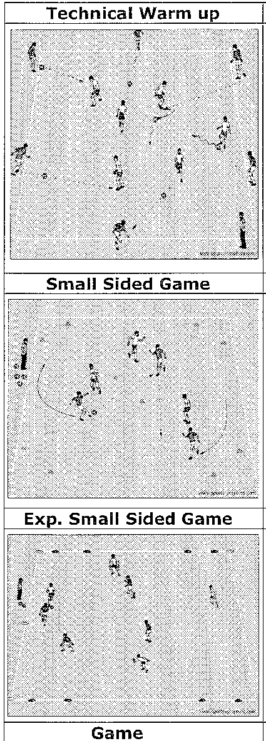Objective: To improve the players' ability to pass, receive, and possess the soccer ball when in the attack

 | Organization | Coaching Pts.
 | Dutch Square:  Half of the players on the inside of the square (with soccer balls), half on the outside. The insiders will pass the soccer ball to the outsiders. The outsiders will pass the ball back with one or two touches to the insiders. The insiders will receive the soccer ball and look for another outsider to pass to. After a few minutes, switch insiders with outsiders.  Coach: have players pass and receive with the right and left foot. | Passing:  - Toe up (inside) or down & turned in (outside)  - Placement of non-kicking foot and good balance  Receiving:  - Keep feet moving before ball arrives and go to it  - Keep ankle of receiving foot locked and body behind ball  - Eye on ball at instant of reception  Time: 15minutes
 | Organization | Coaching Pts.
 | 3v3 5 Goal G ame:  In a 20x30 yard grid, five 2 yard goals are spread out throughout the grid. The teams score by passing and receiving through any of the goals to a teammate.  Coach: Emphasize the importance of being in good supporting positions and good attacking shape. 3 Players need to be in a triangle. | - Tech of passing and receiving  - Players in good supporting positions  - Pace and accuracy of the pass  - Finding the open gate or goal  - First Touch -Directional  - Clear communication (demand the ball)  - Good team shape  Time: 15 minutes
 | Organization | Coaching Pts.
 | 4v4 or 5v5 to Four Small Goals:  In a 30x35 yd. grid with two small 3 feet cone goals on each of the 35 yard lines, near each comer. Each team defends and attacks two goals. If playing with 4 players, the attacking shape should be a diamond. If attacking with five players, the attacking shape should be a 3-2 or 2-1-2. | - Possess the ball to look for an opportunity to score  - Players in good supporting positions  - Decision making: safety versus risk  - Communication  - Good team shape  Time: 20 minutes
 | Organization | Coaching Pts.
6v6 to 8v8 Scrimmage | If 6v6, play in a 45x60 yd. field. If 8v8, play in a 55x80 yd. field. Play with Goalkeepers and encourage them to communicate with teammates. | - All of the above  Time: 30 minutes
COOL DOWN | Activities to reduce heart rate, static stretching & review session. Time: 5-10 Minutes

Go To Mass Youth Soccer website and there are week by week lessons that you can use to have your players learn the skills needed to move on to Travel Soccer.
Massachusetts Youth Soccer Coaches Corner Website: http://www.mayouthsoccer.org/coaching/practice_plans_u8.aspx
***** Also See they BYSA Coaches Corner for lesson plans from US Youth Soccer. *******

RISK/INJURY MANAGEMENT AND PREVENTION

An integral component of all coaching and playing activity throughout the season must be the prevention and management of injury to players (and coaches). There are numerous simple tasks a coach can and should do in order to secure the health of his
or her players. Before the season begins, the coach should make sure all parents know the emergency procedures for all situations (injuries, accidents, weather problems). This procedure should be clear and simple. If it includes cell phone use, the coach should make sure he/she gets reception at all playing sites.

Field Safety/Weather Conditions

Before starting practice or a game, it is important to check the field for dangerous objects. Often glass and other sharp objects can be found on fields, as well as holes and other hazards. Goals need to be inspected and anchored properly, or moved away from the playing area if not being used. When moving goals, it is important to utilize adults and to supervise them, as often it is the first time they are moving goals. They may not know how to move them or realize how heavy they are.

At every field, look to see where you could go in case of lightning or heavy rain. Is there a building or public bathroom nearby where you could fit all the children? If not, do enough parents stay to watch practices and games in order that all the children could fit in their cars in case of severe weather? At the first sign of lightning, get the players into a safe environment. This is where your written emergency plan comes into use.
Lightning detectors are already in use at many of the parks in which you play. Make sure you know the meaning of all signals coming from this system. If you do not have a lightning detection system, seek out ways to get one installed.

Seeing all the Children

Players cannot be let out of your sight. Often times, young players need to go to the bathroom. Make sure they are supervised when they go (preferably by their parent). Never allow a child out of your sight without adult supervision.

Second Adult Present

Always have a minimum of two adults at every practice. This allows one person to care for injuries or bathroom breaks as the other tends to the rest of the team. It also
provides for another witness in the case of injury or accident. Make sure that both of you are present until the parents of the last child arrive. You should stress to parents they should arrive on time to pick up their children.

Injury Prevention for Common Injuries

Heat Stroke - If a player shows signs of heat stroke their sweating will stop, the player may be confused or dizzy, have pale skin, an extremely dry mouth or be unconscious. It is important to call an ambulance immediately. This can be life threatening. While
waiting for the ambulance, similar steps to that which are taken for heat exhaustion should be followed. Making sure your players are properly hydrated will help prevent heat injuries.

Fractures & Dislocations - If a body part does not have a normal appearance or function, then suspect a fracture. Do not move the player, keep warm and make comfortable, call 911. With a possible dislocation, the joint will have a marked deformity with intense pain. If a player can walk, immobilize the joint and immediately transport to hospital. If the player is unable to walk, call 911.

Abrasions - Abrasions are very common sports injuries that are usually caused by a fall on a hard surface. As the athlete falls or slides on the ground, friction causes layers of skin to rub off. General treatment of abrasions includes treating the area by cleaning the wound with mild soap and water or a mild antiseptic wash like hydrogen peroxide, and then covering the area with an antibiotic ointment and a dry dressing. Be sure to wear latex gloves before you treat the player!

Sprains, Strains and Contusions - R.l.C.E. Principle (Rest, Ice, Compression, and Elevation) is the best method of dealing with these injuries. Using these four immediate first aid measures can relieve pain, limit swelling and protect the injured tissues. The
      - Method of Acute Injury Treatment:

o Rest: Resting is important as it will allow the injured area the time to heal itself as · well as help prevent further injury.

- Ice: Use ice bags & cold packs to limit swelling by reducing blood flow to the injured area. Do not leave ice on an injury for more than 20 minutes at a time. Compress or wrap the area with an ACE bandage around the swollen part of your body. If throbbing occurs, remove the bandage and re-wrap the area so the bandage is a little looser.

- Compression: Compress or wrap the area with an ACE bandage around the swollen part of your body. If throbbing occurs, remove the bandage and re-wrap the area so the bandage is a little looser.

- Elevation: Elevating an injury reduces swelling. It's most effective when the injured area is raised above the level of the heart. For example, if you injure an ankle, try lying on your bed or sofa with your foot propped on a couple of pillows.

Two important factors with dealing with field injuries of this nature:

        - If you see clear visual evidence of abnormal deformity to the injured area, call emergency professional care immediately.

        - If symptoms persist (pain, swelling, severe bruising) after 24-48 hours of using the R.l.C.E. method, consult your doctor.

SYSTEMS OF PLAY

Although we would love to be able to recommend a perfect system of play to you and save hours and hours of consternation, we cannot. There simply is not one system of play that has been proven most effective at any level.

A system of play is simply a way to organize the players in hopes your organization will allow your team to apply the principles of play better than the other team. Through a specific arrangement of players on the field, the coach tries to close dangerous spaces when defending and take advantage of open spaces when attacking. This requires a great deal of understanding of the role of each position and capabilities of each of your players. Soccer is all about the players, their skills and personalities. A system must fit the abilities and characteristics of your players. Too often a system is seen as a solution to all problems and is forced on unwilling players. When a coach at any level imposes a particular system on players in disregard of their abilities, success is highly unlikely.

The importance of systems of play is exaggerated. It should be understood there is no system which will overcome inaccurate shooting or inaccurate passing; there is no system which caters to players who will not support each other and there is no system which caters to players who will not or cannot run. No system can improve ball control; no system can improve decision-making; no system will accommodate a lack of aggression or composure or confidence. However, a coach should be able to teach their team how to employ different systems when the game dictates the need for a change.

When discussing organization within a system of play we talk of lines of players from back (defense) to front (offense) and these lines are generally arranged into three groups (defense, midfield, offense). For example, a 4-4-2 is comprised of 4 back players, 4 midfield players and 2 forwards. The GK is a constant and need not be mentioned.

The following factors can be taken under consideration when selecting a system:

- Technical ability of the players
- Tactical understanding by the players of their roles in the game
- The fitness required for particular systems
- The system, style of play or the strengths and weaknesses by the opposing team
- Game situations

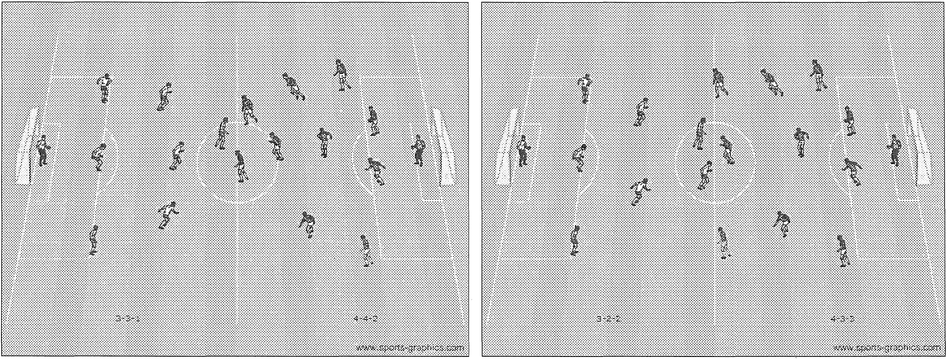

3-3-1 to 4-4-2 3-3-2 to 4-3-3

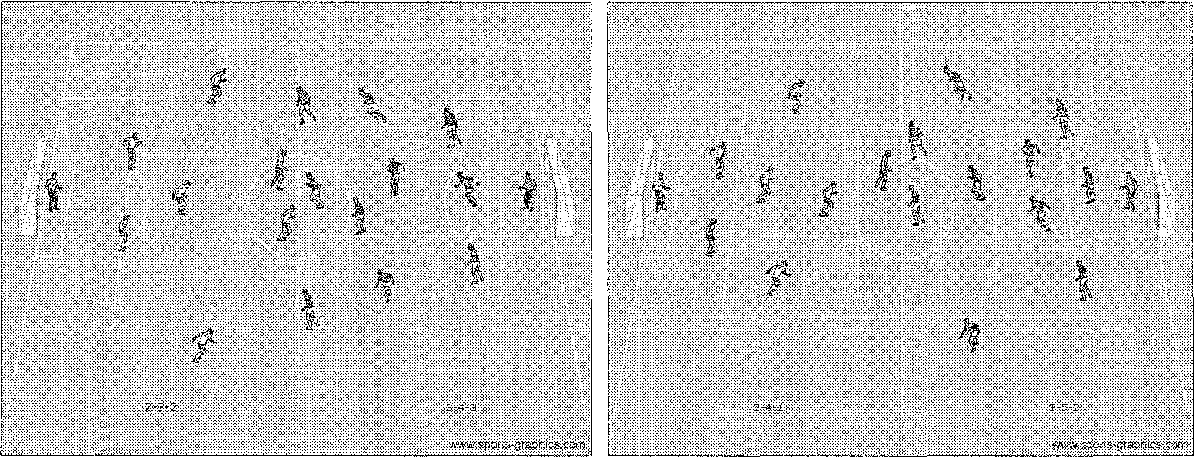
2-3-2 to 3-4-3 · 2-4-1 to 3-5-2

TEN TIPS TO BE A BETTER SOCCER PARENT

- Soccer is a team sport.

- Our children are on the team, not us.

- If you want your child to improve his/her skills and performance, then leave it to the coaches.

- If you think you can offer good advice to one of the coaches, then arrange to take the coaching certification exam.

- If you want to coach from the touchlines without coming to team practices, coaches clinics or coaches meetings, keep the thought to yourself until you can watch soccer on TV.

- Although coaching advice from parents is generally not appreciated, communication is very important. If anything at all is bothering your child, let he coach know as soon as possible so that he/she has an opportunity to adjust if possible to make your child's experience more rewarding and enjoyable.

- If you think you can offer good advice to a game official. ..(see #5 above)

- A soccer match is not won or lost by any child. (see #1 above)

- Follow the rules and use good judgment and everyone will have a great season.

SAMPLE U12/U14 PARENT MEETING AGENDA

Team Goals: Our primary goals as a team are to have fun and to develop as young soccer players.

I hope to be able to teach the players to perform skills under pressure and at full speed, which will help them improve in the game. I also hope they learn how to make basic tactical decisions on their own during the games. We will have fun practices that focus on technical skills and on basic tactics. Winning will not be a priority for our team. Team priorities will be developing skills and enjoying the game. If you watch practice you may at times see us engaging in activities that do not look like -real soccer. Please be assured that all activities we do will help with skill building, tactical awareness, team­ building, and enjoyment.

Style of Play: I will be encouraging the players to try new things and to be creative. It is my hope that players have the confidence to show their skills and make tactical decisions in the game. We will try to move up and down the field as a team, use combination plays, and give proper offensive and defensive support. I will be moving players into multiple positions to help them learn all parts of the game. It is my hope that the players will be coaches on the field for each other and will encourage each other as well.

Attendance: I will be at every practice and game foregoing any unforeseen emergencies. Please make every attempt to have your child at every practice and game (on time) as well as it is part of learning the responsibility of being on a team. Given our hectic lives, I do understand that players may have conflicts here and there. Please let me know before the first game of any conflicts you might have for the season so I can prepare my practices accordingly and we can make sure our team has enough players at every game. Please have your children at the field 30 minutes before the game starts and please pick up your children promptly after every practice and game.

Discipline: I have been told I run a tight ship and will continue to do so. If players are acting out, I will ask them two times to fix their behavior. If they fail to do so after these warnings, I will sit them down at practice or during a game. If the behavior continues, we will need to talk about it to find a way to help resolve the behavior without it detracting from the rest of the players' experiences on the team.

Communication: I am typically a difficult person to reach by phone. The best way to contact me is via email at soccercoach@sampleclub.com. Should you wish to talk by phone, my office number is 508-555-1234 and the best time to reach me is between 12pm and 3pm. If these times do not work, let's schedule a time that works for both of us. Please do not ask to talk to me during a practice or game or immediately before or after the game or in front of your child. I do encourage open communication and questions, as we all hope to make this a great experience for the children.

Sideline Behavior: Please be supportive and enthusiastic on the sideline during games. · The players and I will truly appreciate your applause and encouragement. However, if

everyone is coaching, this will only confuse the players. Please do not coach from the sideline. The players need to make their own decisions and we need to support them and educate them at practice. Remember, you are a role model on the sideline for the players. Please set a good example.

Overall: I am excited for a great year and I hope you and your child are as well. Let's all have fun and enjoy the game. If you have any questions, please, let's keep open communication.

Volunteer Responsibilities

VVP Parking
- All teams (instructional, intramural & travel) playing at the VVP will be responsible for supplying volunteers to help with the parking lot on Saturdays
- Coaches, assistant coaches and parents are welcome
Field Lining
- Coaches from all programs will be responsible for helping to line their assigned fields
Field Clean-up
- All teams will be responsible for supplying volunteers to help on Field Clean Up Day, tentatively set for April
- Volunteers will be responsible for bringing items such as, rakes, wheel barrels, weed whackers, clippers, chain saws, leaf blowers, etc
- Volunteers will be assigned to the fields their children play on

FUNDRAISING EVENTS
BYSA will be holding 2 fundraising events this spring season that will require a lot of volunteers as well as well as donations from every team to make them a success. These fundraisers are an important part of BYSA as these events help us to keep the registration fees down.
Memorial Weekend Tournament
- This will be a weekend that we will be looking for volunteers for
  - Field set up & clean up
  - Registration
  - Snack tent
  - T-shirt sales
  - Parking
  - Etc

Casino Night Fundraiser – Saturday, May 31 @ Billerica Elks
- Every team will be required to collect $10/player to go towards either a team basket for raffle or a large prize for that night. We would suggest each team designate a team parent to help them out with this.
- Each coach will be responsible for promoting and selling tickets to the fundraiser
  - Volunteers for night of this event will be needed in many aspects which we
Will discuss as it gets closer

Important Contacts

Ricci DeRosa, President rick.derosa@yahoo.com
Bob Lage, Intramural Director boblage@rocketmail.com
Paul Trask, Referee Assignor paul.trask@verizon.net
Anthony Giordano, Coaching Director agiordano17@gmail.com

Web sites for Soccer info
Billerica Youth Soccer Association
https://www.sportsmanager.us/billericasoccer.htm?REFEREEURL=LoginArea.html?https
Middlesex Youth Soccer League
http://www.sportsmanager.us/orgmanager/mysl.htm
Massachusetts Youth Soccer Association
http://www.mayouthsoccer.org/default.aspx
United States Youth Soccer
http://www.ussoccer.com/news/news-landing.aspx
\
Coaching Websites
http://www.cdc.gov/concussion/sports/index.html
http://www.stack.com/soccer-drills/
http://www.stack.com/soccer-drills/
http://www.worldclasscoaching.com/
www.Soccerexpert.com
www.freeyouthsoccerdrills.com
Be sure to check You Tube for demonstrations and ideas as well!

