- Log into Sportsmanager and go to your team page. Click ADD/EDIT PRACTICES.

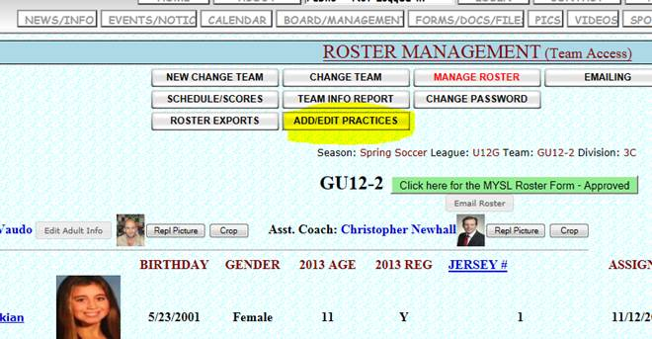

- Click on the practice you need to modify.

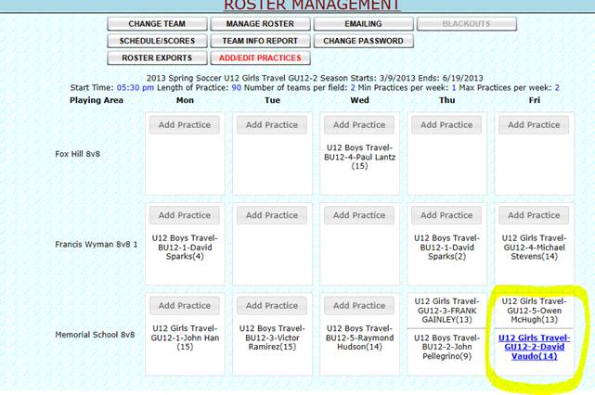

- Change the time to the correct practice start time and duration. To make things easier use Copy and Paste for each field you need to modify. After all fields are changed, click the Save button for each change.

