BURLINGTON YOUTH SOCCER ASSOCIATION

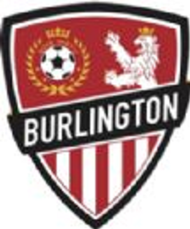

U8
PLAYER AND COACH DEVELOPMENT CURRICULUM

Hello Coaches -
Thank you for volunteering to help with Burlington Youth Soccer Association (BYSA) this season! As the Director of Coaching (DOC), I would like to say, on behalf of the program, that we are really thankful for your participation. The contribution of your time and energy will help to develop our kids into better soccer players and to encourage them to have fun (and who doesn’t like that?!).
In this guidebook you will learn a little bit more about coaching U8 players. This guide will help you to create the right environment for development, learn common characteristics of this age group, and learn techniques for how to teach them the game of soccer. Additionally, this guidebook will provide the weekly session plans for your teams.
We strive to support your development and inspire your passion as a coach as we all work together to encourage the love of the game for the players. During your time coaching you will learn how great and rewarding this experience can be (hopefully, you already know and feel this, if you are a “returning” coach).
I hope you have a fun and successful season coaching the kids. I also encourage you to come to me for help and with any questions and/or clarification with understanding this guide or with running your training sessions.
I look forward to working with each of you. Good luck this season!

U8 General Guidelines
- Have Fun!
  - Be Positive
  - Be Patient

- Focus on player development vs winning games
  - Encourage learning - mistakes are not bad, it’s how we learn!
  - Reinforce correct technique vs speed.
  - Notice and acknowledge individual progress of players.
  - Coach the team, not the player. At this age group, there's no point shouting information to them all the time. Use the water breaks or when they are subs to do that.
  - The main focus of the U8 program is to have these kids associate soccer with something fun. Avoid excessive competition or instruction and focus on the players having fun.

- Teach Sportsmanship and Teamwork
  - After games line up for “air” high fives with the other team and then form a circle with appropriate distancing with your team to point out positive things they did (end on a high note).
  - When children are watching on the sidelines, have them cheer on their teammates.
  - Keep an eye on parents’ behavior. Please feel encouraged to talk to the parents if they are making inappropriate comments. If you need support call for me, another coach on site or anyone from the Board.

- Coaching Points
  - Keep kids moving (explain activities quickly, their attention span is short) and maximize the number of touches they have with the ball during activities.
  - Go down to their level to talk to them, take a knee or bend over, stay on their natural visual field while talking.
  - Take lots of water and mask breaks.
  - Ensure equal playing time.
  - Kids can be shy at first in this age group, so jump in! Play with them to help them to break the ice and get confidence playing.

  - Give attention to players doing things right instead of calling the attention of players messing around. That will trigger on them the idea of getting attention/recognition by following the coach’s instructions.
  - If you already went through the drills of the session and you still have time use the extra drills at the end of the curriculum! (Please don't let the players kick around anticipating the start of the scrimmage). If you need help with any of them reach to me.
- Session Format
  - All the U8 sessions will be an hour long and will be divided in:

  - 30 minutes for drills (including water breaks).
  - 30 minute scrimmages.
  - When the balls go out, players will take kick-ins.
  - 6v6 or 7v7 with goalies

WEEK 1
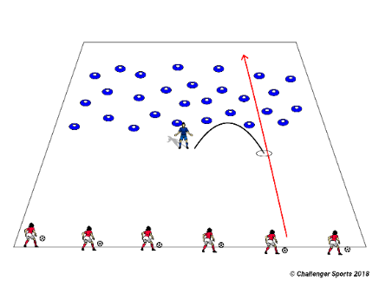
LANDMINES/STINKY BOMBS: Coaches spread cones (landmines) on the grid (image above). Players have to dribble their soccer balls around the cones without hitting them to cross the minefield. If a player hits a mine they have to do 10 toe taps before going back to the game.
.
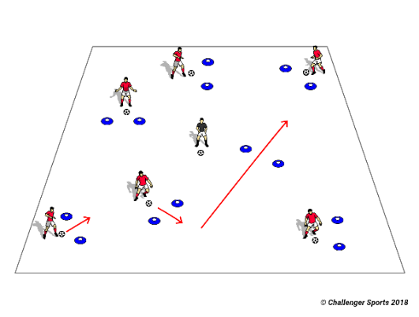
MARIO KART: Players have to dribble their soccer ball around the track and through checkpoint “gates” that will be positioned inside the grid. Players have to see how many gates they can get in one minute. Don’t put the gates side by side, spread them around to make the players work on changing directions. Coaching progression: continue the drill but coaches can kick extra balls (turtle shells) into the “track”. If the coaches hit the ball with the turtle shells, the players have to do sole rolls on the ball before continuing.

GAMES: 30 min. 6v6 or 7v7 with goalies.

WEEK 2
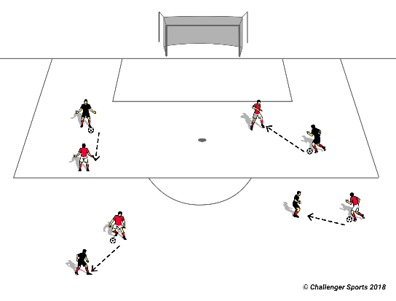
PINNIES PASSING: Give pinnies to half the players on the field. Have players partner up pinnie with non-pinnie and free pass in a large space using proper passing technique and practicing communicating with their partner.
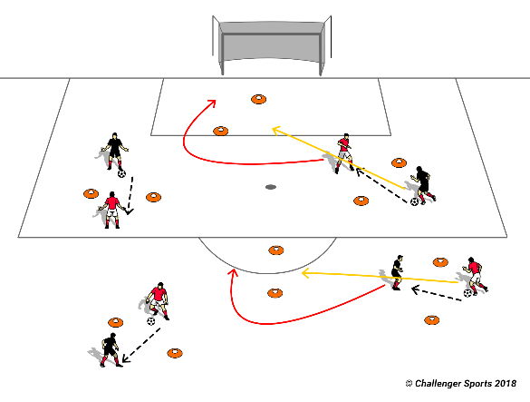
PASSING MARIO KART: Players are paired up and must successfully pass the ball through the cones, to their teammate, to earn a point. Players may not go through the same cones twice. Players try to accumulate as many points as possible in the time allotted. Play multiple games and have them try to beat their previous score. Reinforce communication and teamwork to help players increase their previous score.
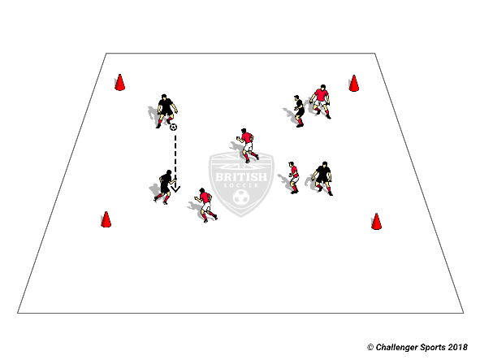
KEEP AWAY: Players wearing pinnies will now be on one team and compete against players without pinnies. Every time a team gets 3 passes in a row, they get a point. If 3 passes are too easy, move to 4 passes and then 5 passes to earn a point. Encourage players to call out the name of the teammate they are passing to.
GAMES: 30 min. 6v6 or 7v7 with goalies.

WEEK 3
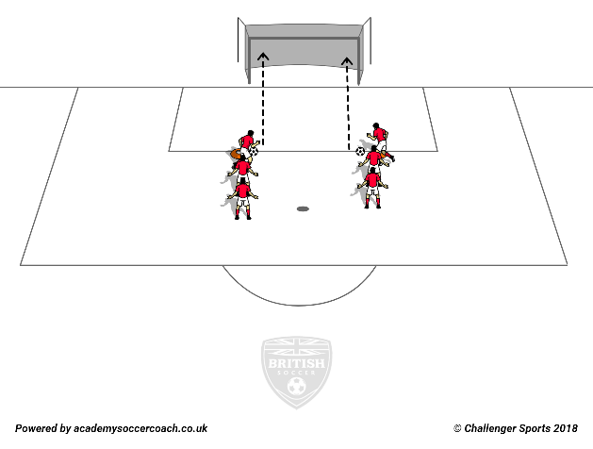
SHOOTING TECHNIQUE: Players form two lines outside the goal. Players take turns shooting the ball from a stop. If players crowd the shooter, push the line back and have the players who are shooting step forward during their turn. Empahasize proper shooting technique: Knee over the ball, laces, landing on your shooting foot.

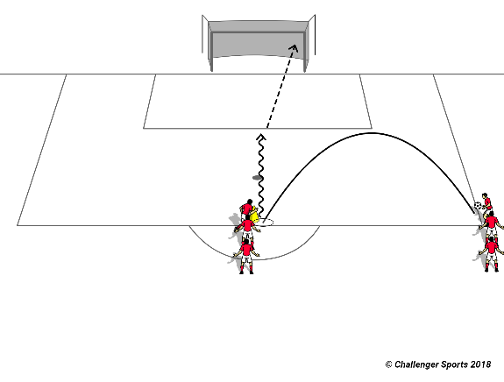
SHOOTING FROM A PASS IN: Players are split into two lines. One line passes in to the other line which dribbles the ball up and then shoots on the net. Encourage shooting player to call for the ball from the pass-in and to go to the ball when it is passed.
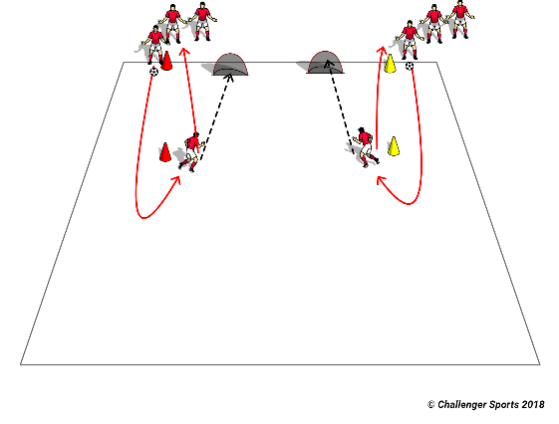
SHOOTING RELAY RACE: It’s a relay race with shooting. Players have to dribble the ball around a cone, get back and shoot in the net. After the shot, they go back and “air” hi-five the next player who then takes their turn to dribble the ball around the cone. Once the last players shoot, the winner is declared. The quicker team wins first round and progresses. The team that scores more goals wins.
GAMES: 30 min. 6v6 or 7v7 with goalies.

WEEK 4
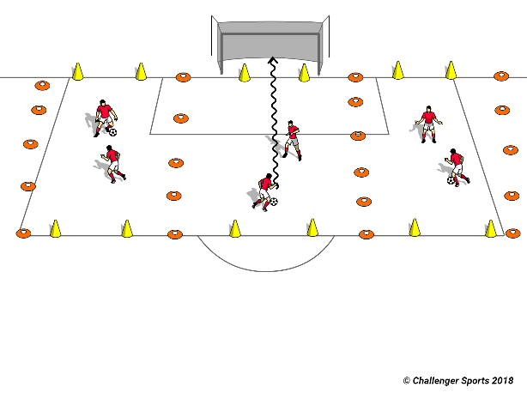
PREMIERSHIP: “Premiership” Create 10 x 5 yd rectangles for as many pairs as there are players. Have the players compete 1 vs 1 to the line for 1 minute intervals. Every time a player gets the ball to the line, with control, they get a point. Rotate players between the rectangles or have winners move up a field and losers move down a field.

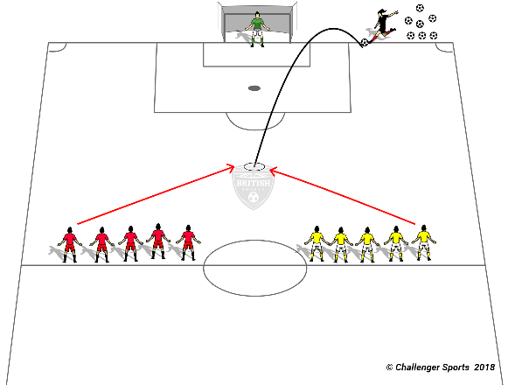
NUMBERS 1V1s: 1 vs 1 numbers with shooting. Give every player a number and have them stand on the middle line. The Coach calls out the numbers and kicks a ball from the goal line out towards the midline. Players compete to shoot on goal. Try to balance skills of the same number of players, however, if skill levels are imbalanced, call out a second number to help.

GAMES: 30 min. 6v6 or 7v7 with goalies.

WEEK 5
LANDMINES/STINKY BOMBS: The Coaches spread cones (landmines) on the grid (image above). Players have to dribble their soccer balls around the cones without hitting them to cross the minefield. If a player hits a mine they have to do 10 toe taps before going back to the game.
.
MARIO KART: Players have to dribble their soccer ball around the track and through checkpoint “gates” that will be positioned inside the grid. Players have to see how many gates they can get in one minute. Don’t put the gates side by side, spread them around to make the players work on changing directions. Coaching progression: continue the drill, but coaches can kick extra balls (turtle shells) into the “track”. If the coaches hit the ball with the turtle shells, the players have to do sole rolls on the ball before continuing.
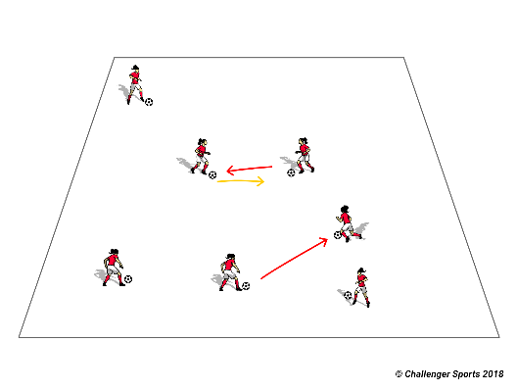
KING OF THE RING: Set up a grid/ring that make sense for how many players you have. All players have a soccer ball inside the grid/ring. Players have to try to knock the others balls out of the “ring” while keeping their balls. If their balls get knocked out or players dribble out, they have to do 10 toe taps before getting back in.
GAMES: 30 min. 6v6 or 7v7 with goalies.

WEEK 6
PINNIES PASSING: Give pinnies to half the players on the field. Have players partner up pinnie with non-pinnie and free pass in large space using proper passing technique and practicing communication with their partner.
PASSING MARIO KART: Players are paired up and must successfully pass the ball through the cones to their teammate to earn a point. Players may not go through the same cones twice. Players try to accumulate as many points as possible in the time allotted. Play multiple games and have them try to beat their previous score. Reinforce communication and teamwork to help players increase their previous score.
KEEP AWAY: Players wearing pinnies will now be on one team and compete against players without pinnies. Every time a team gets 3 passes in a row, they get a point. If 3 passes are too easy, move to 4 passes and then 5 passes to earn a point. Encourage players to call out the name of the teammate they are passing to.

GAMES: 30 min. 6v6 or 7v7 with goalies.

WEEK 7
SHOOTING TECHNIQUE: Players form two lines outside the goal. Players take turns shooting the ball from a stop. If players crowd the shooter, push the line back and have the players who are shooting step forward during their turn. Empahasize proper shooting technique: Knee over the ball, laces, landing on your shooting foot.

SHOOTING FROM A PASS IN: Players are split into two lines. One line passes in to the other line which dribbles the ball up and then shoots on the net. Encourage shooting player to call for the ball from the pass-in and to go to the ball when it is passed.

SHOOTING RELAY RACE: It’s a relay race with shooting. Players have to dribble the ball around a cone, get back and shoot in the net. After the shot, they go back and “air” hi-five the next player who then takes their turn to dribble the ball around the cone. Once the last players shoot, the winner is declared. The quicker team wins the first round, progress to the team that scores more goals wins.
GAMES: 30 min. 6v6 or 7v7 with goalies.

WEEK 8
PREMIERSHIP: “Premiership” Create 10 x 5 yd rectangles for as many pairs as there are players. Have the players compete 1 vs 1 to the line for 1 minute intervals. Every time a player gets the ball to the line, with control, they get a point. Rotate players between the rectangles or have winners move up a field and losers move down a field.

NUMBERS 1V1s: 1 vs 1 numbers with shooting. Give every player a number and have them stand on the middle line. Coach calls out the numbers and kicks a ball from the goal line out towards the midline. Players compete to shoot on goal. Try to balance skills of the same number player, however, if skill levels are imbalanced, call out a second number to help.

GAMES: 30 min. 6v6 or 7v7 with goalies.

EXTRA DRILLS:

DRIBBLING:

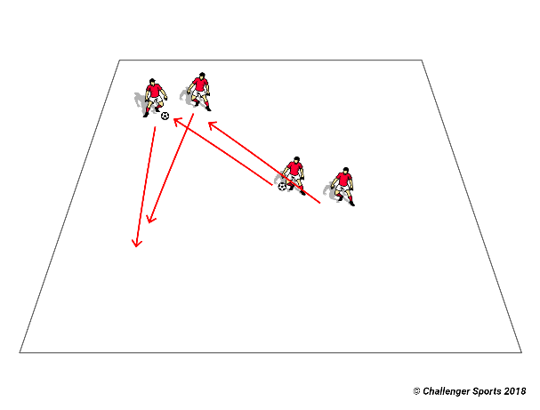
SHADOW: Players work with partners. Each player has a number (1 and 2), one of them starts with the soccer ball and dribbles it on the grid. The other players have to follow him around paying attention to the change of direction. After a minute, change the player that has the soccer ball. A progression that coaches can make, if the game is going well, is making the player without the ball try to take the ball away from the player with the ball. Count how many times he/she manages to do it in a minute. Then switch.

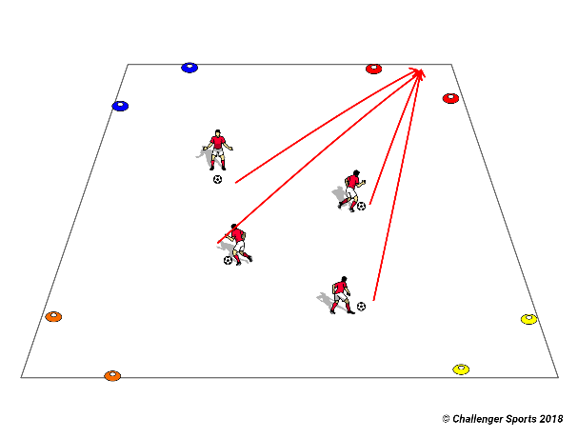
COLORS CORNERS: Coaches set up bases on each corner of the field and name it after a color. When the coach shouts a color all players have to dribble their soccer ball as fast as they can to that corner. Then switch colors of the corners during the game.
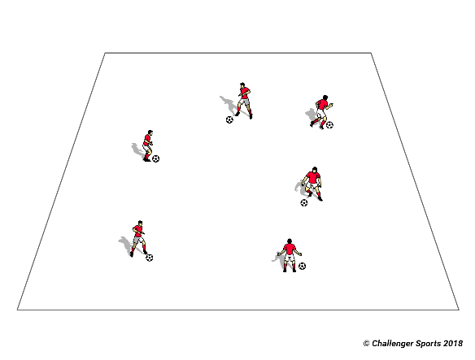
BODY PARTS: Players dribble the soccer ball around the grid. Coaches call a body part and they have to touch that body part on the soccer ball.
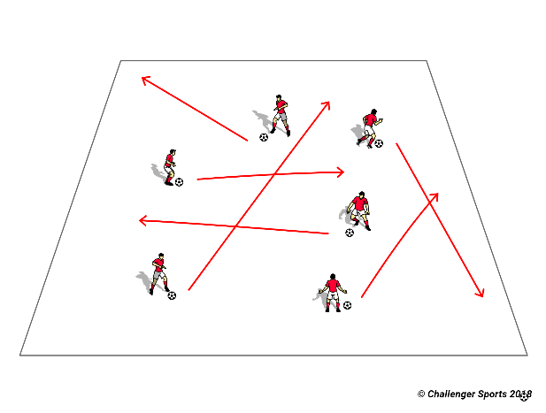
PAINT THE FIELD: Coach gives a color to each player. Every time they dribble the ball on the field they are “painting” that area with their color. Players have to try to paint as much as they can of the grid.
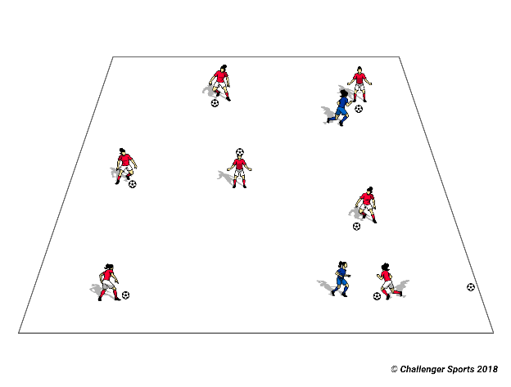
KANGAROO JACK: Select a player to be a Kangaroo. The remainder of the team is drilling their soccer balls around the grid. The Kangaroo hops around the grid and tries to knock out the balls that players are dribbling. Once a ball is knocked out, the player puts their soccer ball aside and become a kangaroo too! Play until all the balls are knocked out.
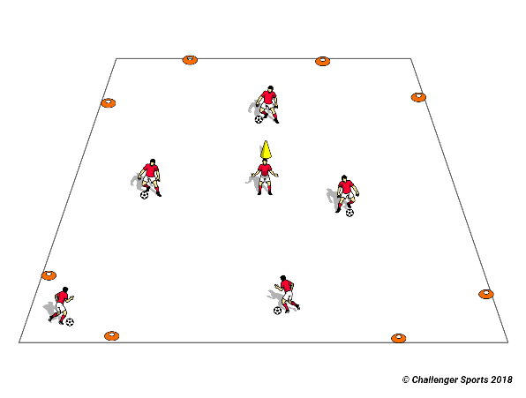
SHARK ATTACK: Coaches make safe zones on the corners of the field. Two players stay in the middle of the grid as sharks. When the coach yells "shark attack" players have to dribble the ball to other safe zone without getting their ball knocked out by a shark. If their ball gets knocked out they become sharks. Sharks can put their hands on their heads like a shark fin.

PASSING:
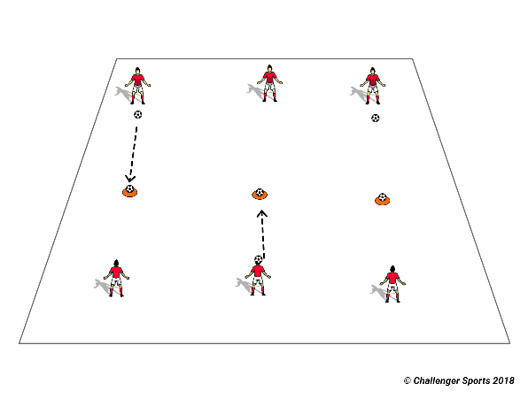
BULLSEYE: Make the players line up 10 yards apart. Place a ball on the top of a cone between them and make them try to hit the ball in turns. Every time a player knocks off the ball they get one point. If the players are finding it too hard, decrease the distance between them and the ball. Coaches can also make this a 2v2 game in case of too many players or a small number of balls.

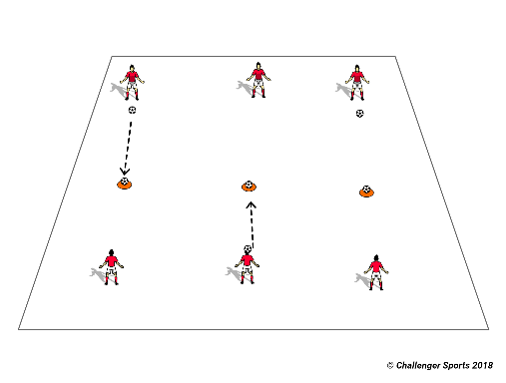
KING CONES: Same idea of the bullseye but it's a team game. Coaches set up tall cones or cones with balls on top 5 yds from each team. The team that knocks off more cones/balls down wins the game.
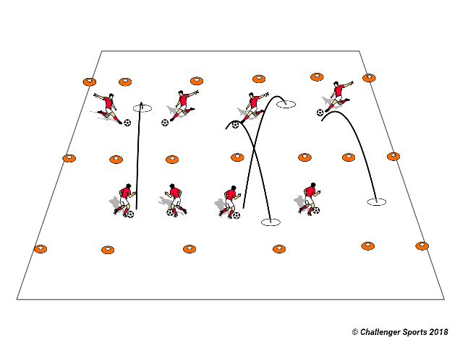
MESSY YARD: Coaches set up a line in the middle of the grid that splits both "yards". Coach also sets up a line at the end of each yard to make the boundaries. Players are divided into two teams and have to try to kick balls into the other yard. If the balls are in the yard they are live. If they go out of the boundaries they are out. At the end of the round coach counts how many balls are left on each side’s “yard”. The team with more balls inside their yard loses the round as they have the “messy yard”.

SHOOTING:
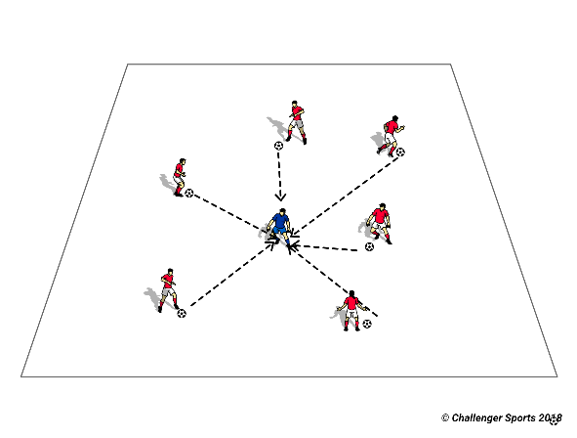
SHOOT AT THE COACH: Kids love this game for the simple reason that they get to hit their coach with soccer balls. Coach has to move around the grid and the kids have to try to hit him/her by kicking their soccer balls.
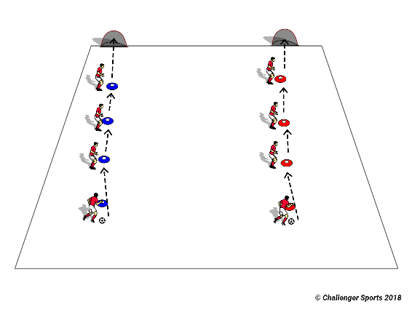
CONNECT 4: This game is a passing relay race. Players have to pass the ball to the players at the cone ahead of them and make the ball get to the last player. The first team that manages to do that without making a bad pass wins. Coaches progress to make the ball to go all the way up and then down. The second progression can be adding a shot in a goal after the ball gets to the last cone (if you do that, rotate the players after each round to give them all a chance to shoot).

1V1s:
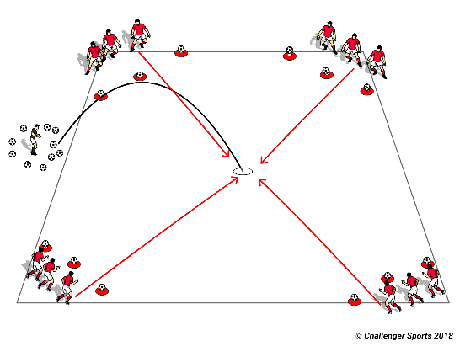
BATTLESHIPS: Players are divided into teams. Each player has a number and each team has its battleships (tall cones or balls on the top of cones). Coach calls a number and plays a ball in. Players have to try to knock down other battleships and try to protect theirs. Numbers not called cannot block balls coming to their ships. Once a team is out of battleships they keep playing to try to knock down other team ships.

