Click on the link received in the email –
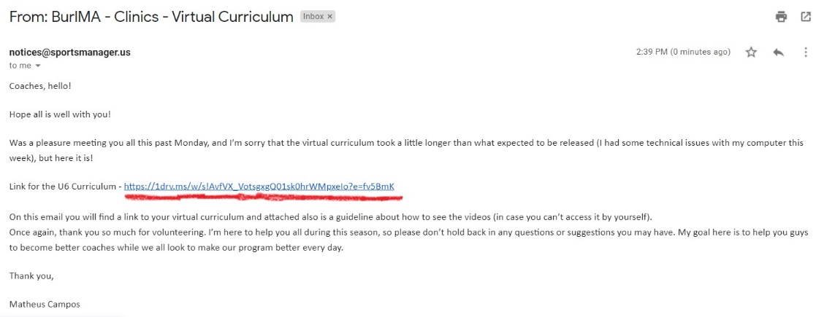

Then the curriculum should open like that:
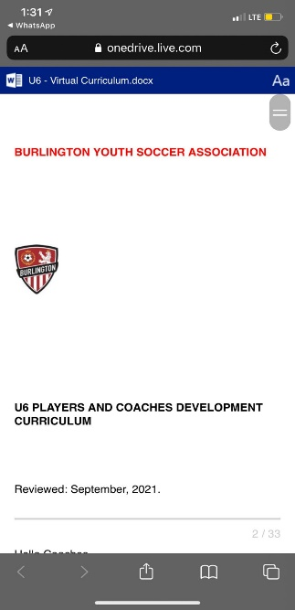
Go to the desired week/exercise and click on the blue name:
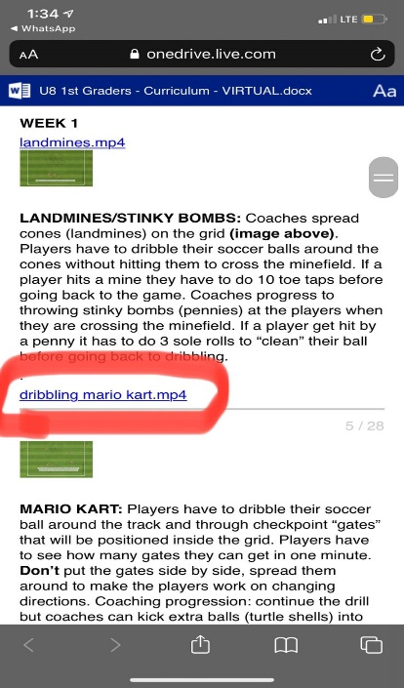
A new page/tab should open with the video of the exercise, just hit play and watch it!

