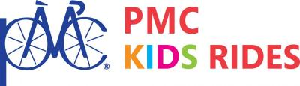

Hello BYSA Community,

We wanted to let you all know that the Burlington PMC Kids ride is back this year! After a very successful first year in 2019 with 238 kids riding and $93,544.13 raised, we were sadly sidelined because of Covid. In person rides were not allowed. This September we are back to hosting a ride at The District on Sunday, September 18th and would love it if the BYLA community would be a big part of it. Go to www.kids.pmc.org/burlington to register your child to ride. We are also looking for adult volunteers to help the day of the ride.

We will also be hosting a raffle (where you can win a free season tuition thanks to the generosity of BYSA) if you have anything that you would like to donate to the raffle or silent auction please email us at burlingtonpmckids@gmail.com

Thank you!!
Christine Steiner
Burlington PMC Kids Ride Coordinator

