CSSC Spring Newsletter

Happy Spring CSSC families! It’s good to see most of the snow off the ground and hope it stays like this so we can get our practices started.

The spring season is slated to start Monday, April 22nd. This does not mean your team will have a game specifically on the 22nd but rather this is when games in general begin. As soon as schedules come out, we will get them to you. You can always check our website as well.
Uniforms: The only players receiving uniforms this spring are those that are new to the club or didn’t play in the fall. If your child needs a new shirt or shorts, you can purchase those by contacting Kathy Weiss (kweiss15@gmail.com). Shirts are $36 and shorts are $17.

Highlights of what has been happening:
Cold Spring indoor keeper training
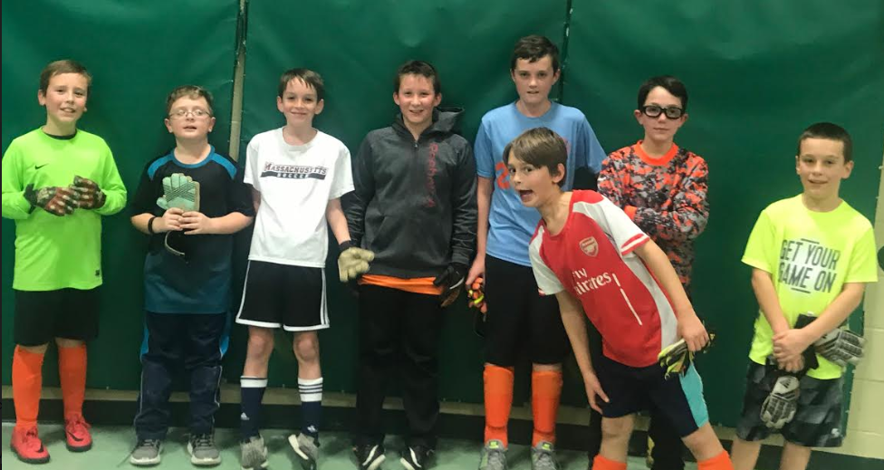
Cold Spring soccer club was able to provide free keeper-training sessions to our interested players during the winter months, December through March. The turn out was fantastic! On average each sessions included 10 to 14 keepers. The training took place at Swift River Elementary with the focus on developing technical skills. The players worked on hand spacing and placement, body positioning, situational awareness, and core muscle grouping for a quicker and stronger approach. These trainings were led by coaches Matt Dudek , Bill Longridge and Tim Haley. The feedback received about theses training sessions was very positive and greatly appreciated.
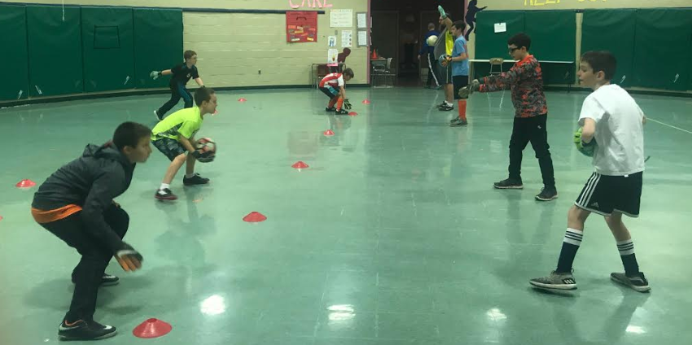
Due to the positive feedback, CSSC will be extending these keeper-training sessions through the spring season. We will continue to develop the technical aspect but will also be able to start introducing other developmental elements of the game.

Cold Spring Soccer Club winter trainings with Global Premier Soccer club
CSSC also was afforded the opportunity to team up with GPS Soccer Club during January and February for training sessions. These Friday night sessions offered a developmental opportunity for both coaches and players of CSSC. The focus of each session was chosen by the CSSC coach (i.e. defensive marking, technical skills, attacking skills, etc.) Before the session, a training lesson plan was provided, by GPS, to the coach, so they were familiar, prepared, and comfortable with the session plan. During the actual training, both the players and coaches participated. CSSC coaches also received guidance with the skills being developed and the purpose of the drills so it could be either duplicated or adjusted by the CSSC coach when running their own practice. It was great to see an even split of the boys and girls teams from all different age groups participating in this event.
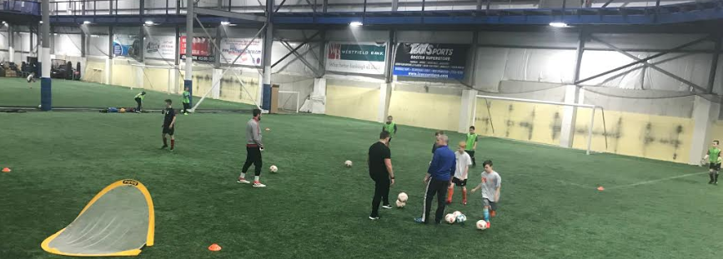
CSSC will be offering technical training sessions in the spring for field players which will include speed, agility, ball control and skills. Time and location is currently TBD, but again watch for an email.

Upcoming Events:
- Keeper Training Sessions
- Technical Training Sessions
- The Inaguaral Commenwealth Soccer Classic 2019 Memorial Day Tournament
  - Located at UMass Amhert
  - Guaranteed 4 games over a 2 day period
  - U9-U10 7v7; U11-U12 9v9, U13-U14 11v11
  - www.commonwealthsoccerclassic.com

