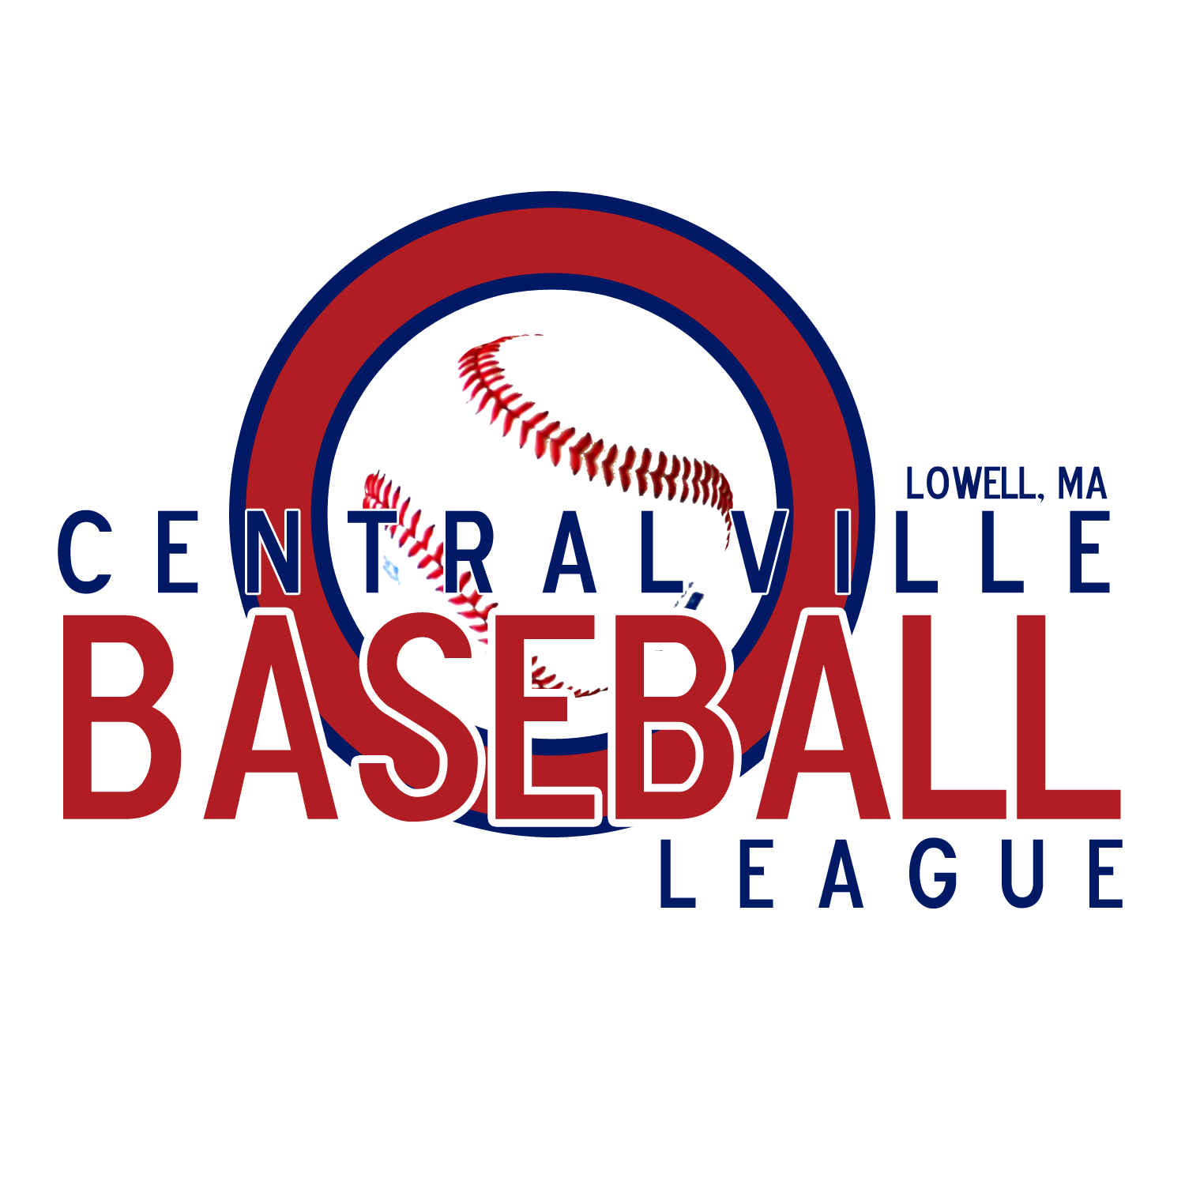

SPONSORSHIP FORM
2015

Company Name ______________________________________

Address ______________________________________

______________________________________

Contact person ______________________________________

Telephone number ______________________________________

Email Address ______________________________________

( ) $150.00 -- donation for “Friends of Centralville Baseball League” sign
( ) $200.00 -- returning supporter/ single sign
( ) $250.00 -- sponsor name on the back of team jersey
( ) $300.00 -- donation for (1) new sponsorship sign
( ) $300.00 -- returning supporter/ (2) existing signs
( ) $400.00 -- returning supporter/ creating a second sign
( ) $500.00 -- donation for (2) new sponsorship signs

If purchasing a sign, or having a sign re-hung, at which field would you like your sign hung:

Finn Field _____ Whalen Field _____
(Little League Diamond) (Senior League Diamond)

( ) No, I am not interested in sponsorship but would like to make a donation to CBL in the amount of $ ___________ .

