DRACUT SOCCER - APPAREL SALE 2022

August 25th -September 5th

In Partnership with Dracut Threads, DSA is having an apparel sale. Stock up on your favorite items as we get ready to start our Fall Season!

Please visit
https://www.dracutthreads.com/product-category/dracut-soccer-association/

Items like these are available and more! Online only!

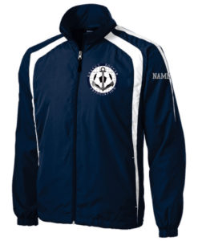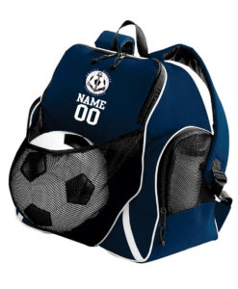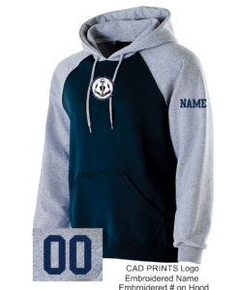

For merchandise and questions please contact:

DRACUT THREADS
1595 Lakeview Avenue
Dracut, MA 01826
978-710-3501
threadsdracut@comcast.net

