DRACUT SOCCER HOLIDAY APPAREL SALE

November 16th - November 30th

In Partnership with Dracut Threads, DSA is having a holiday apparel sale. Check out the link below for great holiday gifts!

Please visit
https://www.dracutthreads.com/product-category/dracut-soccer-association/

Items like these are available and more! Online only!

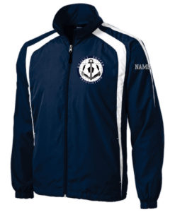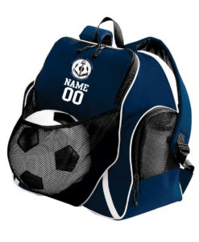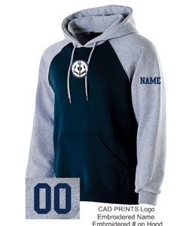

For merchandise and questions please contact:

DRACUT THREADS
1595 Lakeview Avenue
Dracut, MA 01826
978-710-3501
threadsdracut@comcast.net

