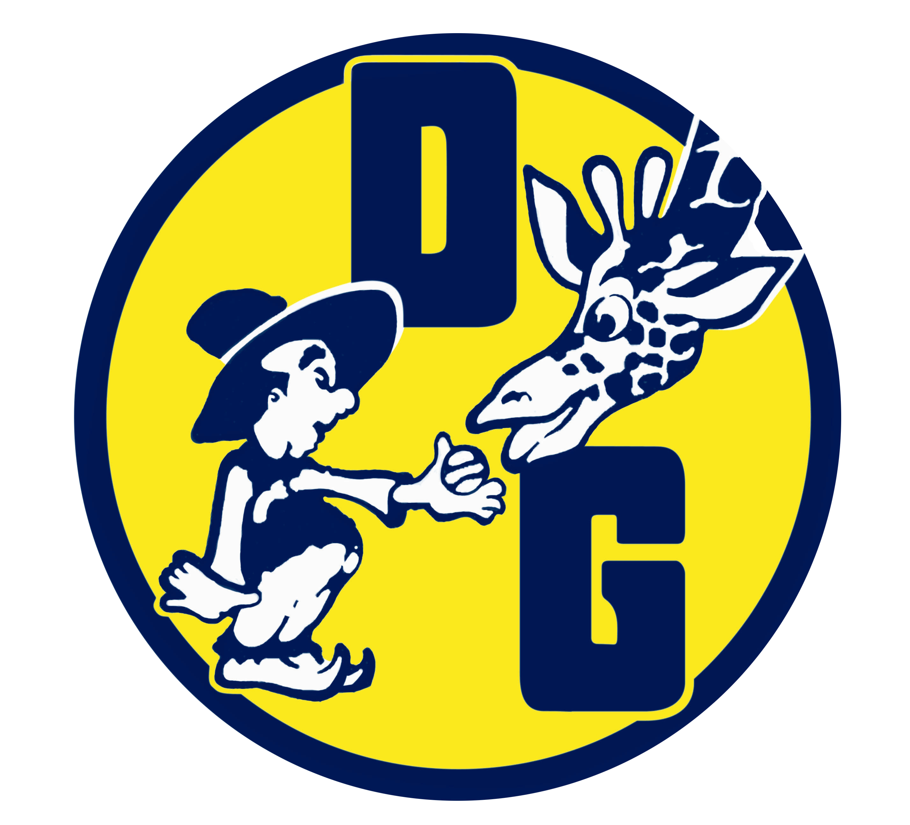

Board of Directors
Elected Officials

Jay Vigorito President
MCF Associates

Honorable Jose Rodriguez
Vice President

Robert Downward Treasurer
Jaros Baum & Bolles
Consulting Engineers

John Hemple Recording Secretary

George Mirtsopoulos Corresponding Secretary
National Grid-Retired

Dave Legaz
Second Vice President
Keller Williams Real Estate

Appointed Athletic Commissioners

Baseball Commissioners Frank Mezzanotte Steve Wilson
Basketball Commissioner Ben Tockarshewsky

Commissioners of Girls Athletics
George Mirtsopoulos

Web Site Coordinator Anthony Castellano

dwarf giraffe athletic league
Building Address – 149-50 15th Road, Whitestone, NY 11357

Phone (718) 746-1539

Mailing Address
PO BOX 570035
WHITESTONE, NEW YORK 11357

A NON – PROFIT, NON SECTARIAN ORGANIZATION

Visit our Website at: www.dwarfgiraffe.com

Dear Sir/Madam:

I am writing on behalf of a very special organization, the Dwarf Giraffe Athletic League of Whitestone. DGAL is a 501c3 non-profit organization that has provided the children of Northeast Queens with quality sports programs for over 50 years. At present, we have over 1,000 players participant’s age 4 to 18 competing in boys and girls basketball, baseball and girls softball.

DGAL is the only local sports program that is fortunate to be housed in its own facility. This has allowed DGAL to offer its space to other community and civic groups. The DG building is used by the Greater Whitestone Taxpayer’s Association, FDNY and NYPD’s basketball teams, Public School #79 as an emergency shelter/evacuation site and the weekly meeting of the Ramblers, a senior citizen social program.

Over the years DGAL has also offered its facility to other organizations for their fund raising efforts. We have assisted St. Mary’s Children’s Hospital, local veteran’s associations and Susan G. Komen Organization by hosting dinner dances, Zumbathons and special events. As you can imagine our building requires constant upkeep and improvements.

Donations from local businesses like yours have been a vital source of support. Recent donations have been utilized for roof repairs, electrical upgrades, and gym floor maintenance as well as for sports equipment.

We are reaching out to you and other local businesses once again in hopes that your donation or sponsorship will allow us to continue to serve the community in all aspects possible. Enclosed please find a sponsor form, our tax exempt certification and additional information about DGAL. All sponsors are recognized on our sponsor board located in our building and our big screen TV monitor during DGAL games. Sponsors are also listed on our web site with a link to their business or web site. We hope that we can count on your support.

For additional information or questions, please contact the league at 718 746-1539 or visit our web site at: www.dwarfgiraffe.com.

With best regards and thanks,

Jay Vigorito
President, Dwarf Giraffe Athletic League

