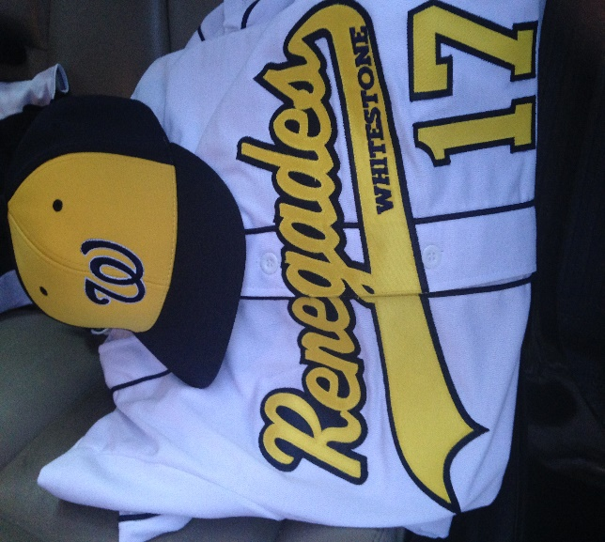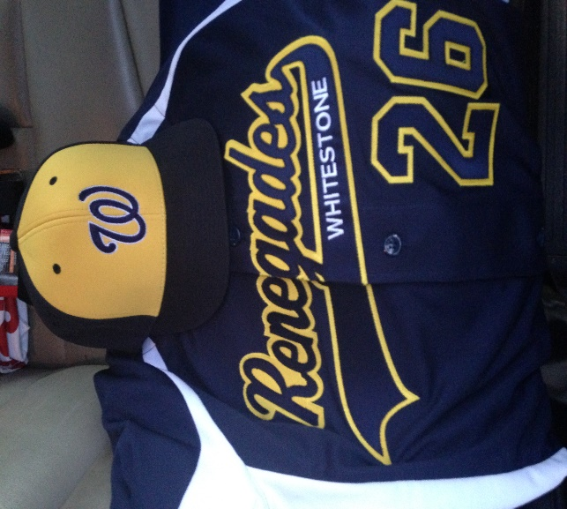
WHITESTONE RENEGADES
TRAVEL BASEBALL
-A DEDICATED, EXPERIENCED COACHING STAFF
-GIVE YOUR CHILD THE TRAVEL BASEBALL EXPERIENCE AT EXTREMELY AFFORDABLE COSTS
-WE HAVE COMPETITIVE TEAMS FOR AGES 8u-16u
-IF YOU ARE INTERESTED IN TRYING OUT OR HAVE ANY QUESTIONS, PLEASE EMAIL US AT DGBASEBALL@YMAIL.COM
(PLEASE BE SURE TO LIST YOUR CHILD’S D.O.B. IN YOUR EMAIL)
