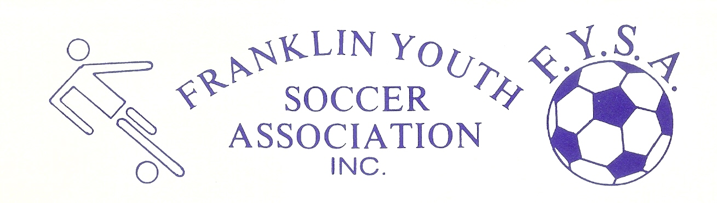Franklin Youth Soccer Academy Program – Game Day Spring 2021

- 5v5 play
- 2 halves of 30 minutes, with a five-minute halftime
  - Mask breaks every 15 minutes – 2 minutes in length – clock keeps running – continue with this
- No offsides
- Defenders withdraw to build out line (dashed line on the field) on any keeper possession
- Normal substitution rules
- Lower Dacey layout has been modified:
  - 3 fields only
  - No spectator limits – seated on the outer perimeter of the fields, and 6 feet from the line – line will still be painted to ensure 6 feet of distance, and directional signage will still direct parents to the perimeter of our fields
  - Staggered start and end times will improve traffic flow
- “Theme of the week” model will still be used
- Normal “visiting player policy” is in effect
- Goalkeeper gloves will not be used this season
- Same standards for proper equipment and uniforms will be enforced
  - Tight fitting clothes, hat, etc. under uniform – no jewelry
- Standard warm-up procedure
  - Arrive 15 minutes before kick-off
  - Avoid line drills and shooting on the goalie. Use a warm up that relates to the theme of the week
- No COVID related game rule changes. However, the following rules ARE in effect. Some are unique to the Academy
  - Masks will be worn
    - No gaiters
  - No Heading (normal for Academy)
  - On goal kicks or keeper distributions, ball must touch the ground or a player before passing midfield (normal for Academy)
- Standard Academy rules for adding / swapping players
  - When a game has a 5-goal differential, the trailing team may add a player.
  - After an 8-goal differential, the teams must trade players (don’t let it get that far)
- Pinnies:
  - Laundered white pinnies will be brought to each field for each game by the Academy director, along with a “used pinnie” bag. Once a pinnie has been used by a player, it will be considered used and should be put in the “used” bag if it is taken off
- An Academy “Event” will be held at the end of the season. Multiple games in a single day are now allowed, which will allow us to revert to a standard format

