*** Hollis/Brookline Spring Softball ***
Spring Softball signup is here
Join a great team sport and outdoor activity
Play Softball and Have Fun!
Signups are open now at:
http://www.sportsmanager.us/HollisNHRec.htm

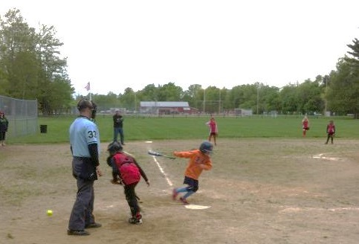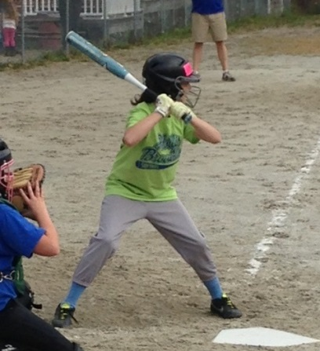
Age Groups are
U10 Rookies
U12 Majors & Minors
U16 Juniors

No experience necessary
This is not a school sponsored event

