
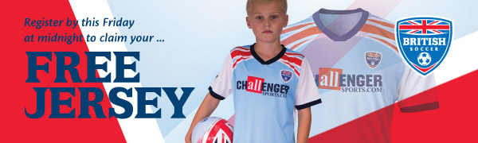
DON’T MISS OUT! REGISTER BY MIDNIGHT THIS FRIDAY JUNE 16!



British Soccer Camps will be coming back to our community this summer!
Local Program: Jamestown Youth Soccer League

Dates: July 31 – Aug 4
Location: Jamestown Athletic Complex

Note – you can still register for camp after the FREE Jersey deadline but you miss out on the awesome British Soccer Jersey!
Improve your game with the most popular soccer camp in the USA and Canada!
• Incredible Coaching Staff  • Develop new skills and refine existing ones  • Play with more confidence and have more fun  • Learn the NAIA Champions of Character traits; respect, responsibility,  integrity, sportsmanship and leadership  • Represent your country in your very own World Cup | Click here to find out what people are saying about our Camps!
Free gifts worth over $100 with camp sign-up!
 | + | 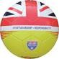 | + | 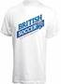 | +  more!
*Free Jersey for with online sign-up only at least 45 days before camp

