DAVID NASCIMENTO INSTRUCTIONAL TOURNAMENT SCHEDULE 2016

FRIDAY, JUNE 3RD
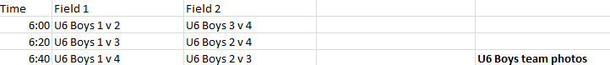

SATURDAY, JUNE 4TH
