How to set up your on-line registration for the Fall 2016 season

Below are the changes to SportsManager to support the new Fall Soccer Age/Grade Eligibility for registration setup. These are changes your SportsManager site administrator can make by following steps 1 and 2 below. If you want SportsManager to make these changes let us know by emailing your site link and request to support@sportsmanager.us.

As you review this process keep in mind that after all this is done, you should be able to open Fall registrations. When registrations start coming in you can review them by age group on the Registration/#2 Player Team registration report. In that report you will see both grade and age group and will be able to move player’s registrations. By clicking the edit button you can move a player up or down an age group if necessary.

We have already made these 2 important changes to all organizations to support the new Age/Grade Eligibility: 1---The need to capture and store the grade the child is in for the Fall season. We are doing this in step 3 of the registration wizard. So this part is done. 2---Change the Age eligibility cutoff date from July 31 to December 31. This has already been done for all Fall Soccer seasons. If you edit the Fall Season and go to the bottom you will see it shows January 1 as the cut off but the system subtracts 1 day from that to make the cutoff December 31. The cut off for the Fall 2016 and Spring 2017 seasons is 12/31/2016. This cutoff date is used to determine the eligible age. All you have to do is determine the age (whole number only) of the child on 12/31/2016 and that is their eligible age for the 2016-2017 season.

- Change name of the age groups. To do this click on Leagues/Groups button, select Fall Soccer as the season at the top, then click Group Edit, then for each name and abbreviation add the grade range as shown in yellow below. Add “Grade 3-4” to the U10 name and add G3-4 to the abbreviated name just to keep that small. Note in this example below we added ”Fall Grade 1-2”, it could also just be “Grade 1-2” without the “Fall” . Also in this example if you have intown groups in the same season you can make the same changes for them but that is optional. Then click SAVE at the bottom of the page.

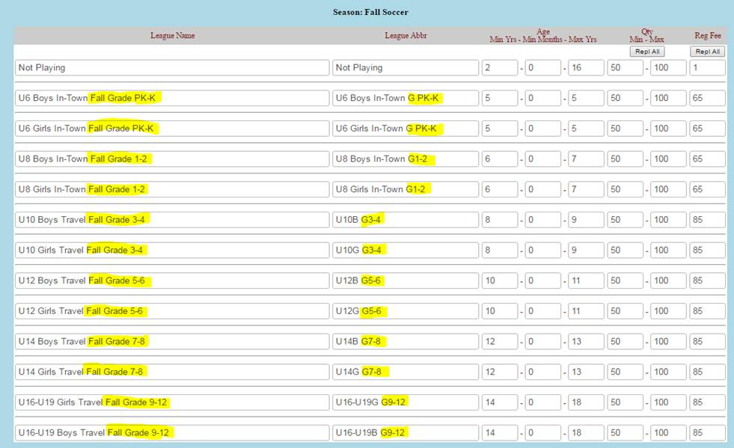

- Now you need to change the Min year and Min Months for each Fall Season Age group to obtain the full range of registration to include the grade. This is described as the “born Between” option on the second page of the attached document from Mass Youth Soccer. If we use U10 for example, the strict 2 Calendar year approach would be from January 1, 2006 to December 31, 2007. But we want to add 7 months to this so it becomes January 1, 2006 to July 31, 2008.
To make this go back to the Group Edit option you were just on for Fall Season to fix the age group names. See example below. In this example I have highlighted the 2 columns you need to change. You can compare this to the image above that shows how it was before the change.
The change you need to make is in the “Min Yrs” column. Reduce that number by 1 for each age group (even if it is a 1 year age group). For example U12 use to be 10-11, now you will make it 9-11.
Then in the Min Months column insert 5 for each value as shown below.
This will change the Date of birth range FROM: (use U12 for example) 1/1/2004 to 12/31/2005 TO: 1/1/2004 to 7/31/2006. That will allow the older players in this group who are most likely playing in U14 to see both U12 and U14 groups and pick the correct one based on Grade.

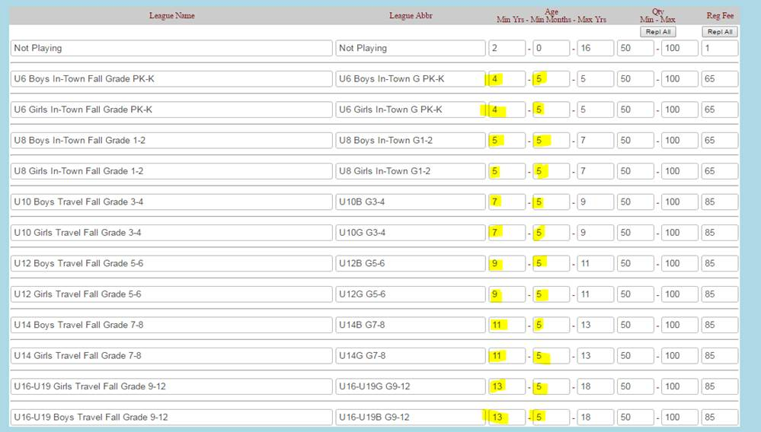

- Keep in mind when this is done you will have overlapping age groups if a child is older in that group. So the parent in that case will be presented with 2 age groups because the child is born on March 1, 2006.
The parent should pick the age group based on the child’s Fall grade.
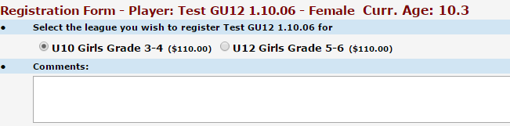

- As a final step, review your player/team registration list. You can see the grade of the child on that page now. Parents will be updating the grade for the fall registration. You will use this report to make sure all players are in the correct group by age or grade prior to forming teams.

Thanks, Shawn Harty, SportsManager Solutions, 508-423-2444

