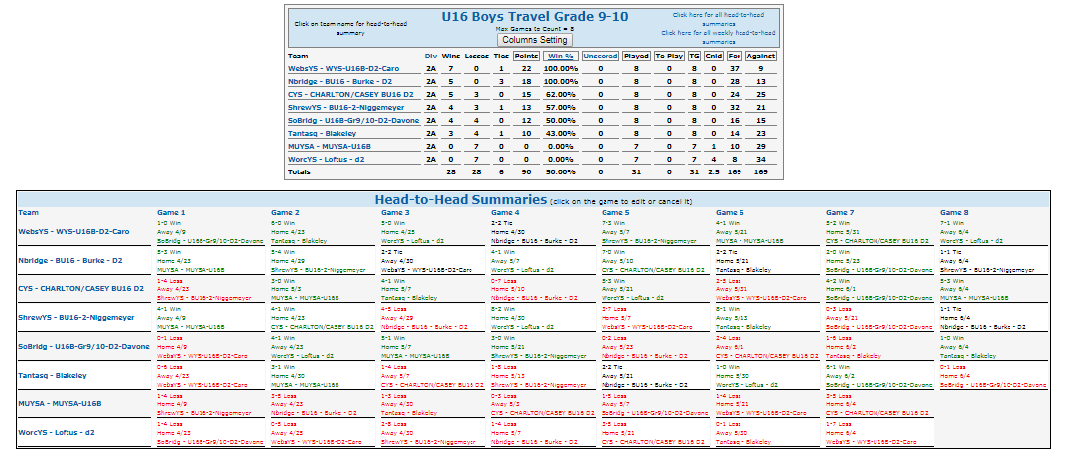
ONLY ONE GROUP – EVERYONE PLAYED IN THIS GROUP

