


Midland Area Youth Soccer
REVS TICKET OFFER!

Revolution v New York City FC
Revolution v Chicago Fire
When: September 29, 2019
Where: Gillette Stadium
Kick-off: 5:00 PM
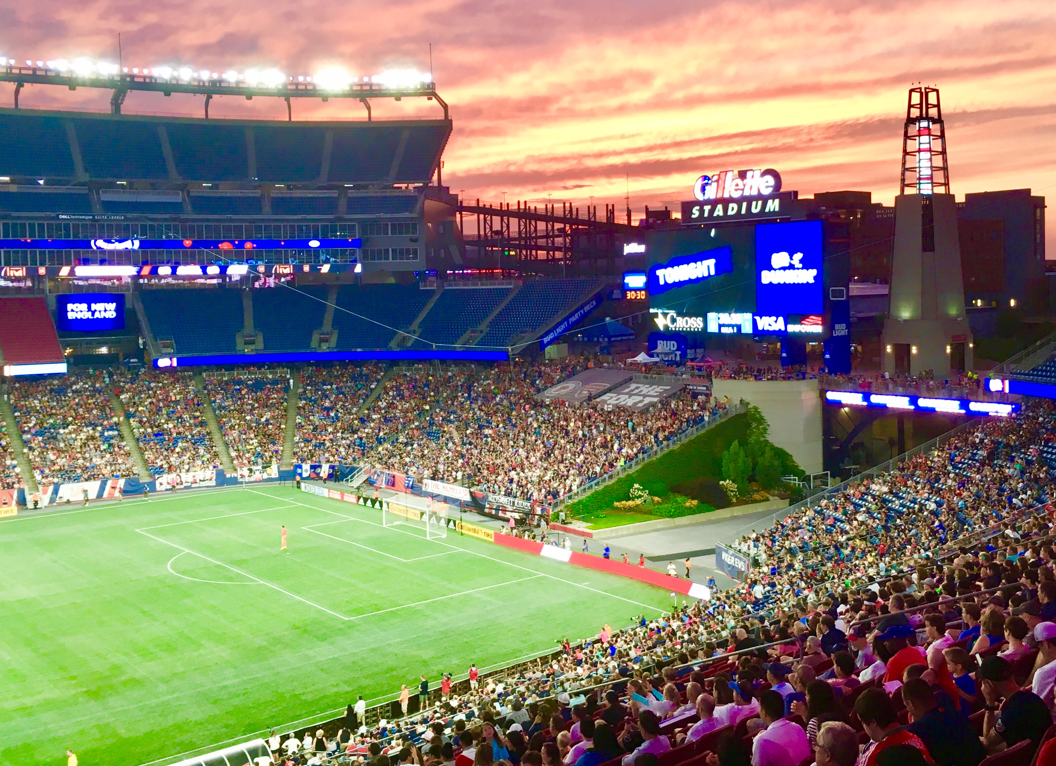


Bring Your TEAM . Bring Your FAMILY . Bring Your FRIENDS
Tickets Only $21
To purchase, simply click on the TICKET LINK with PROMO CODE MAYS
Ticket Link: https://oss.ticketmaster.com/aps/revolution/EN/link/promotion/home/377b321479c8b8769fb966af2222df777955973a
Paul Blanchard / New England Revolution / Gillette Stadium / 774.893.3380 / paulb@revolutionsoccer.net

