Good Afternoon Town Reps;
As we come to the end of another calendar year, we are preparing for another Soccer Season. January 12th is the deadline to enter your teams into Sports Manager. If you have new registrars, or just need some help, please reach out to either Shawn Harty at sharty@sportsmanager.us or me. I will have limited access to the internet between Jan 6th through Jan 11th.
If anyone is finding that the number of players is a little low, reach out to the parents in your town. You can do this by sending an email out through Sports Manger to all your parents telling them that teams are being formed. You can remind them to register. You may also include the following:
“To all parents: the following internet connection is to help all spectators. It’s called “The Parent Seat”. https://www.nfhslearn.com/library/videos/478 . The main site is from National Federation of State High School Associations. The purpose for this clip is to Improve Parent/Spectator Behavior at events. Other educational courses from this Association is “Protecting Students from Abuse, Fundamentals of Coaching, First Aid and Concussion Courses” Some courses are free and some are not. The one mentioned is free.”

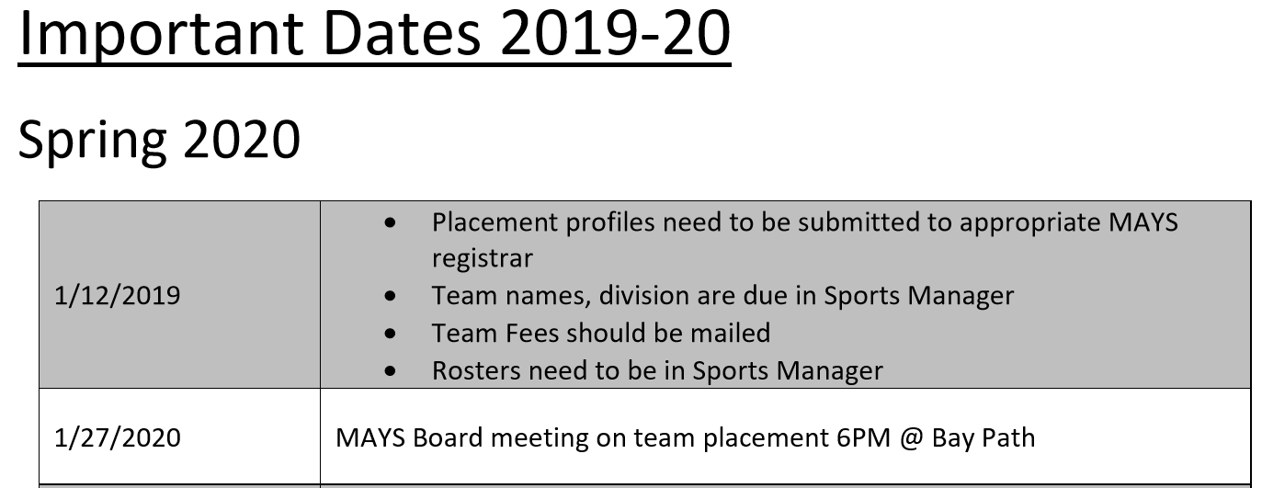

Clifford Cloutier
MAYS President

