Good Evening,
The MAYS Board is getting ready for their meeting to see which teams will need to be called in to justify their division requests. We have many that will be automatically called in for the lack of a profile form. Please help avoid giving the registrar more work by not submitting these forms. Please submit them now, it’s not too late. I listed the registrars’ emails below. Fee’s for teams should have already been mailed in but right now the big push is the TEAM PROFILE FORMS. Again, please get them in.
A reminder that all players and coaches need to have a current picture in the system for the roster to get approved. Also, in the system - as voted by the TOWN REPS - players current grade level needs to be listed. The registrars will not approve a roster that is missing the grade level in the system.
U10Girls@MAYSL.com
U10Boys@MAYSL.com
U12Girls@MAYSL.com
U12Boys@MAYSL.com
U14Girls@MAYSL.com
U14Boys@MAYSL.com

U16-19@MAYSL.com
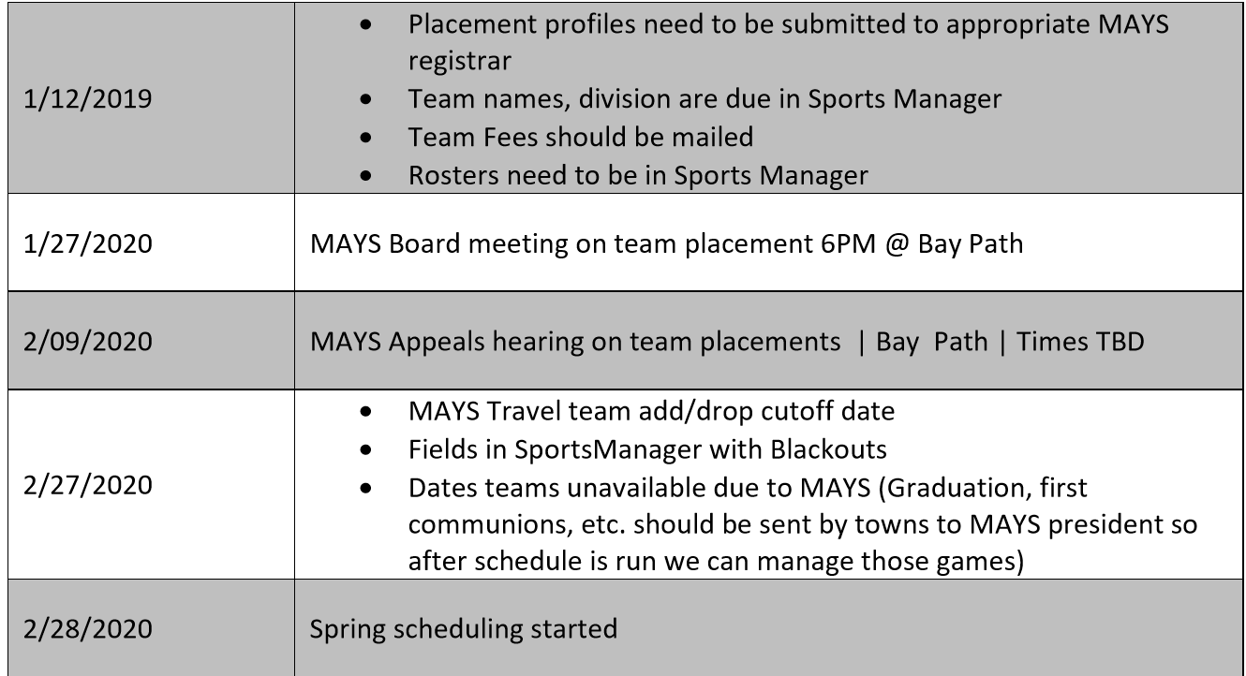

Clifford Cloutier
MAYS President

