Having meeting with the board on Tuesday, towns on Wednesday and coaches on Thursday. All at7PM
Meeting for Spring.
- Towns listed as Red.
Last year the town was shut down. Now I think we have to look at it differently. With each town having a COVID Safety Director or some name like that. We should leave it to the towns if they are going to go play the game or allow them in. The State has left it up to us/ the towns. They are saying that when a town is red percentage wise it has not been the kids. So there one topic.
- Face Mask
Massachusetts Youth Soccer is requiring all players to wear a face covering in accordance with the EEA Safety standards for Youth and Adult Amateur Sports activities, Phase IV Step 1 effective March 22 2021
- Spectators – Is the responsible of the COVID Manager at the field
Not the REF.
Outdoor Facilities: Spectators must maintain distance of at least 6 feet between spectator groups. A spectator group is defined as a family unit. Operators are encouraged to mark off spectator viewing sites to allow for social distancing and all spectators must be kept at least 8 feet away from the playing surface. Spectators must wear facial coverings. There is no limit as of today on the number of spectators.
- Sportsmanship should continue in a touchless manner- no handshakes/slaps/fist bumps.
- Game cancelation because of COVID must be put in Sports Manager – time is the same as if it’s a rainout. Don’t wait till the last minute. Remember sending a request still needs to make it to the recipients so it can be processed and back out to notify everyone.
- COVID Manager is responsible to communicate with the other towns and then advise if the game is cancelled. Also if it something about a player after a game comes down with symptoms COVID Manager must notify the other team ASAP
- Coach’s credentials – for this season we are using the roster one more time. As a town you are verifying that the coach is fully covered. So, the printed roster with their print on it will be what the ref’s will go on. If there is an MTOC the teams that make it the coach’s will have to get the proper credentials. Think about that later. So, your coach’s will need to have at the field 2 copies of the rosters. We are working on something for the ref’s with I-phone but they all won’t have them and it can’t be the coach’s phone.
- Game request to be postponed – review.

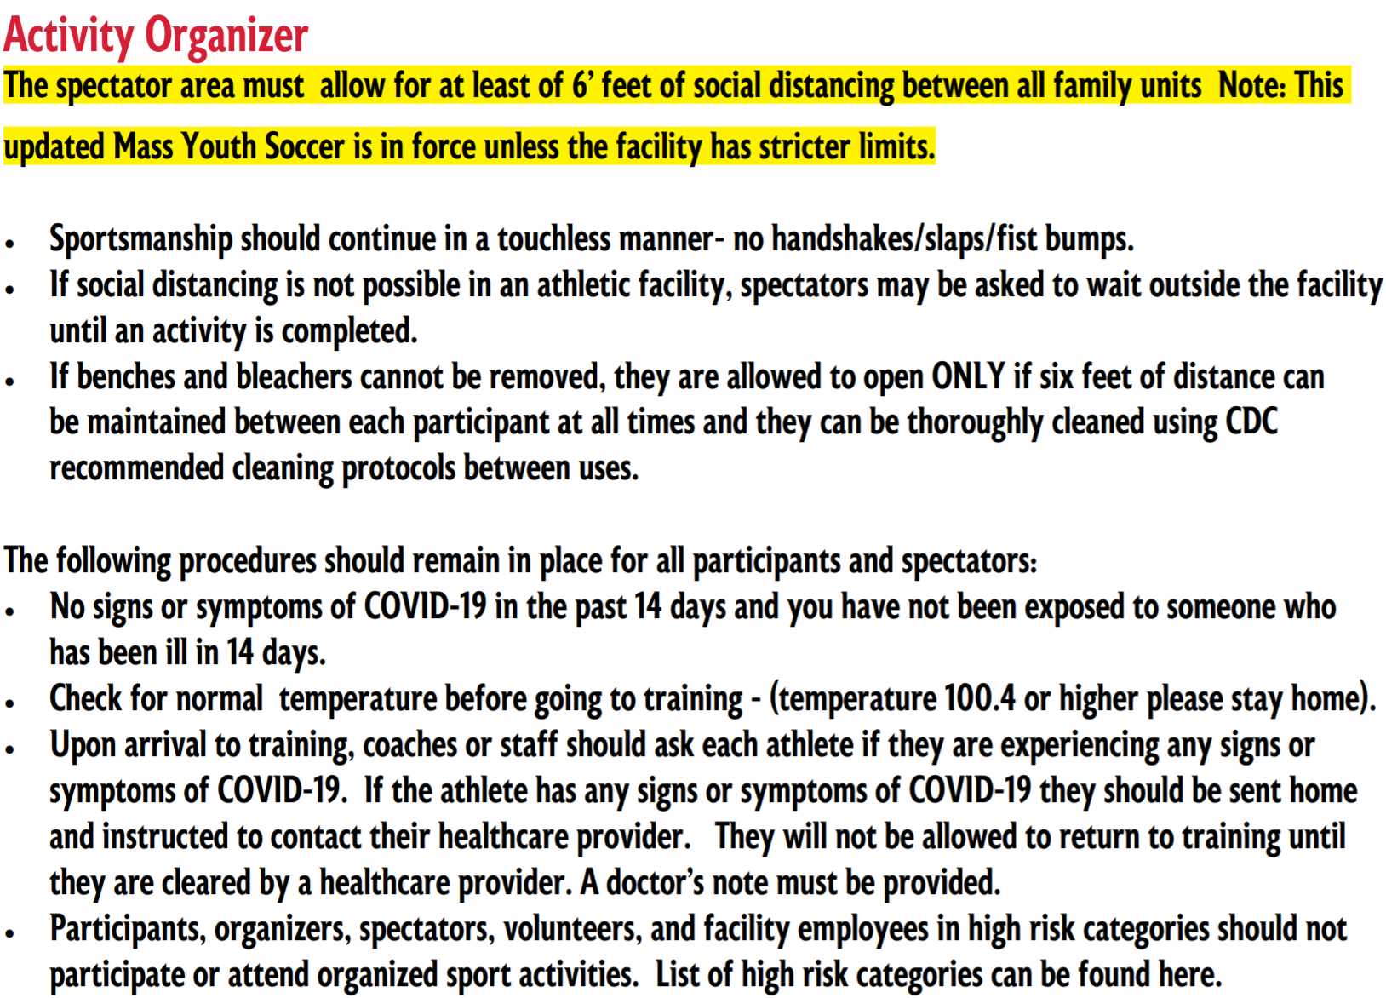
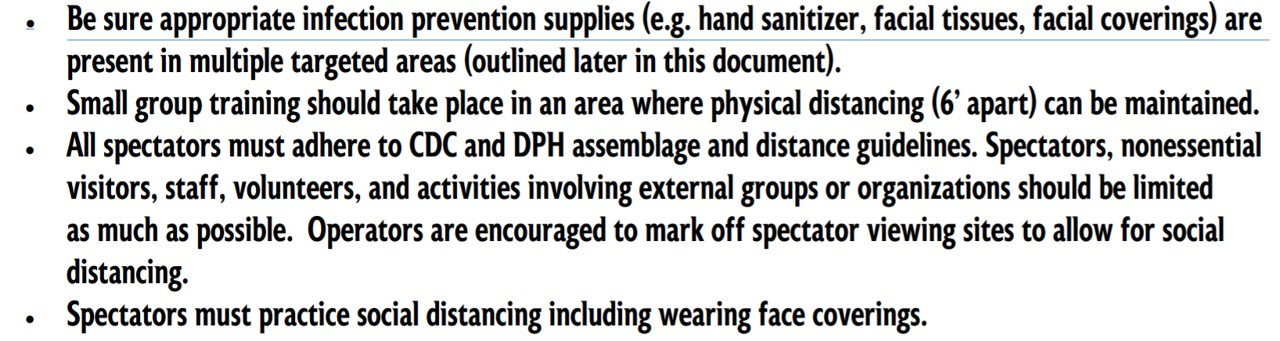
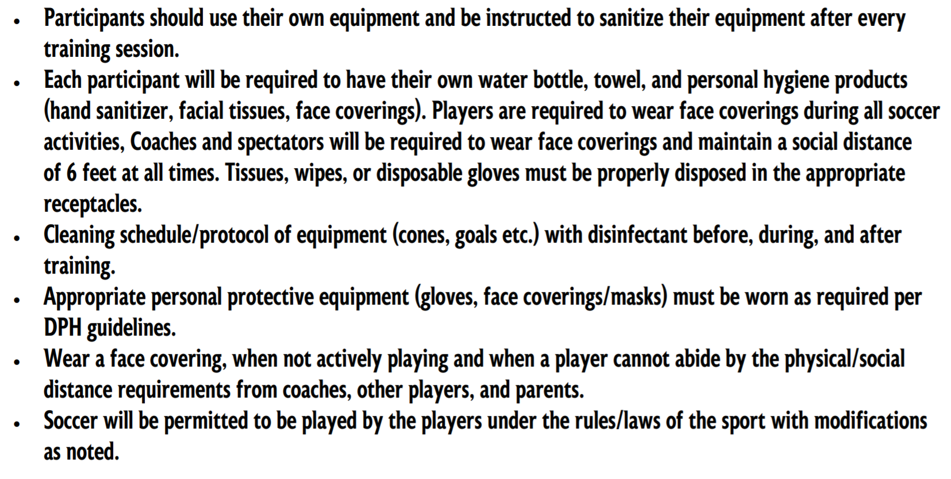

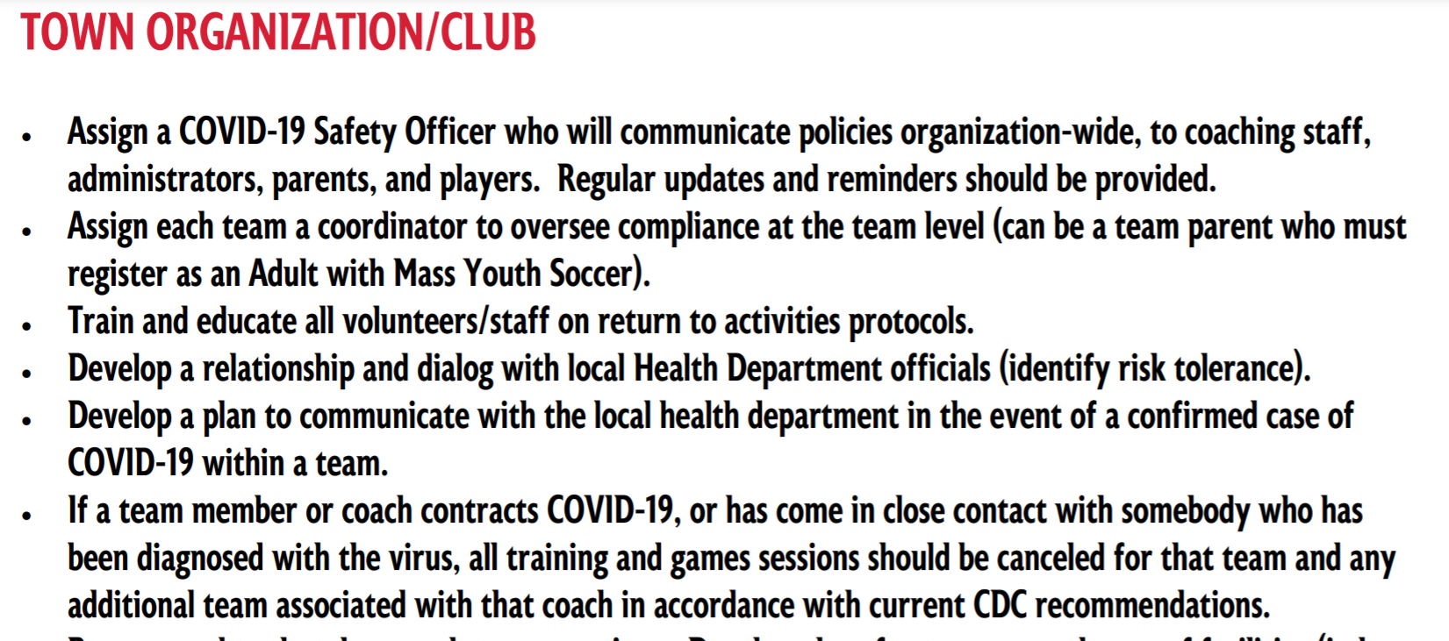
To review the whole document go to: https://www.mayouthsoccer.org/assets/61/6/soccer_activities_protocols_march_25_2021.pdf

