Fall 2021 Girls Grade 7 & 8 Results

Division 1:
No D1 Teams
Division 2:
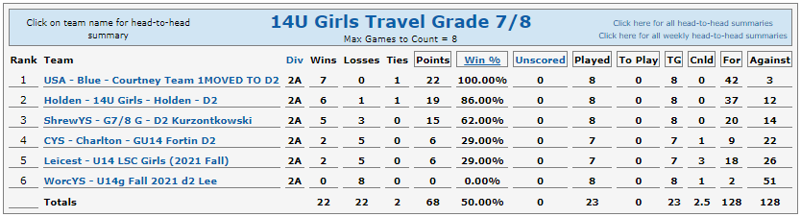
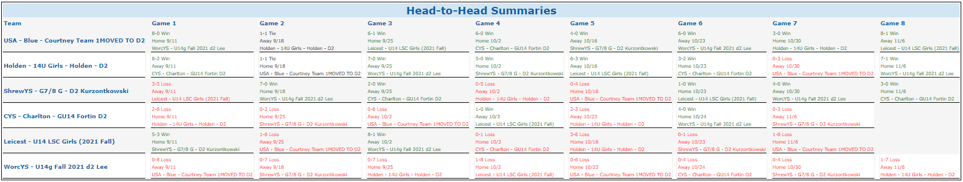

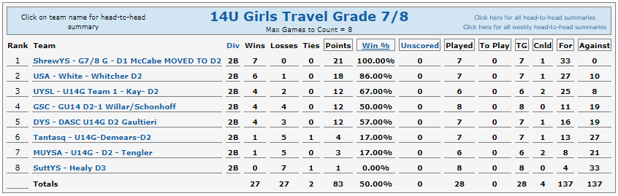

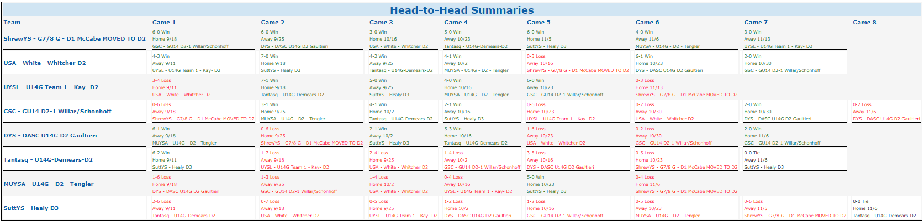

Division 3:
