Adding a Photo to the SportsManager System – For Spring Soccer

Step 1:

** Please use a solid/plain background for the picture.

Option A - You can use an existing photo if you have a recent one. You just need to make sure it is a close up of the face. You can also crop an existing photo with a photo editor to get a close-up of the face.

Option B – Take a new picture and upload it to your computer:
- Make sure you take a close up of the face from a front view. The phone/camera should only be a 2-3 feet from the face when you take the picture. This way you won’t have to edit or crop the photo later.
- Note - If using an iPhone
  - don’t take in portrait orientation, you need to take in landscape mode (holding iphone sideways)
    - the button (bottom of iphone) should be on the right
    - if you are taking a selfie then the button (bottom of iphone) should be on the left when you take the selfie.
  - If you have a picture that needs to be rotated you can use a computer program, like MS Paint, to rotate the photo. MS Paint comes with Windows and should be on your computer if you are using Windows.
- Android Users - If using an Android phone the orientation should not matter

Step 2:
Email photo from your phone to yourself, or connect phone/camera to your computer, and then save the photo to your computer.
- Remember where you saved it

Step 3:
Log into SportsManager using the ‘Parent Login’ tab
Here is the URL - https://www.sportsmanager.us/muysa.htm

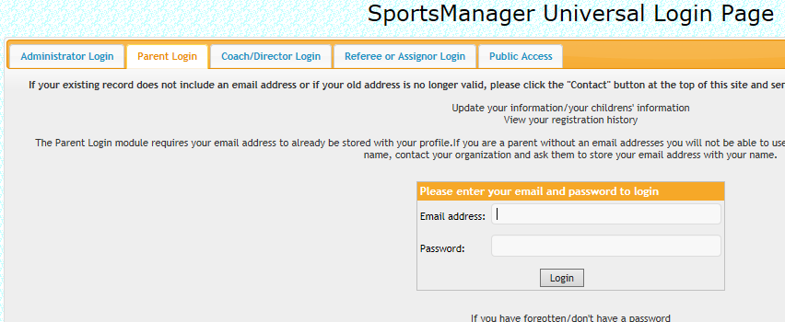

Step 4:

Below is a picture of the landing page you come to after logging in – click the ‘Add Photo’ button next to the person’s name you want to upload a photo for.
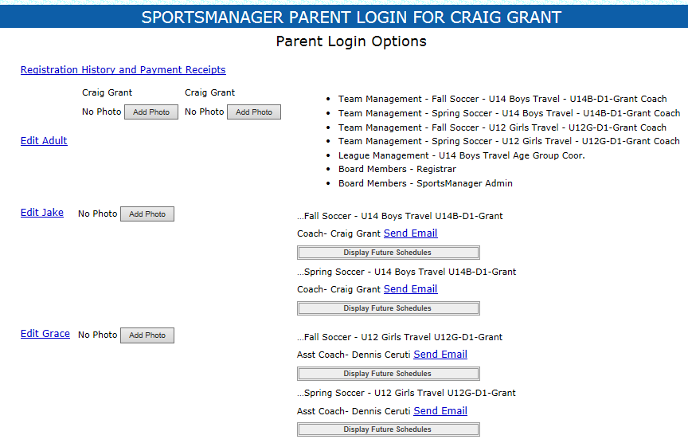

Step 5:
Click the ‘Browse’ button to find the photo on your computer.



Step 6:
Find the photo you want to upload on your computer, click on it once, and then click the ‘Open’ button.



Step 7:
Click the ‘Submit’ button

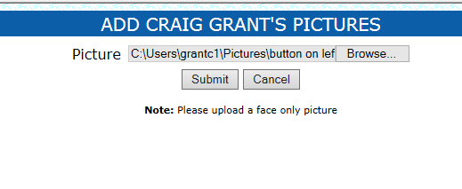

You should see the photo uploaded under the Adult or Childs name.
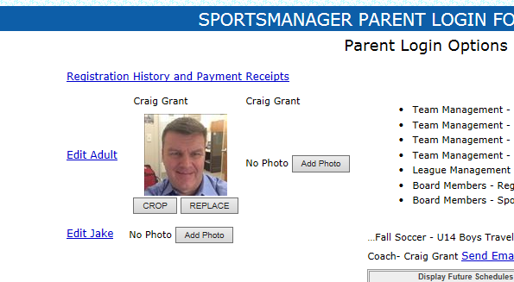

You are done! Repeat for any additional Adults or Children you need to upload photos for.

