May 16 - revs event

Muysa parent’s please

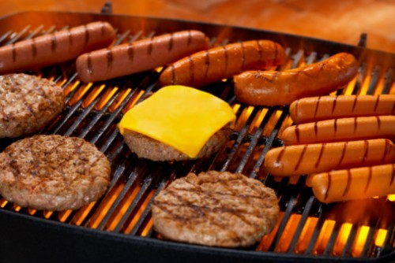
Leave your Grill at Home!

Cause we’re bringing a really big one!

Hot Dog $2.00 Hot Dog Combo $3.00
Hamburger $3.00 Hamburger Combo $4.00
Cheeseburger $4.00 Cheeseburger Combo $5.00 **** combos include a bag of chips and a water
All proceeds to support muysa

And if you haven’t gotten your tickets do it now as time is running out! The link:

https://muysa.np.sportspilot.com/store/products/2-night-at-the-revs.aspx#.VR1FsvnF_jk

