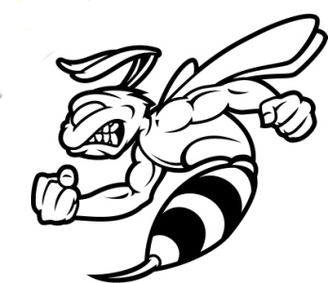
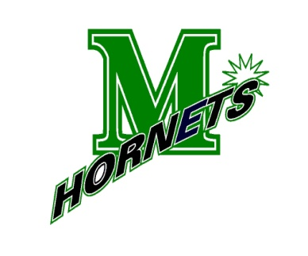
MANSFIELD YOUTH WRESTLING
& High School Team

Apparel Order
Today – Thursday Dec 8th(midnight)
^{Online Ordering only:}
This is for wrestlers, family and friends.

- Team Warm Up Jacket (embroidered)
- Team Warm Up Pants
- ¼ Zip Jacket (embroidered)
- Black Under Armor Sweatshirt (embroidered)
- Short Sleeve T-Shirt (silkscreened)
- Mansfield Wrestling Shorts (embroidered)
- ¼ Zip long sleeve shirt (embroidered)

https://mansfieldwrestling16-2.itemorder.com

Any questions or problems contact:
Karen Farley
774-444-5005 or kefarley3@gmail.com

Final Team Orders Being Places on Friday Dec 9th
Please note orders will not be in before Christmas

