BAYS.ORG

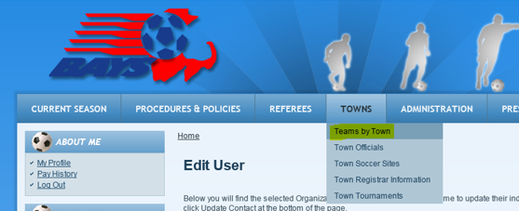

Choose Mansfield and ALL

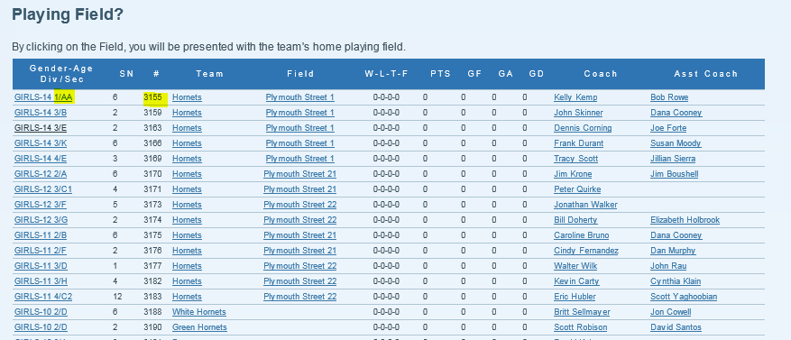
This is a list of all Mansfield teams. Highlighted is the DIV and SEC and TEAM

Next Go to Sports Manager: Teams/Rosters button
Click on EDIT for team
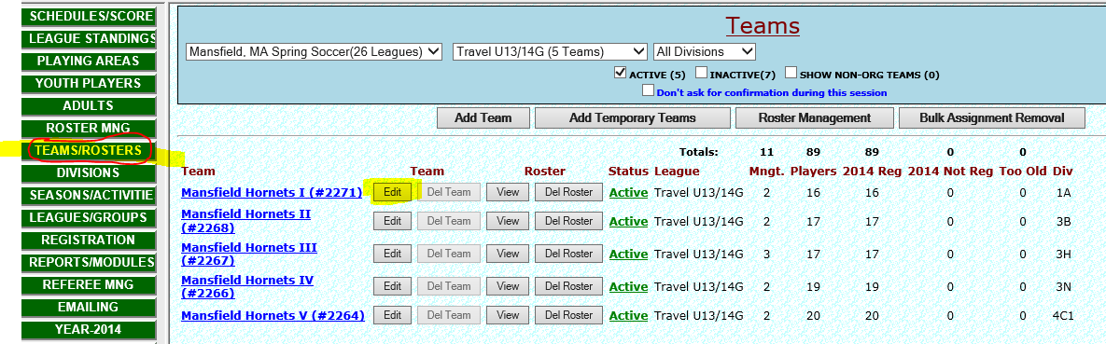

Fill in the DIV/SEC from the BAYS list and the TEAM number for the BAYS list
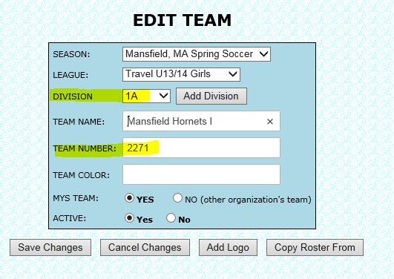
If a DIV/SEC does not exist then you need to go to the Division menu on the right bar and add the div/sec for the age group and assign to the team. When you go back to the team this div/sec will be updated.
