Instructions to Create a Master List of Mansfield Home Games
First week (or before opening day) create a weekly master game schedule of all of MYS games. This allows you to ensure there are no field conflicts that need to be resolved as well as giving you a list in case a week is washed out you know whom needs to reschedule and you can track when that is done.
If conflicts are seen then games need to be moved/rescheduled.
Once the master is reviewed and all games are accurate then this master list should be given to the game evaluation coordinators so they can start the process of scheduling game evaluations.
You can export the season off of the BAYS website under tab home town games (under top of page “current season”)
Sign into BAYS
Choose menu Home Town Games under Current Season
Select Mansfield Soccer All Weeks
Click on Go
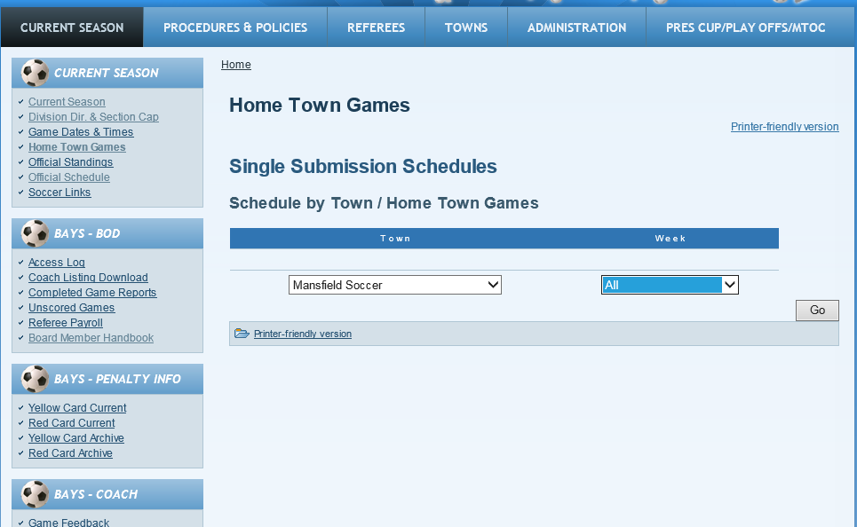

Click on CSV download, week by week
Load into one spreadsheet with a separate tab for each week
Place games into matrix as week below
