Instructions for BAYS Waivers
Information about Waivers
Sign onto Unified Signon on BAYS.ORG
Under Procedure & Policies, select Waiver Procedures
http://bays.org/node/68
When and Why a Waiver is needed for MYS players
Explanation below is from BAYS handbook https://www.bays.org/node/802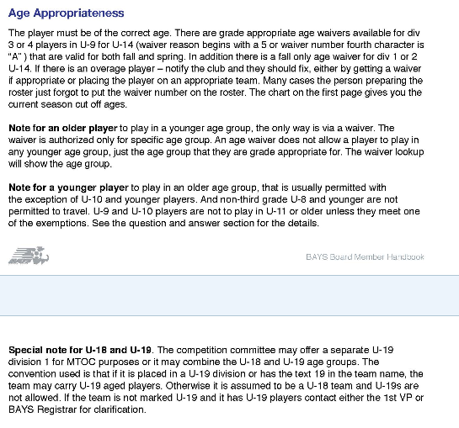
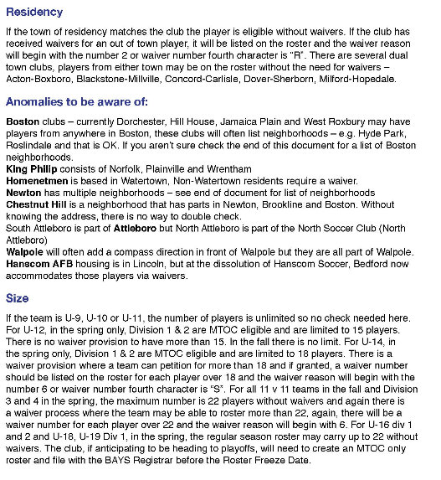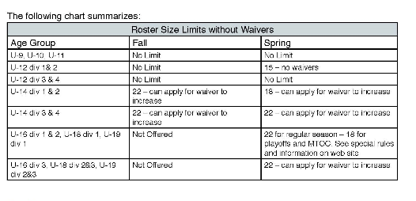

Sports Manager has a report which will display any player too old for their team. Any player on a travel team will need a waiver. This report runs off the max age field in the League record. Make sure that is set correctly. It should be set to the max age of a player when the 7/31 cut off it.
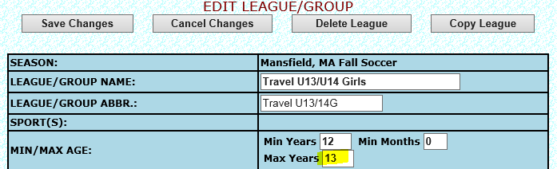

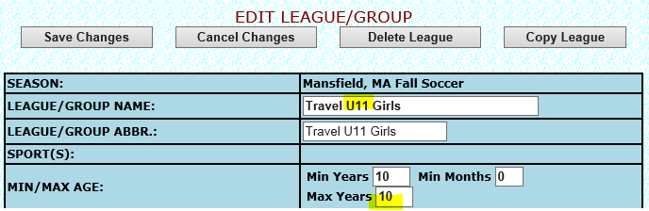
Run report Too Old for League. This will report any travel player who needs a waiver.
For any player moving to another town but wants to continue to play in Mansfield needs a waiver as well.
Basic Rules: Players can play with their grade no matter their age. No BAYS waiver is required for playing up with a grade unless the player is U8 and wants to play U9. MYS travel director does need to be notified of the player request to play up with their grade.

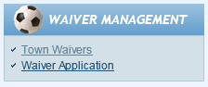
Waiver Application
Sign onto Unified Signon on BAYS.ORG
Last menu item, Select Waiver Application to submit waiver for upcoming year

SAMPLE of Past Waivers Approved by BAYS
Sign onto Unified Signon on BAYS.ORG
Last menu item, select Town Waiver to view approved/requested waivers
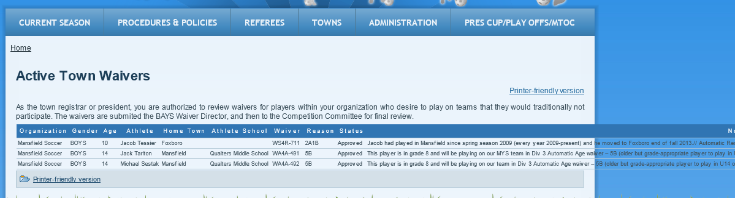
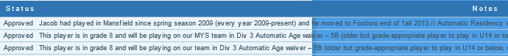
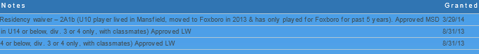

From: BAYS <webmaster@bays.org>
Date: Tuesday, September 2, 2014
Subject: BAYS Waiver - Approved
To: mysregistrar@gmail.com
 | BAYS Current Waiver Status | Date: September, 2 2014 - 9:09
Dear, Andre Fernandes - The BAYS Waiver Secretary has Approved your request for waiver William Lynch.
Notes:
Billy is playing MYS Division 3 team and is entering 8th grade =============== Automatic Age waiver – 5B (older-U15) but grade-appropriate player to play in U14, div. 3 or 4 only, with classmates) Approved MSD
This waiver has been assigned waiver number - WA5A-555.If for any reason you have questions about this process please email waivers@bays.org.

