
Sponsorship Packages

RELEASED fall 2014 a new state-of-the-art website and logos
www.MansfieldYouthSoccer.com
TOURNAMENT - 120 New England Based teams participating
Drawing in over 4,000 people over 3 days
SEASON – FALL and SPRING
1000 players,800 families,100 MYS teams,100 Out of Town teams
All fields in one location, New turf field and new grass area in full use

Tournament Map Flyer Sponsorship:
- Front facing Map side $500 (includes logo on new website year around and link to company site)
- Small ad $100

Year Round Sign Sponsorship:
Prime location on the fence of our center attraction turf field
- Full year large sign 4x6 $750.00 (includes logo on new website year around and link to company site)
- Full year small sign 4x4 $450.00

Raffle Item: Donate an item and we will promote your business on the raffle table.

Other tournament options:
Field Sponsorships – This field sponsored by XXX (excludes turf field)
Golf Cart or Fall Decoration location options (ex: of sign on cart: This RIDE brought to you by XXX)
---------------------------------------------------------------------------------------------------------------------------------------
Company Name ________________________ Contact Name________________________________________
Address _______________________________ Email Address _________________Phone ________________
Sponsorship Item ______________________________________________________ Amount:_____________

All donations are tax deductible (MYSs nonprofit 501(c)(3) tax exempt ID number is 04-3466647). Please send this form and check made payable to Mansfield Youth Soccer to:
Mansfield Youth Soccer
ATTN: Tournament/Year Round Sponsorships
P.O. Box 1053, Mansfield, MA 02048
Any questions, please contact Chip Stapleton at mysfundraising@gmail.com

Promotional Offer
Mansfield Youth Soccer’s New Website

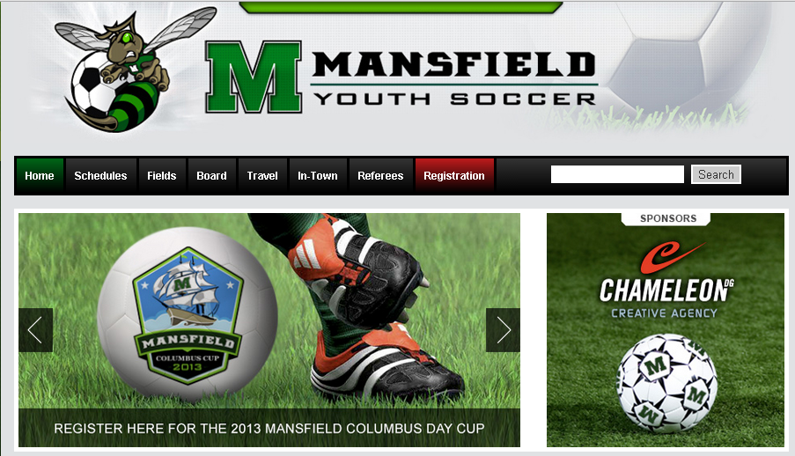

.
Preview our new site and the decision will be as clear as the new pages, now is the time to join Mansfield Youth Soccer as a sponsor. Your company logo and easy access to your company web page will JUMP out at our 800 families and to the 100s of local town teams coming to play soccer in Mansfield this year.

ACT NOW to benefit from the release of our new website.

