Instructions for BAYS rosters
How to Send Rosters to coaches, Download Division Directors and Send Official Rosters to Division Directors
Before each season BAYS needs to receive the MYS rosters for all travel teams so they can review, approve and file them. Division Directors are instructed to review the DOB for players, waivers, addresses, CORI status of coaches before they allow a team to play on opening day of the season. MYS should plan to get the rosters sent to the BAYS division director at least 1 week before opening day.
The same roster should be sent to the MYS coaches with instructions that they need 2 copies of the roster for every game.
Below are the instructions for this process.
Print Rosters
Sign into SportsManager
Choose Reports
Report #22 Soccer League/Team Roster Form Download
Choose Season, Choose all Travel Teams EXCEPT Spring Only for MTOC eligible teams*, Indicate BAYS league
*MTOC eligible team rosters need to be stamped in the spring before being send to coach and division director.
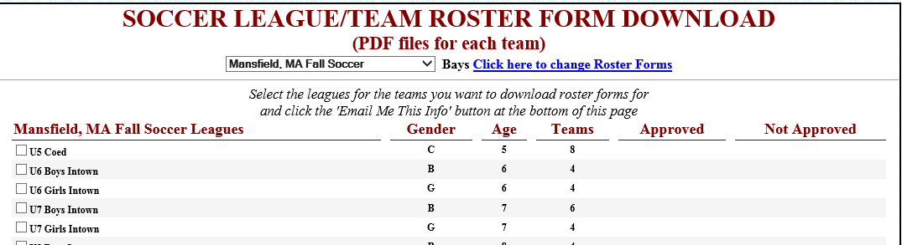
Click on Email Me This Info
On the pop up fill in according to input below
Fill in as seen below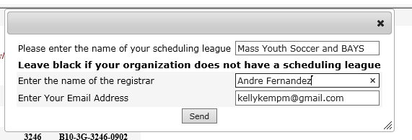
Create a work sheet of Mansfield teams, coaches and division directors for the teams. Vlookup to merge data together. Use last columns to track which rosters have been sent.
http://www.sportsmanager.us/DownloadFile.asp?File=%5CDocuments%5CMansfieldYouthSoccer%5C19688%2Exlsx
REPORTS
Teams by Town
https://www.bays.org/?q=node%2F113&town=MAN&vGender=ALL&Submit=++Go++
Division Dir.& Section Cap. Report
https://www.bays.org/node/254
Coach Email report
Sports Manager Team Management
Fill in the coach’s email so roster is sent directly to the coach
Fill in the Division Director when sending rosters to BAYS. OR send all rosters to MYS travel then MYS travel forwards all rosters in one email to the Div Director.
BAYS division director needs a copy 2 weeks before the season starts. BAYS checks that the coaches are CORId, DOB of all players, any player over age for the age group needs a waiver on the roster, check that all players are in Mansfield (waiver needed if not). MYS should also check that all these points before sending to BAYS.
For MTOC teams in the spring see the MTOC instruction document. The rosters for MTOC teams need to go to the Division Director to be stamped.

