Spring MTOC eligible team instructions
MTOC information https://www.bays.org/node/356
Handbook page 35: https://www.bays.org/node/802
Appendix A
MTOC eligible teams play in:
U-12 Div 1, U-12 Div 2, U-14 Div 1, U-14 Div 2 U-16 Div 1, U-16 Div 2, U-18 Div 1 and U-19 Div 1
** MTOC eligible teams must have PLAYER pass cards and BAYS stamped rosters before the first game
PASS CARDS
Send notification to MYS pass card maker (2015 Mary Beth Jeans) to inform her of which teams are MTOC eligible.
To determine which teams need pictures follow these instructions:
Sign onto SportsManager
Go to Teams
Search the Div column (last column) for any team U12 or above which is D1 or D2
ROSTERS
MTOC eligible team must have their roster submitted to BAYS registrar 2 weeks prior to the season. The BAYS registrar stamps the roster and send it back to MYS. MYS then send a copy of the stamped rosters to Div Directory and to coach.
Before submitted to BAYS be sure the coach is CORId and all players are of age. TO check CORI go to http://www.mansfieldyouthsoccer.com/coaches-corner/ and click on CORI Process icon to check coaches have valid CORIs
Also make sure the BAYS team number is in SM and the correct Division is in SM.
Sign into SportsManager
Choose Reports
Report #23 Soccer League/Team Roster Form Download
Choose Season, Choose Travel Teams eligible for MTOC, Indicate BAYS league
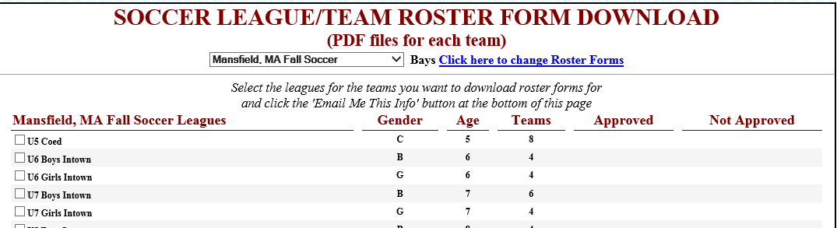

Click on Email Me This Info (then forward to BAYS registrar with note that team is from Mansfield and is eligible for MTOC so we are requesting a stamp)
https://www.bays.org/BoardofDirectors
On the pop up fill in according to input below
Fill in as seen below 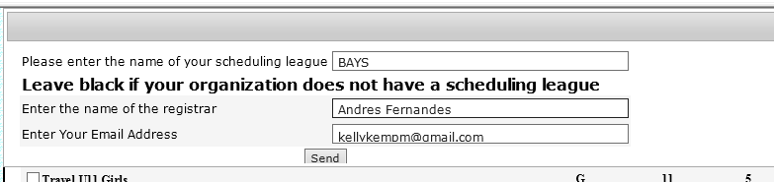
IMPORTANT : MTOC rosters are not frozen until end of May. This allows teams to make changes to the roster throughout the season but at the end of MARCH the roster is frozen and no changes can be made after that time.
After BAYS registrar sends the roster back with the stamp then send to coach of team and to division director for the teams. BAYS site shows the division director on report https://www.bays.org/node/254

APPENDIX A:
