Sign into SportsManager
Go to Registration on left nav bar
Click on report #4
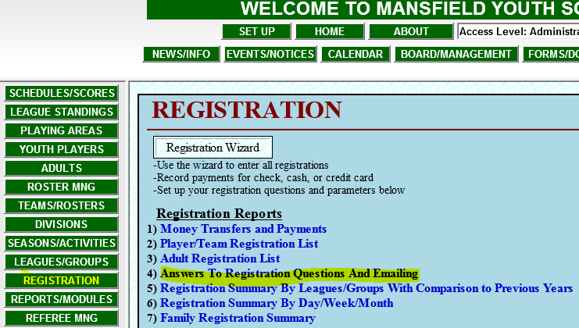
Select Answer Type = Adult Answers
Click on ALL Questions then choose last entry – MYS is a VOLUNTEER organization ….
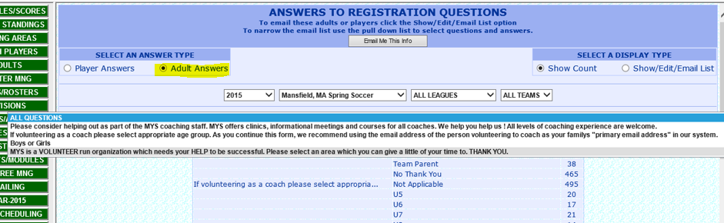

This brings up a summary of the questions
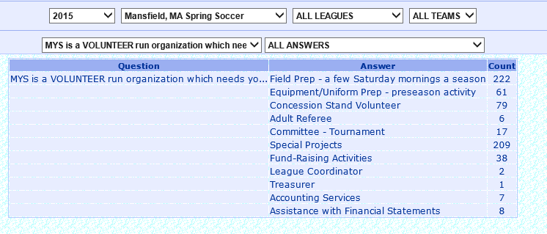
Choose the Area(answer) you want to focus on and Show List. From here you can email the list to yourself or you can click on Click Here to email from SM
