Instructions for Laying out 11v11 field
330’ long
210’ wide
Penalty area (18 yd box) 54x132
Goalie Area (6 yd box) 18x60
Penalty Spot 36’
Center Circle 30’
Corner flag 3‘

Mark Corners

Mark Outside Lines
String corner to corner 330 side lines 210 touch lines
Paint Lines (all four lines, touch lines and side lines)
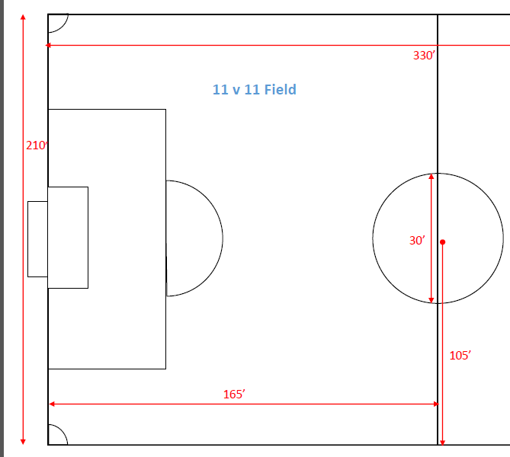

Center Line
Calculate ½ of distance between corners on side line (330/ 2 = 165)
Drop stake on each sideline , String across, Paint Line
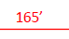
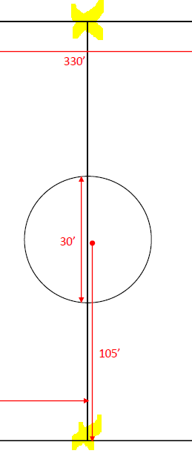
Center Circle
Calculate ½ the distance from side line to side line
Drop stake at middle point and attach string
Measure ½ the distance of radius
Walk painter in circle using the string as a guide

Goal Box
Calculate ½ the distance from corner stake to corner stake(sideline to sideline) (210/2=105)
Drop stake to mark center point

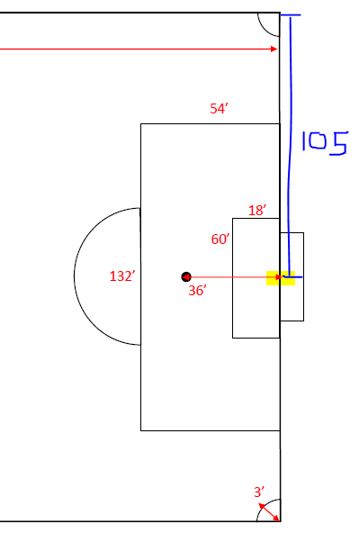

Measure from center point out toward both side lines to create 6yd and 18yd box corners
Calculate ½ the distance for each both (60/2=30) (132/2=66)
Drop stakes at each corner

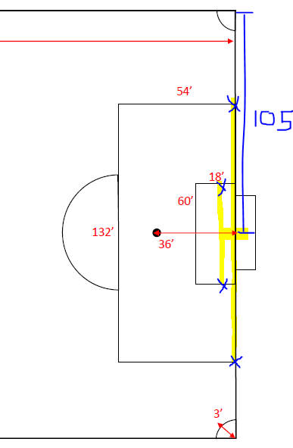

From the 8yd box corner stakes measure out 54ft
From 6yd box corner stakes measure out 18 ft
Drop stakes.
String all corner stakes together to make boxes
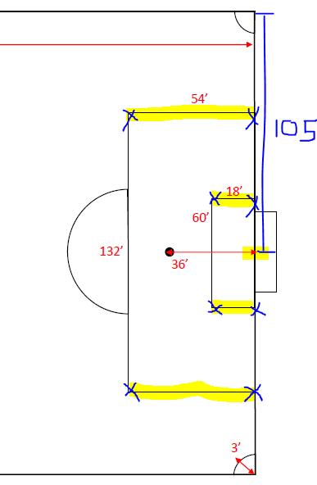

BEFORE PAINTING the lines, double check by taking measurement from
sideline to corner at top box and sideline to corner at bottom box (1 = 2), do for both sides (3 = 4)

Do this same check for 6yd box.
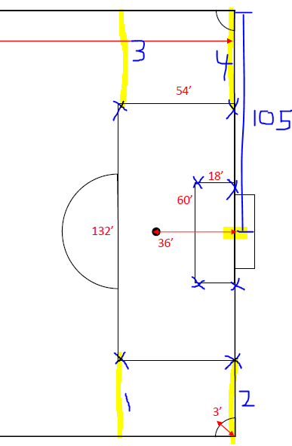

Penalty Line
From center point measure out XX to mark penalty line (XX depends on format of field)
Drop stake, paint line

