Shutting off SportsManager Access to load teams

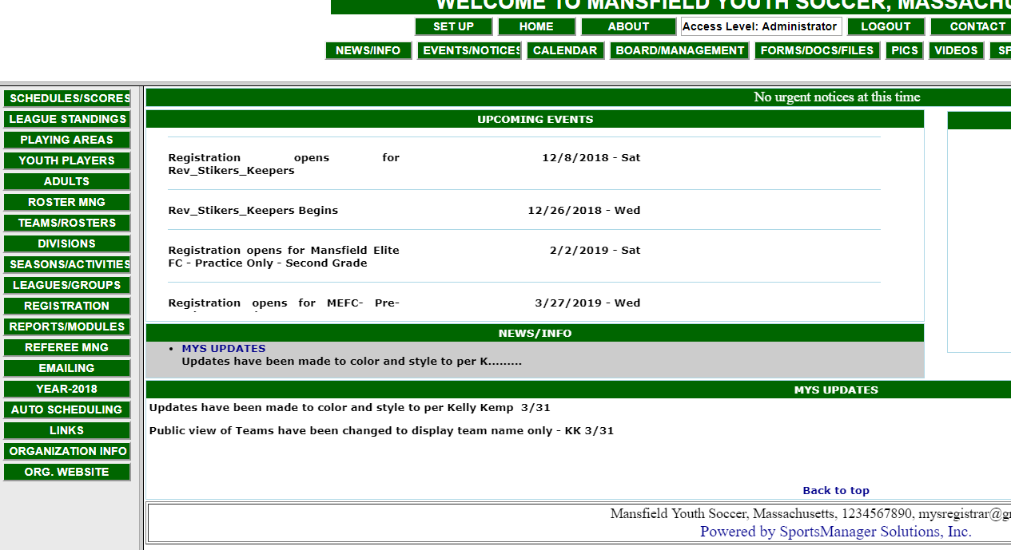

Click on “Roster Mng” to enter the Roster Manager Portal
Click “Roster Manager Settings”

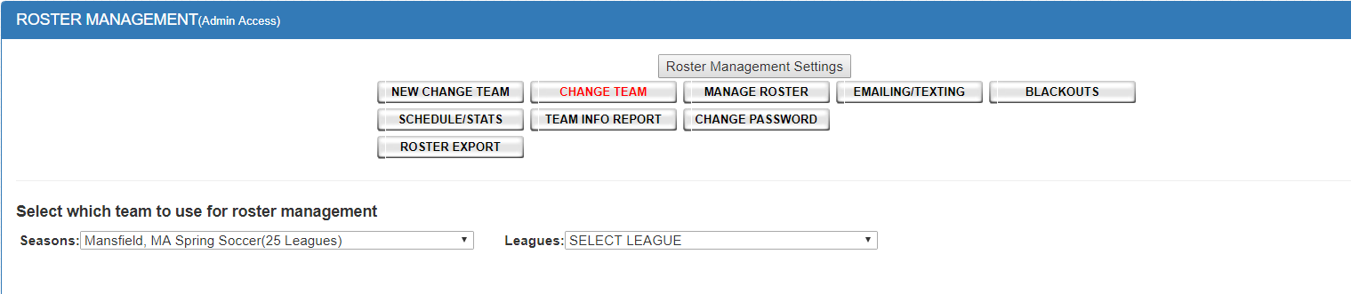

Then select “No Access”

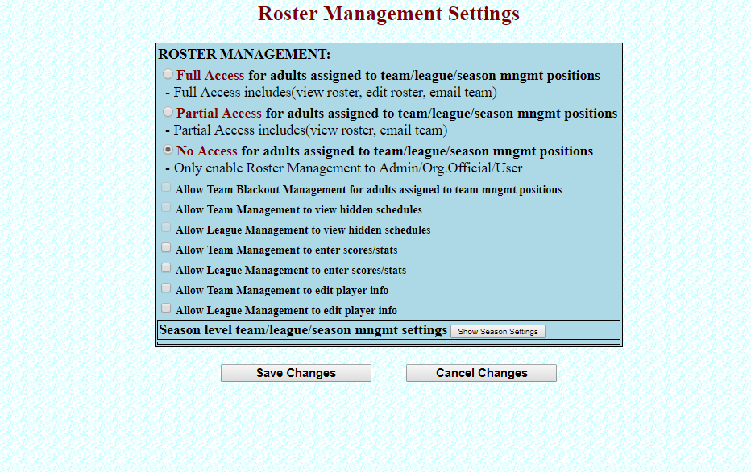
Then select “Board/Management”



Take a screen shot or write down everyone’s access (Admin, Manager, User, etc.) so you will have it for later.

Next: Change all Board Members you want to shut off to “No Access”
(Keep President, Travel Director, Registrar as Admin – use discretion)

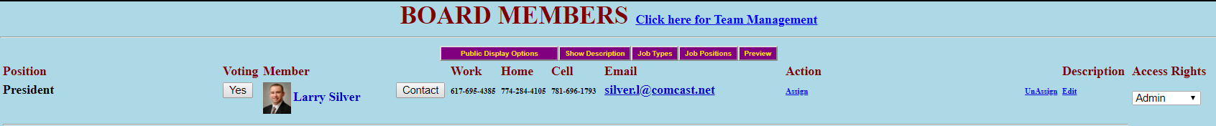

ONCE ALL ROSTERS HAVE BEEN LOADED AND CHECKED, TURN BACK ON ALL BOARD MEMBER ACCESS BY CHOOSING THEIR PERMISSIONS AND CHANGE ROSTER MANAGER TO “FUL ACCESS”

