Mansfield Youth Soccer
Coaches Portal Access (Note: Chrome is recommended

- From the MYS website (www.mansfieldyouthsoccer.com) follow the link to the “Coaches Corner”.
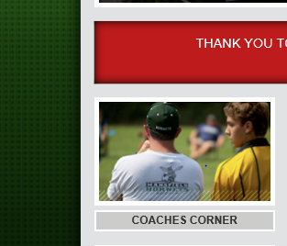

- Follow the link for the “Coach Portal”.
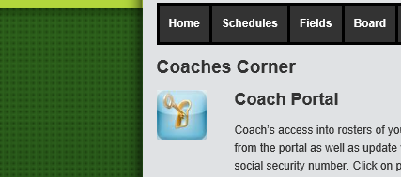

- Log-in to the portal using the email address/password that was originally used when registering for MYS. If you would like to change this let the MYS In Town Director know and this can be updated for a better email. If you don’t remember the password follow the instructions on the web page.
- When you are logged-in you should see your team listed. If you manage more than one team you should see all of them listed.
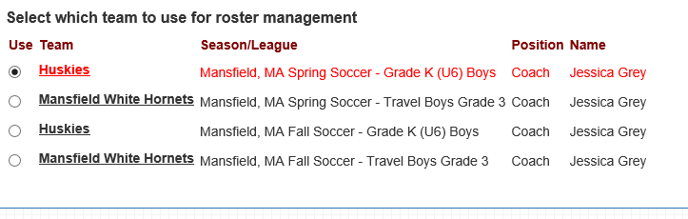

- Once you select the team you would like to manage you should see your complete Roster and other Team Managers listed. From this page you can email the entire team (“EMAILING/TEXTING) and/or print out roster information (Team info Report).
