Hi Coach,
XXXXX here from the Mansfield Grade X team X. We look forward to playing your team this Saturday.
Below is a map of our facility, the address is 50 Plymouth Street, Mansfield MA 02048. We will play on Field XX at X (time).
Please share all of the below information with your team (parents).
COVID-19 Rules at our facility:
- Masks must be worn at all times
- Limit to One (1) spectator per player (Mass Youth Soccer Return to Soccer Activities requirement)
- Maintain social distancing
- Spectators need to stay behind the lines marked on the spectators side of the fields
Shown on the map are locations where warm ups are allowed. We ask that you keep to the minimum space required, as other teams could be in and around that area. The designated areas are large, so there should be no issue regarding distancing.
Game Rules: Mansfield Youth Soccer will adhere to all rules advised by MYSA Return to Soccer Activities Guidelines, including rules relating to masks both on and off the field, along with all game-play rules. It is our expectation that all teams traveling to MYS will do the same. In the event that a team traveling to MYS is not adhering to the rules, MYS has given full authority to coaches to remove their team if they feel there is any risk regarding safety.
https://www.mayouthsoccer.org/assets/61/6/return_to_soccer_activities_phase_3_step_1_-_august_151.pdf
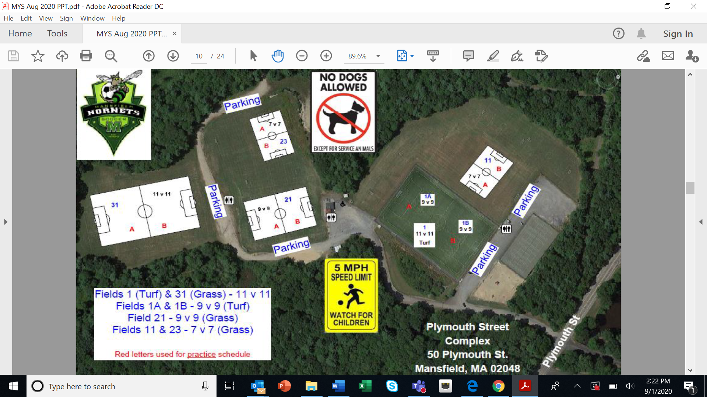
Exit
coachesp
Warm-up
ENTER
Warm-Up
Exit
ENTER

