- Go to http://mansfieldyouthsoccer.com/
- Select Coaches Corner menu
- Then Coach Portal. You have to click on the key, the words are not clickable
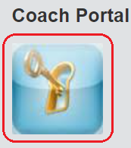
- Sign in with your email & password. If it's the first time you're signing in, then select "Click Here" to have it emailed to you. 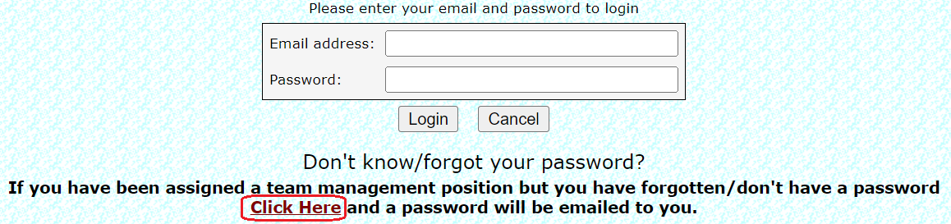
- Once you're signed in, you should see the Teams that you are considered “management” for, whether that is Coach, Assistant Coach or Team Parent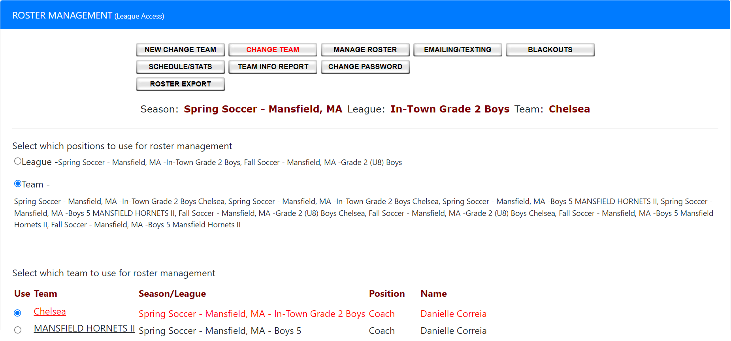
- Select your team, and click on MANAGE ROSTER at the top to view your team.
- Select EMAILING/TEXTING to send an email to all team parents.

