Activity 1 | Activity Description | Time
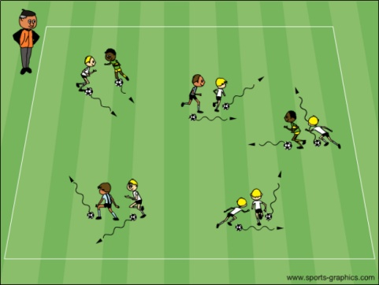 | Tag:  All players dribbling a soccer ball will try to tag each other with their hands. Players cannot abandon their own ball to tag.  Coach: Have players keep count of their own tags. If playing more than one game, have players improve their tags by 1, 2 or 3 more than before. | 6  minutes
Activity 2 | Activity Description | Time
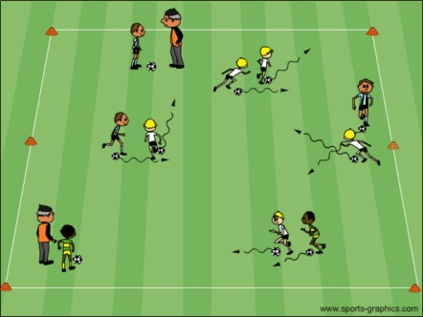 | Hospital Tag:  All players dribbling a soccer ball will try to tag each other with their hands. Once a player is tagged he/she must cover the tagged (injured) spot with one hand, second tag use the other hand, third tag the player must go to the hospital to see the doctor and cure him/her.  Coach: Acts as the “doctor” and heals the dribblers so they can keep involved in the activity. | 6  minutes
Activity 3 | Activity Description | Time
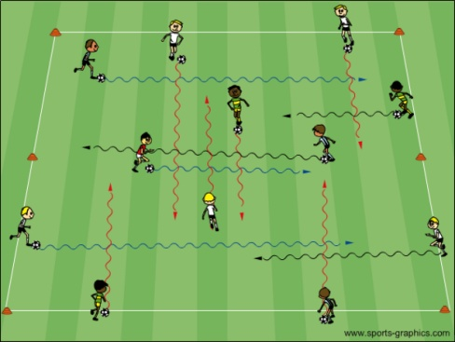 | Cross Over Dribbling:  All players with a ball standing around the perimeter of a 15x20 yard grid. When the coach says “GO” the players will try to dribble to the other side of the grid. When they reach the other side, the players turn and dribble back to their spots.  Variation 2: Have then reach the other side and return to another spot.  Variation 3: Time the activity and see how many times the players cross over in 30 seconds or a minute. | 6  minutes
Activity 4 | Activity Description | Time
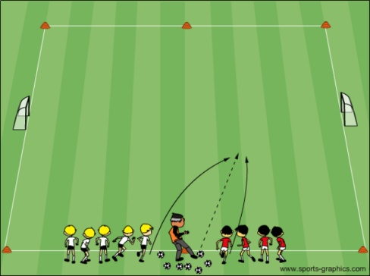 | Get “Outta” There:  The players are divided into two teams, and positioned at either side of the coach with multiple soccer balls outside a 10x15 yard grid with two small goals on each end line. The coach serves a ball into the grid and the players try to gain possession and score on their opponent. If a goal is scored or the soccer ball goes out of bounds, the coach yells “Get outta there”.  Coach: Can make the games 1v1, 2v2 or 3v3. They should vary the service. | 6  minutes
Scrimmage | Activity Description | Time
3v3 - Dual Field Scrimmage | Set up two fields of 15 x 20 yards with a 5yd space between them in order to keep the majority of your team playing. | 25 minutes

