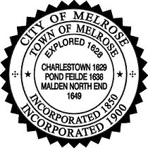

Mayor Rob Dolan

Invites you to join your fellow Melrosians in
Remembering those who died or were injured on Marathon Day
Recognizing the Melrose Marathoners who ran that day
and
Honoring the Public Safety Personnel who assisted in the search

Saturday, April 27, 9 a.m.
Clarence DeMar Monument, Ell Pond
(Main Street, next to the Gazebo)

Remembrance Ceremony, Clarence DeMar Memorial,

National Anthem
Introduction by Mayor Dolan
Invocation by Rev. Barbara Threet, Melrose Unitarian Universalist Church
Remarks by Rev. Larry Starr, Green Street Baptist Church
Laying of the wreath; moment of silence

Award and Recognition Ceremony, Ell Pond Gazebo
Special Guest: Legendary Marathon coach Bill Squires

Please park behind City Hall or walk as there is limited parking in the area.

