US Youth Soccer, US Soccer and NSCAA Course Comparisons

Graph of NSCAA Courses and their path to advancing Graph of USYS Courses and their path to advancing

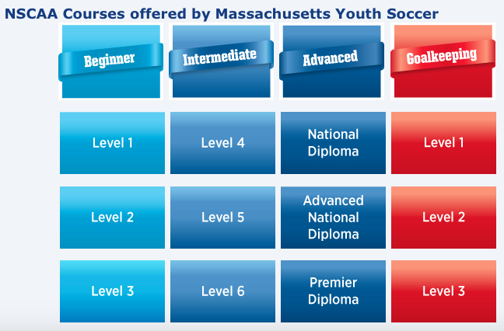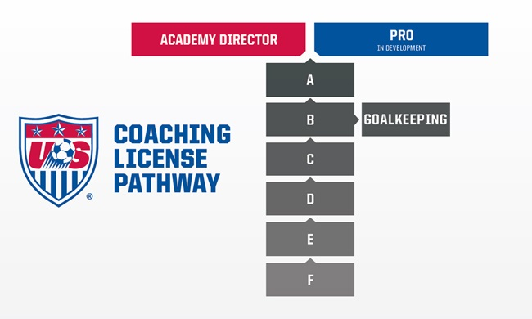

U.S. Youth Soccer & U.S. Soccer Courses | Hrs |  | NSCAA Course Title | Hrs | Rationale
Youth Module I (U6 - U9) | 5 | compares to | NSCAA Level 1 Diploma (U6 - U8) | 4 | Both 4 and 5 hour courses geared to U6 - U10 for the most part.
Youth Module I (U6 - U9) | 5 | compares to | NSCAA Level 2 Diploma (U8 - U10) | 6 | Both 5 and 6 hour courses geared to U6 - U10 for the most part.
Youth Module II (U10 - U12) | 8 | compares to | NSCAA Level 3 Diploma | 9 | YMII is an 8 hour course geared to U10 - U12; NSCAA is a 9 hour course but is geared to novice team coach.
US Soccer 'E' License | 18 | compares to | NSCAA Level 4 AND 5 Diploma | 12+12 = 24 | E course (18 hours) is now a license with formal assessment. The NSCAA courses (4 and 5) do NOT have formal assessment. Level 4 considers technical applications while Level 5 considers tactical applications.
US Soccer 'D' License (State) | 55 | compares to | NSCAA Levels 4, 5 AND Level 6 Diploma | 12+12 +18 = 42 | D course (55 hours) has formal assessment with prerequisite requirements. Level 4 (12 hours) plus level 5 (12 hours) plus level 6 (18 hours) = 42 hours....with the Level 6 having a practical assessment. Comparison requires completion of ALL THREE NSCAA courses.
 |  | OR
US Soccer 'D' License (National) | 55 | compares to | NSCAA National Diploma | 45 | D course (55 hours) has formal assessment with prerequisite requirements. NSCAA National Diploma is a 7 day 6 night program (or two weekend format). It does have formal assessment. No prerequisite (however, Level 6 is strongly recommended).
National Youth License | 32 - 40 | compares to | NSCAA National Diploma | 45 | National Youth License is a 5 day 4 night course (or two weekends) similar in structure to the National Diploma. It does have formal assessment and a prerequisite of 'D' License (or NSCAA Level 5 and 6 - recommended by State DOC) .
US Soccer 'C' License | 60 | compares to | NSCAA Advanced National Diploma | 45 | National Diploma is only accepted as a prerequisite requirement into the C course, not as equivalency by U.S. Soccer. NSCAA Advanced National Diploma is a 7 day 6 night program (or two weekend format). It does have formal assessment. Prerequisite of National Diploma or 'C' License.
US Soccer 'B' License | 60 | compares to | NSCAA Premier Diploma | 45 | Advanced National Diploma or Premier Diploma are only accepted as a prerequisite requirement into the B course, not as equivalency by U.S. Soccer. NSCAA Premier Diploma is a 7 day 6 night program. It does have formal assessment. Prerequisite of Advanced National Diploma or 'B' License.
US Soccer 'A' License | 60 |  |  |  | Must have 'B' license to get into 'A' course - no exceptions or waivers.

