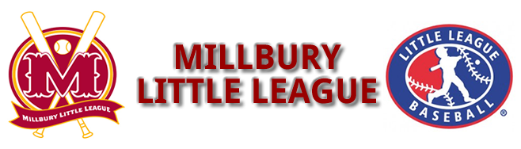

Celebrating our 66th year

Millbury Little League
24th Annual Golf Tournament

DATE: SUNDAY, OCTOBER 14, 2018
1:30 p.m. Shot Gun Start

PLACE: Blackstone National Golf Club, Sutton MA
Fee: $125 per person Hole/Tee Sponsor $100
18 holes with cart
Delicious Steak Dinner
1st, 2nd and 3rd place prizes
Closest to the pin….longest drive contests

Help support Millbury Little League

Please support MLL by playing in or sponsoring a hole at the Annual Golf Tournament.
100% of the proceeds will go directly to support MLL
Win Patriots & Bruins tix! 50/50 Raffle!

Any questions, contact MLL Golf Tournament Coordinator
Rick Sousa, 781-367-7851 or email
sousa_rick@yahoo.com
or
John O’Brien, MLL President
508-726-2213 or email
president@millburylittleleague.org

Deadline: October 10, 2018

