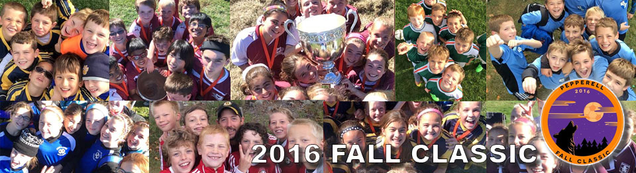
Pepperell Fall Classic Soccer Tournament
Columbus Day Weekend - October 8-10, 2016
REGISTRATION IS OPEN!!!! REGISTER BY 10/1/16!!!

The Pepperell Fall Classic enters its 31st year and is an autumn tradition for youth soccer players of Northern Massachusetts, Southern New Hampshire and Rhode Island. As one of the oldest, continuously running soccer tournaments in the area, the Fall Classic has played host to thousands of teams, and tens of thousands of youth players from all over New England. Register today, space is limited! (130 team limit).
The Pepperell Fall Classic is a memorable tournament for a lot of area soccer players with players playing in our tournament at some point during their youth soccer years. We received a lot of input from teams last year and are introducing a new format this year. Our U14 divisions will being playing a 6V6 format (9 players max per team). There will be a Girls and Boys division as always. Our High School divisions will also be 6V6, but with a new twist, Co-Ed teams. Rules for these new formats can be found on the Pepperell Fall Classic website. The games are typically held either on Saturday (usually girls divisions) or Sunday (boys divisions) which include playoff and championship games. Another new additional, due to input from coaches and teams, we will be adding playoff/championship games for our U12 boys and girls divisions. These games will be held on Monday along with our competitive team playoff/championships. These new formats join our existing line-ups of U8 and U10 divisions for boys and girls. And as always champions of each age division for both the boys and girls (U12/U14/U18) qualify for the Challenge Tour 3V3 National Tournament held at ESPN/Disney Resorts in Orlando, FL. .
The entire tournament takes place in a single location, on adjacent fields with plenty of free parking. Teams are allowed to setup team tents with tables and chairs in areas surrounding the fields. There will be vendors for food, soccer equipment, merchandise and more. The Fall Classic is truly a festival-like atmosphere for soccer enthusiasts of all ages.
To Register your team, please go to: http://pepperellsoccer.org/fallclassic
You will want to click on the Register your team today link which will bring to the registration page. If you have any questions in regards to the Pepperell Fall Classic, please email the director of the Pepperell Fall Classic, Dan Hodgson, at dan@bostonlogistix.com and he will contact you to answer any questions and get your team registered. We hope that you can join us for our 31st tournament this year!!!

