
HYS Unified Soccer Program
WHO: | Youth players in grades 8th to 12th with and without intellectual and/or developmental disabilities
WHAT: | A FREE, inclusive soccer program focused on using sport as the catalyst for building friendships and achieving social inclusion through Special Olympics Unified Sports and Holden Youth Soccer
WHERE: | Holden, MA – Davis Hill
WHEN: | 6 Sessions: Saturdays, Beginning on April 23rd, 2022  From: 5:00 pm to 6:30pm
Register: | Players with IDD: www.holdenyouthsoccer.org. Go to the Registration Tab > Unified Soccer  Players without IDD: Email Jon-Paul St. Germain at jonpaulstgermain1@gmail.com

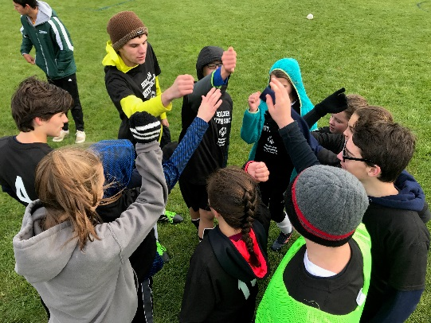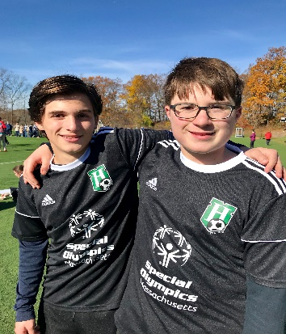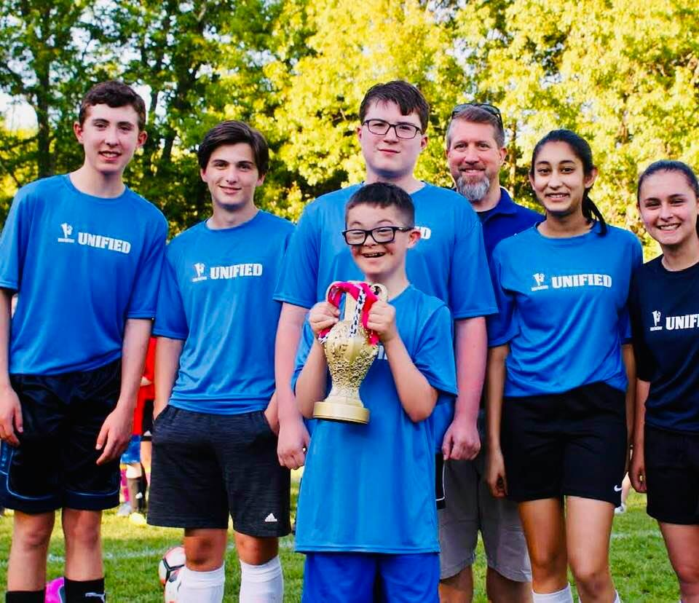
*Any questions? Please email Jon-Paul St. Germain, Holden Youth Soccer at jonpaulstgermain1@gmail.com

