QUABBIN PRIDE
Show your School Spirit!!
Help Support the Quabbin Regional Soccer Teams with our:
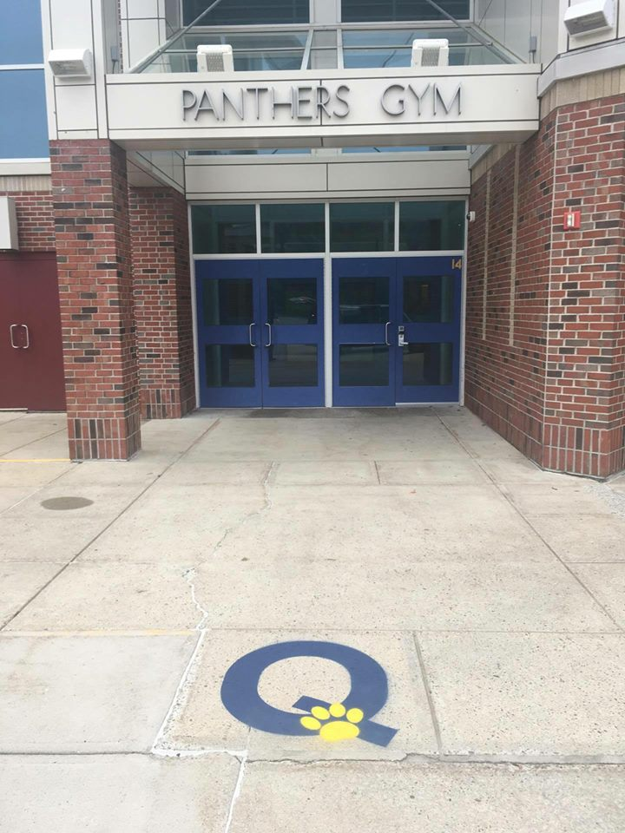
DRIVEWAY PAINTING FUNDRASIER….Show your town and school pride by displaying our 2x2.5 ft. “Q” painted on your driveway. Fill out the form below or create your own email including NAME, ADDRESS, CELL AND ACKNOWLEDGE YOU GIVE US AUTHORITY TO PAINT the ‘Q”. Payment of $40.00 is made on the day of painting, once scheduled you will be notified via text.

*****Please email aordung@charter.net with orders and questions.
Name________________________________________________ Cell#_______________________________

Address_______________________________________________________________________________________

I have the authority to make decisions regarding the above property and grant permission for the 2x2.5 “Q” painted on my driveway.
Signature: __________________________________________________________________________

