



Presented By: SUAA
Check in: 1:00 to 1:30pm
Parent Floor Show: 5:00pm
Participant and Parent diner: 5:30pm


4311 Old Pageland-Monroe Road
Monroe NC 28112
Only $20.00 for a 4 hour Cheer camp
Included: Participant gift bag

Ages 4 – 12 – All skill levels welcome
Students will learn tumbling, stunts, jumps, a floor routine and much more! Please wear workout attire – no jeans

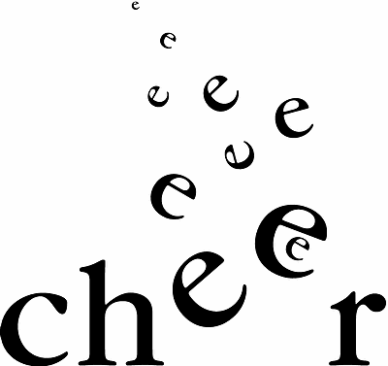


For additional information and registration call Jennifer Rapp at 704-281-7097 or Melinda Haigler at 704-219-1174

