 | 

For more information contact Scott Francis – sfrancis@challengersports.com 860-796-3979
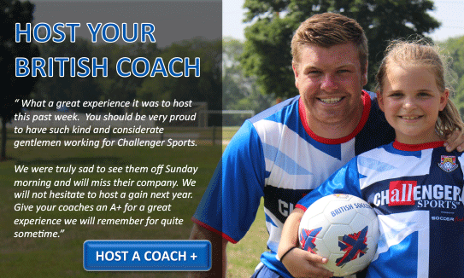

- WE ARE LOOKING FOR HOST FAMILIES IN Shrewsbury, MA & THE SURROUNDING AREA
- HAVE A SOCCER PROFESSIONAL STAY AT YOUR HOUSE, TO PLAY WITH YOUR KIDS AND TEACH THEM ALL THE SOCCER SKILLS.
- ALL OUR COACHES ARE CERTIFIED, PASSED BACKGROUND CHECKS, EDUCATED AND WELL ADAPTED TO THE AMERICAN WAY OF LIFE. SHARE HISTORY, TRADITIONS, CULTURES AND LANGUAGE DIFFERENCE AS YOU AND YOUR CHILDREN GET TO KNOW EVERYTHING BRITISH.
- A TRULY MEMORABLE EXPERIENCE AS OUR COACHES BECOME PART OF THE FAMILY AND THE START OF A LONG LASTING FRIENDSHIP ACROSS CONTINENTS!
- BY PARTICIPATING IN OUR HOST A COACH PROGRAM YOU WILL RECEIVE A $50 PER WEEK REBATE AS A THANK YOU FOR HELPING US AND YOUR COMMUNITY!

You are receiving this email from a send only account.
If you have any questions please reply to info@challengersports.com or call 800-878-2167.

