- www.dor.org
- “CYO Athletics”

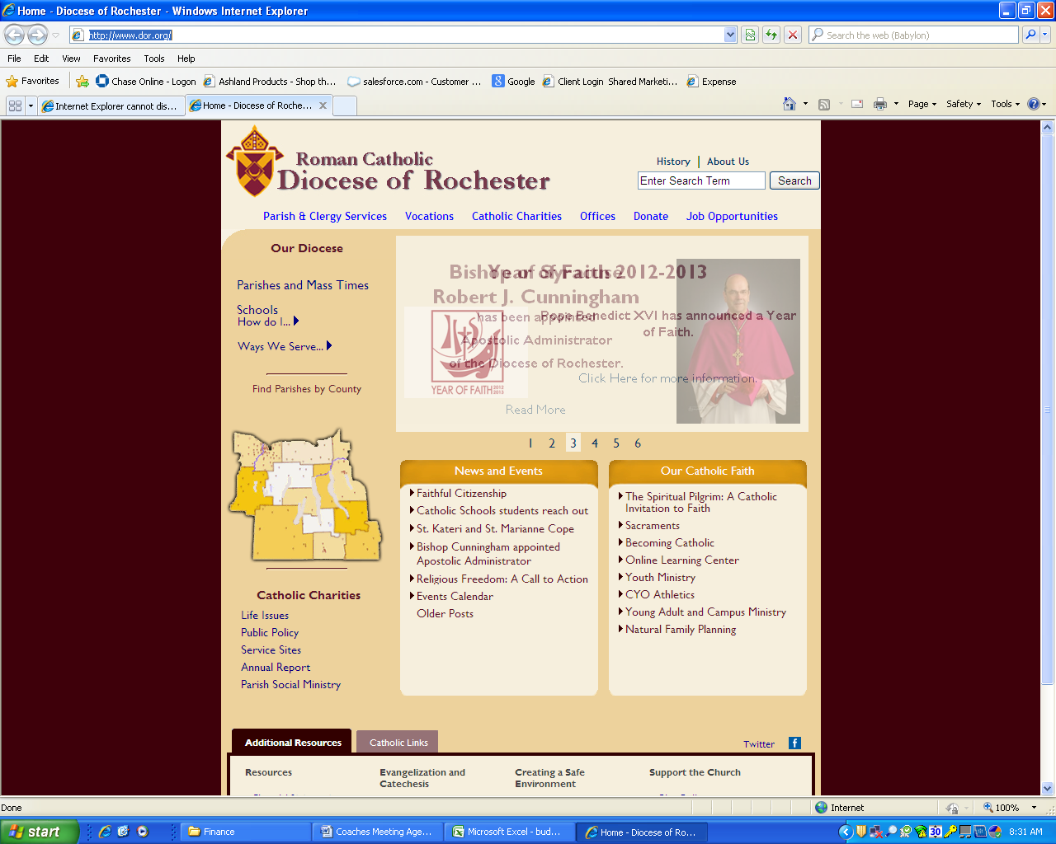

- “Basketball Registration”

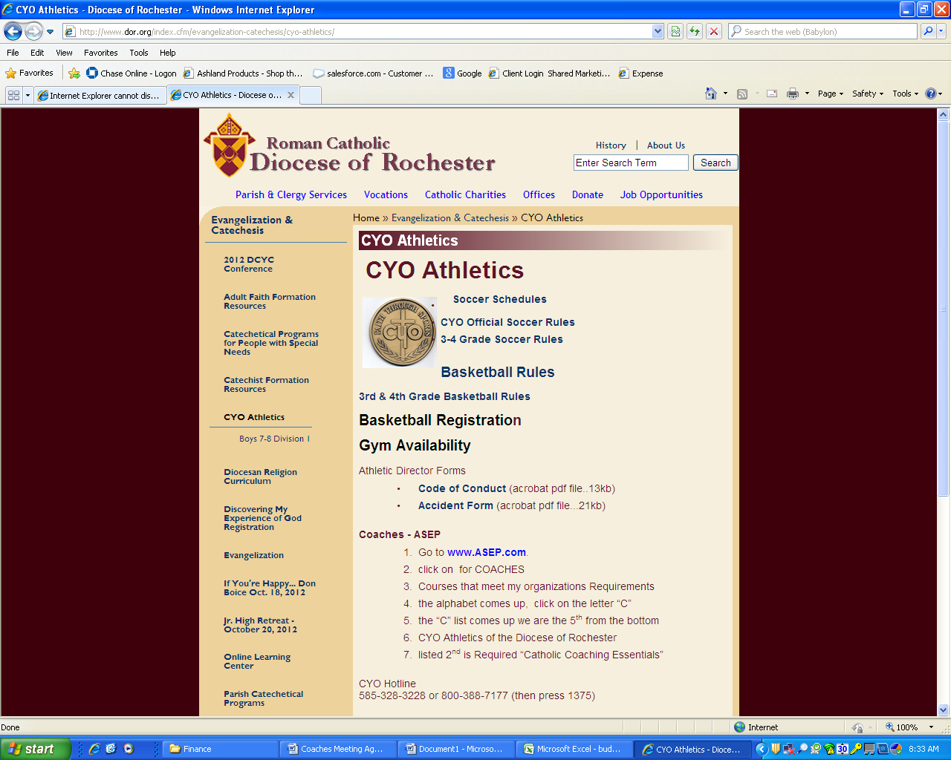

- Complete Basketball Team Registration Form

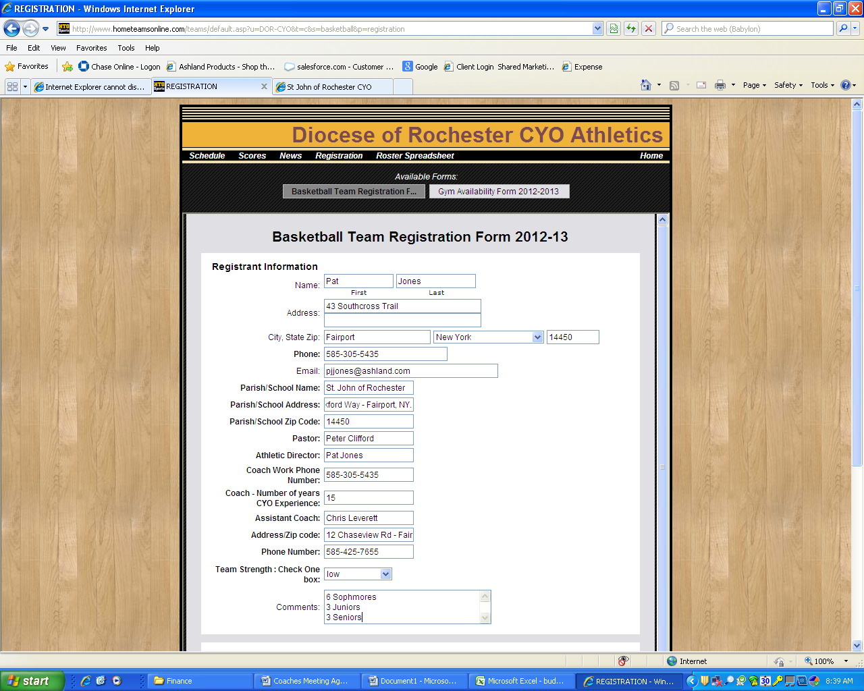

- Bottom of page. Click on division and agree to the terms and conditions. Submit Form

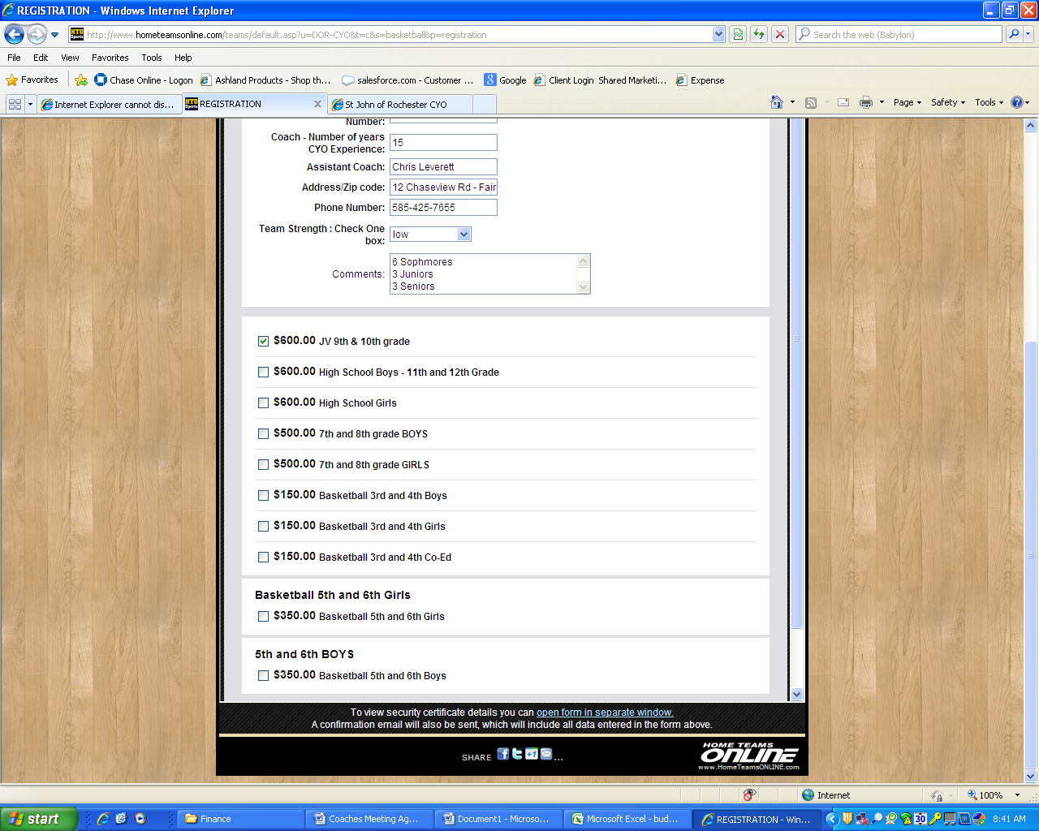

- Print Form and Mail Check.
SJR will send one check for registration.

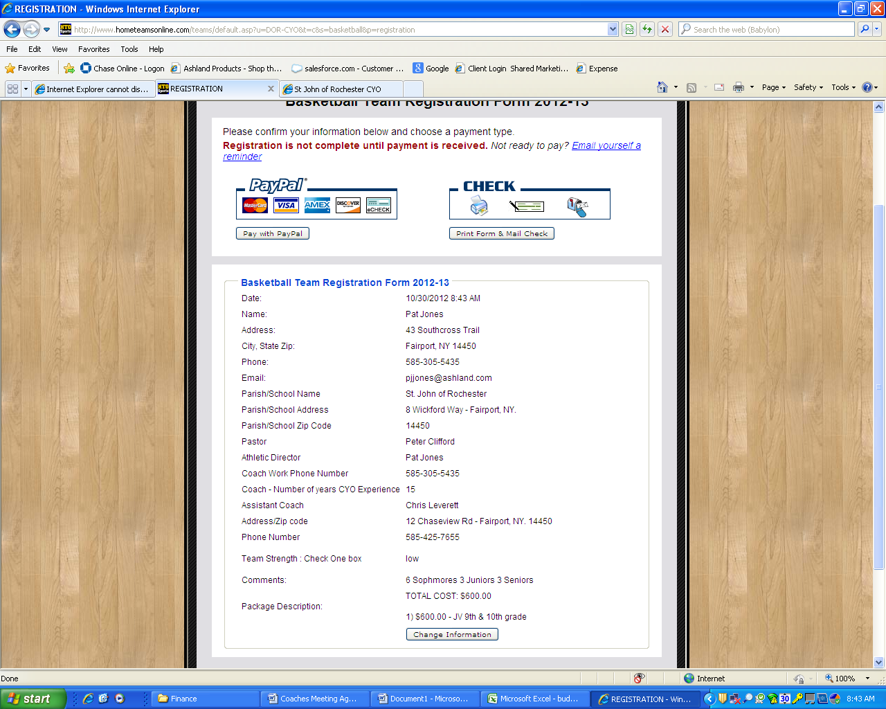

- Print Form and hand it in to SJR CYO.

