ASEP INSTRUCTIONS
1. Go to www.ASEP.com.
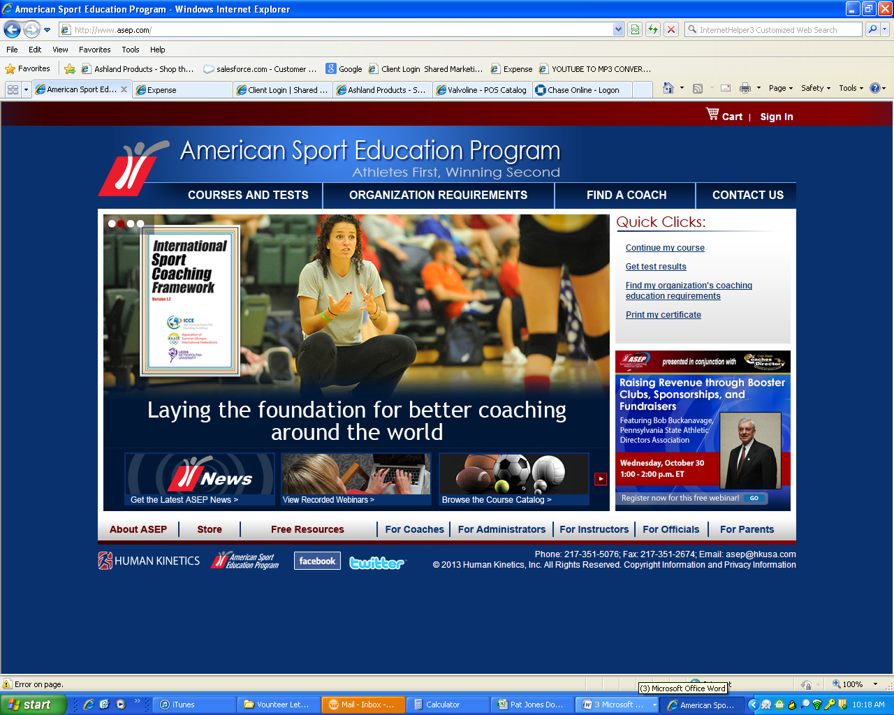

2. click on for COACHES
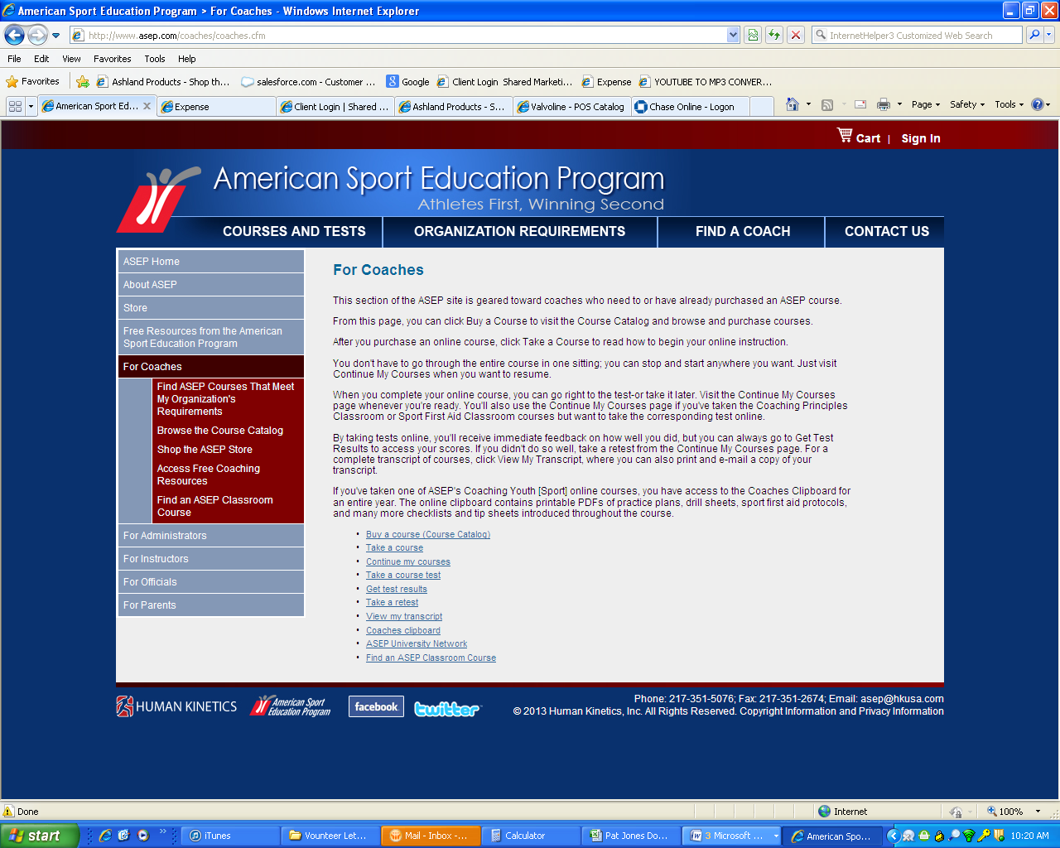

3. Courses that meet my organizations Requirements
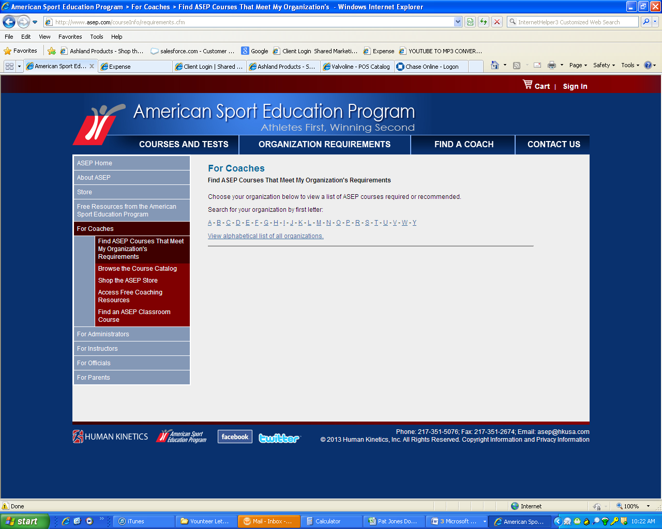

4. the alphabet comes up, click on the letter “C”
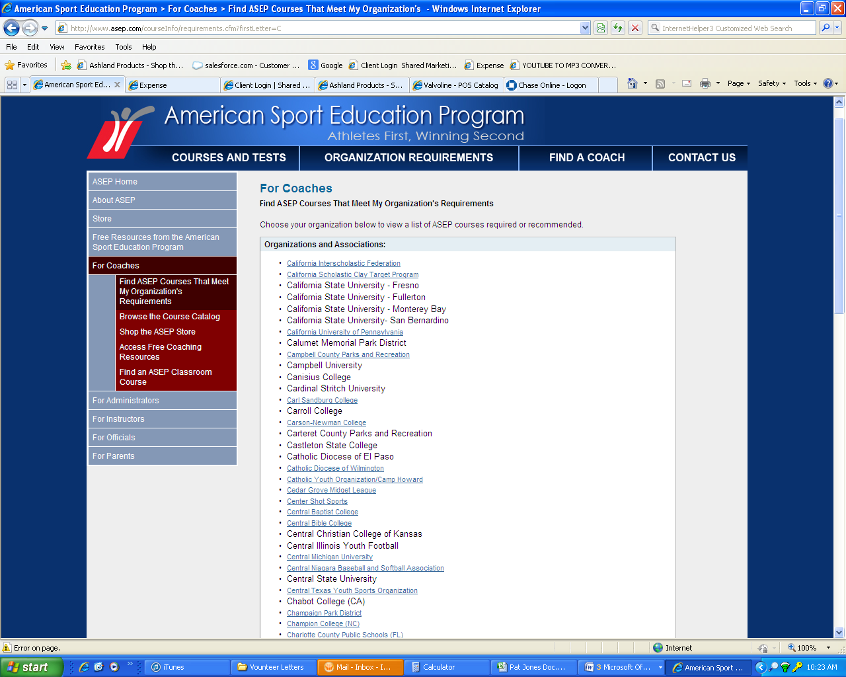

5. the “C” list comes up we are the 5th from the bottom
6. CYO Athletics of the Diocese of Rochester
7. listed 2nd is Required “Catholic Coaching Essentials”

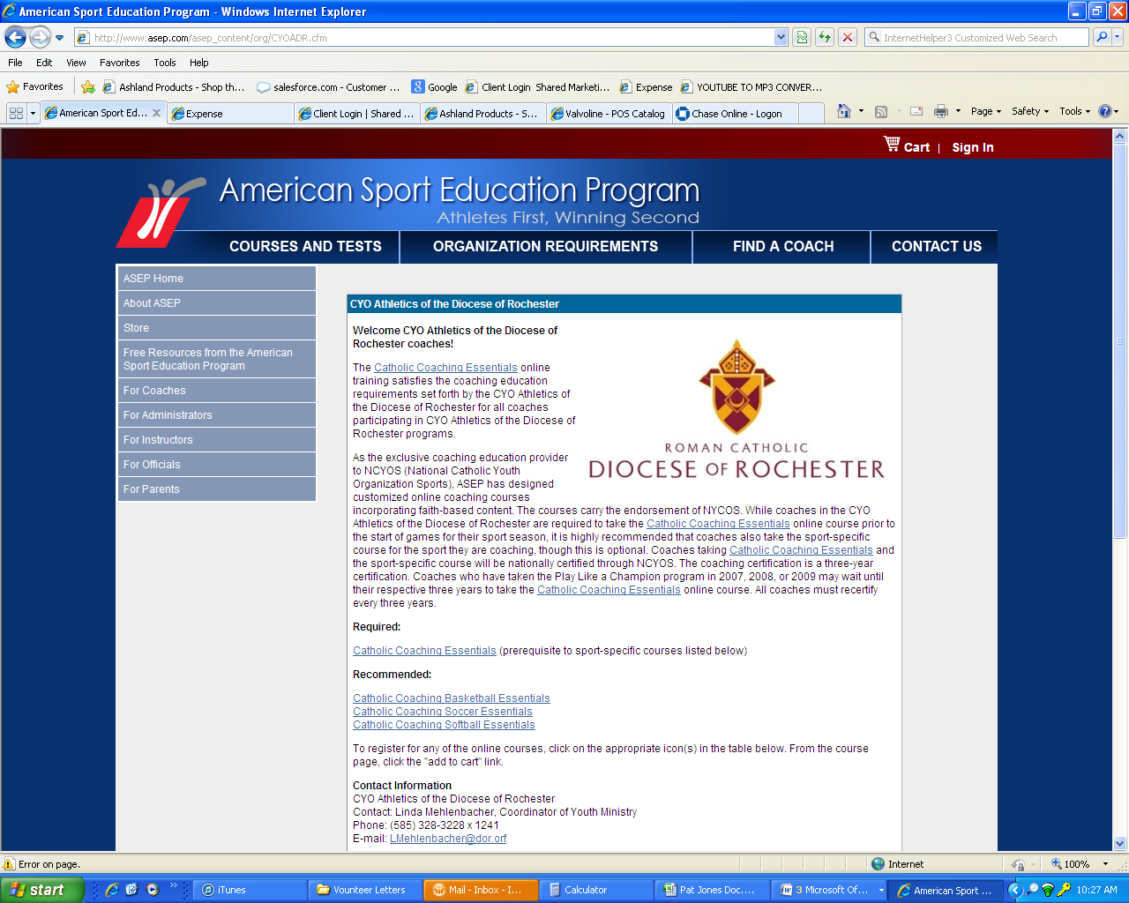
8. “Choose your local organization”
9. Click here to finish

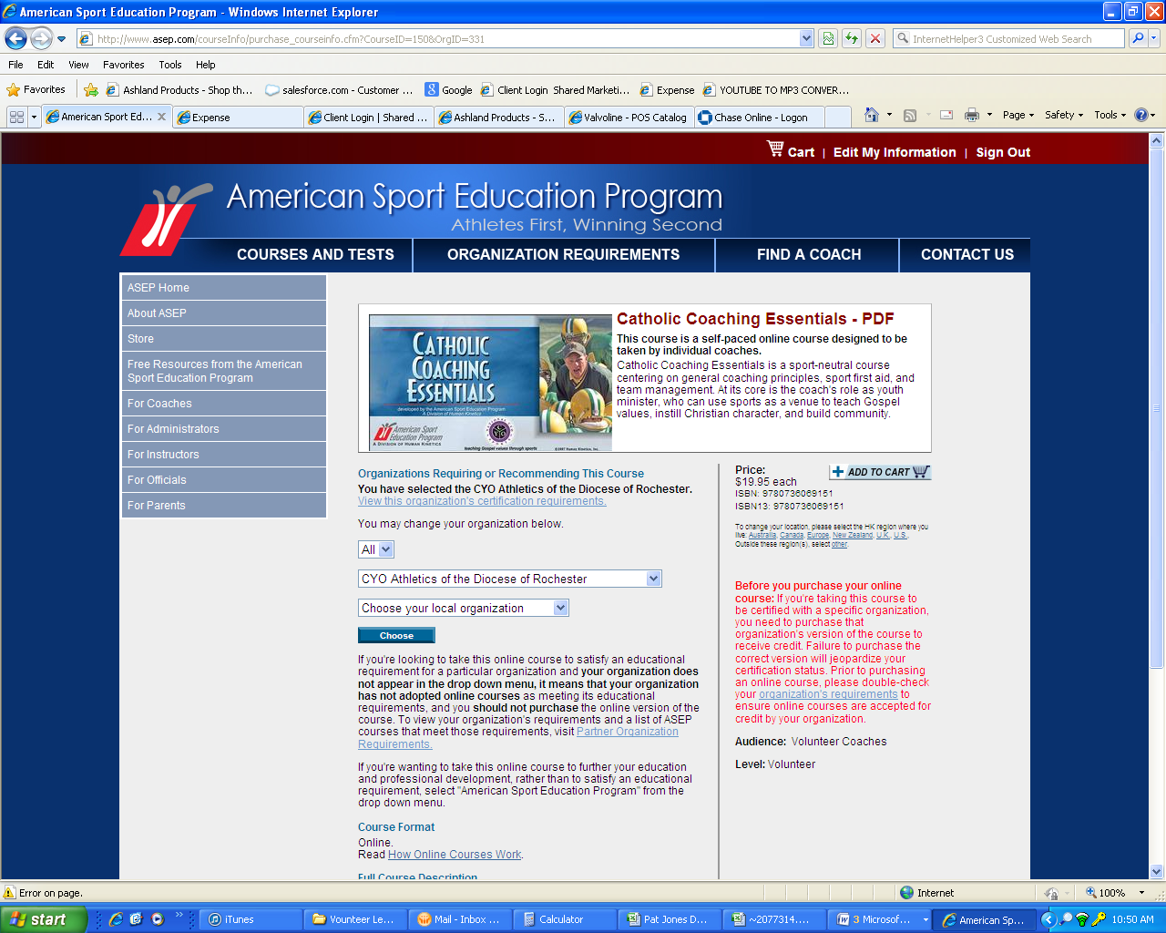

10. Click NO

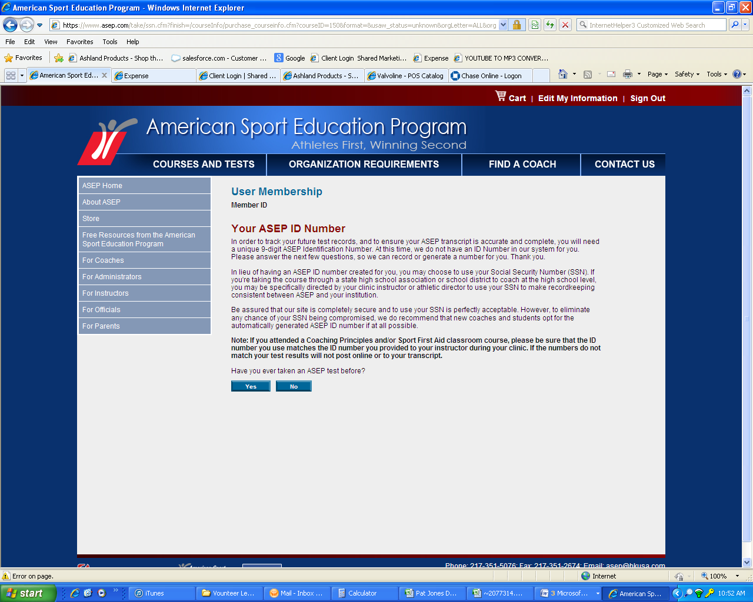

11. I would like to use my assigned SS #

